HELIOS: *Cloud-Native Anomaly Detection & Self-Healing Agent*

*A ML + Cloud Monitoring Research Implementation*

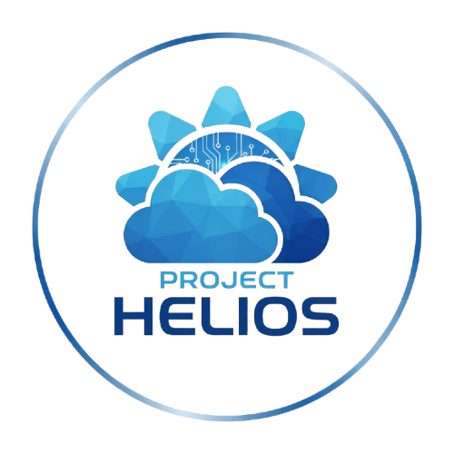

**Name: Nitanshu Tak SapID: 500121943**

**Specialization: CCVT Batch - 2**

**Abstract**

Cloud computing is now the backbone of contemporary IT infrastructure, driving enterprises, startups, and research worldwide. Cloud systems are nevertheless plagued with tremendous challenges posed by anomalies like CPU spikes, network traffic surges, attempted unauthorized access, storage overload, and malicious content injections. These anomalies affect reliability, security, and cost-effectiveness. This project, Helios, brings with it an AI-based cloud-native architecture that identifies anomalies across multiple layers and seamlessly integrates with AWS CloudWatch and SNS for real-time alerting, thus establishing the basis of a self-healing system.

**1. Introduction**

Cloud services provide scalability, flexibility, and cost savings. It is not easy, though, to sustain the reliability of cloud infrastructure. Classical monitoring systems bank a lot on rule-based alerts and thresholds and do not pick up dynamic, evolving patterns of abnormal behavior. The outcome is downtime, security violations, and wasteful usage of the cloud.

Artificial Intelligence and Machine Learning (AI/ML) may improve cloud resiliency by automating anomaly detection and remediation. Helios brings AI/ML models into a cloud-native deployment to help meet this requirement, enabling the cloud to be self-aware and self-healing.

**2. Background and Literature Review**

Cloud system anomaly detection has been well researched, with solutions spanning from basic statistical monitoring to sophisticated deep learning methods. Rule-based techniques like static thresholding (e.g., send alert if CPU > 90%) are prevalent but are not dynamic enough to handle variations in the workload. Recent works present the strong performance of ML algorithms like Isolation Forest, KMeans, and Logistic Regression for identifying anomalies in performance and security metrics.

Helios extends this body of work by integrating several anomaly detectors into a single system running on AWS. This provides real-world practicability in cloud environments where performance, security, and reliability meet.

**3. System Architecture**

The Helios system architecture has the following components:

• Data Layer – Synthetic datasets created and models trained on Google Colab.

• Storage Layer – AWS S3 for storing the trained models (.pkl files).

• Compute Layer – AWS EC2 running a Flask-based anomaly detection API.

• Security Layer – IAM roles and Security Groups for restricted access.

• Monitoring Layer – AWS CloudWatch for real-time visualization of metrics.

• Alerting Layer – AWS SNS for real-time notifications of anomalies.

Data passes through the layers in a cycle: anomalies are identified, alerts are sent, and potential self-healing measures can be taken.

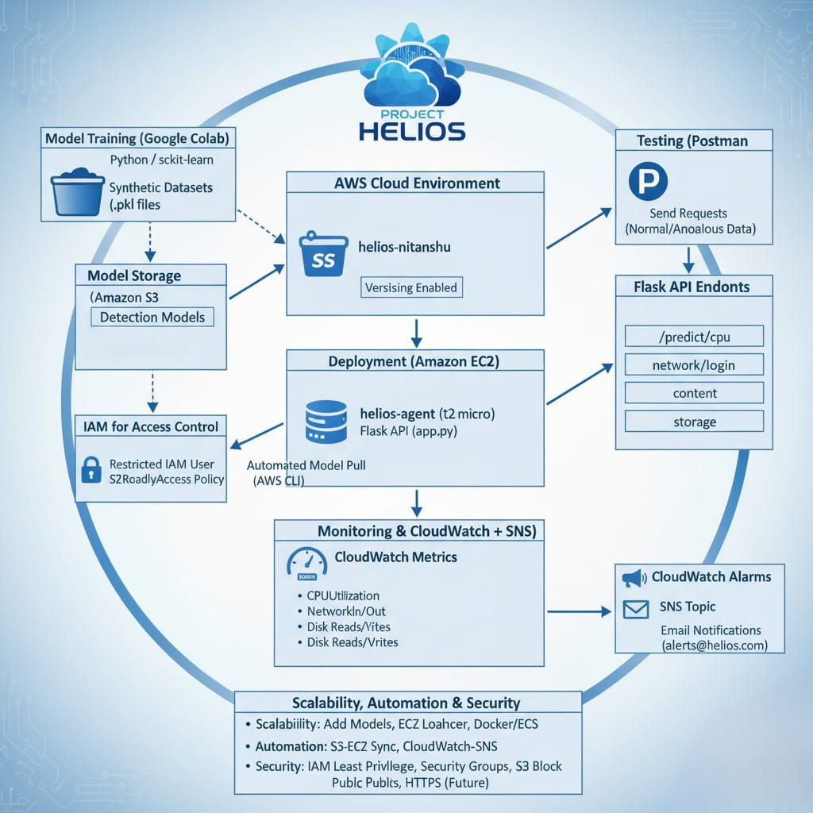

**4. Phase 1: Model Training**

Five separate ML models were trained using Google Colab to identify various types of cloud anomalies:

• CPU Usage – Isolation Forest identifies anomalous CPU spikes outside normal operating levels.

• Network Traffic – KMeans clustering identifies normal vs. anomalous request patterns.

• Unsuccessful Login – Logistic Regression identifies anomalous login attempts.

• Content Injection – TF-IDF with Logistic Regression identifies malicious text/URLs.

• Storage Utilization – Isolation Forest identifies unusual storage growth.

All models were trained on synthetic datasets and exported as serialized .pkl files to be deployed.

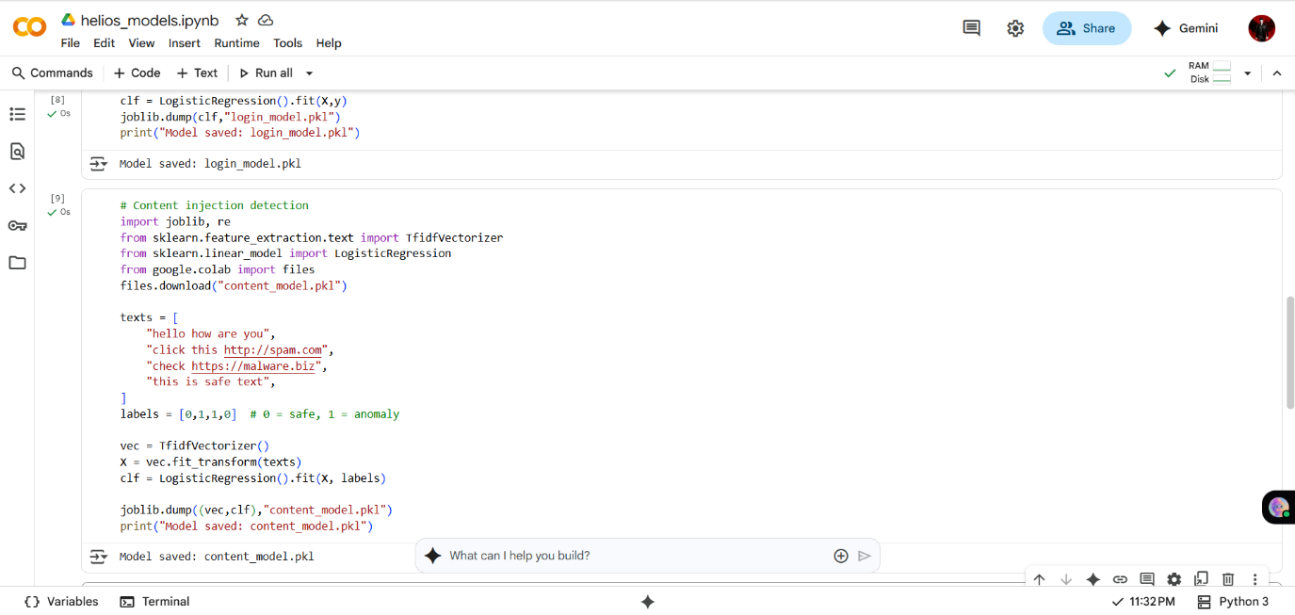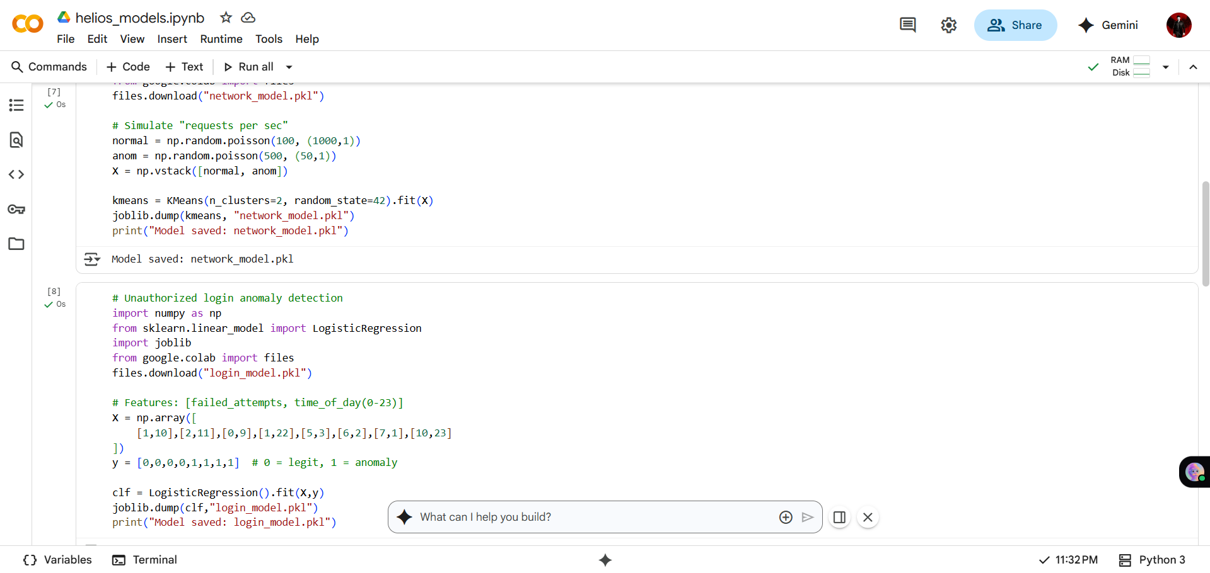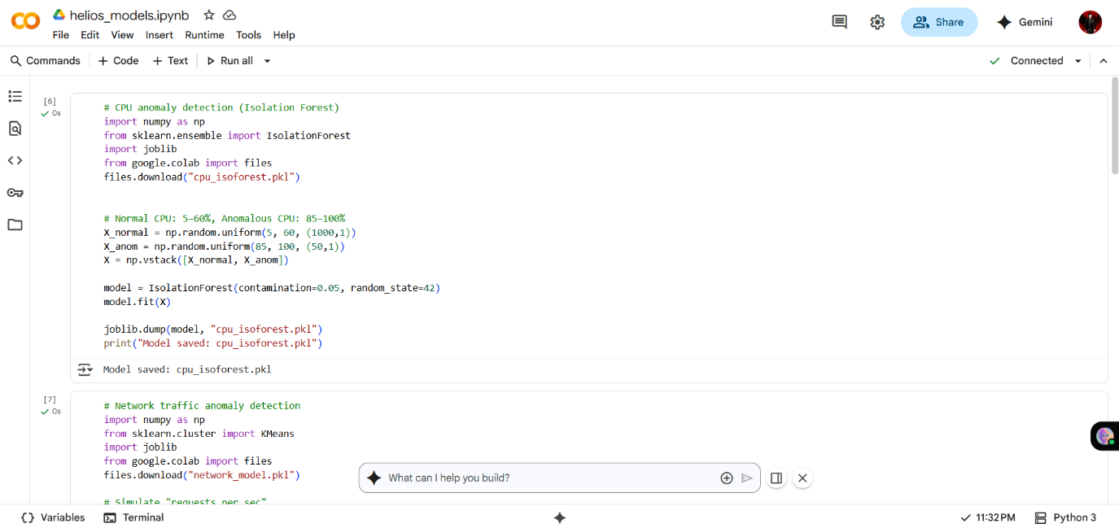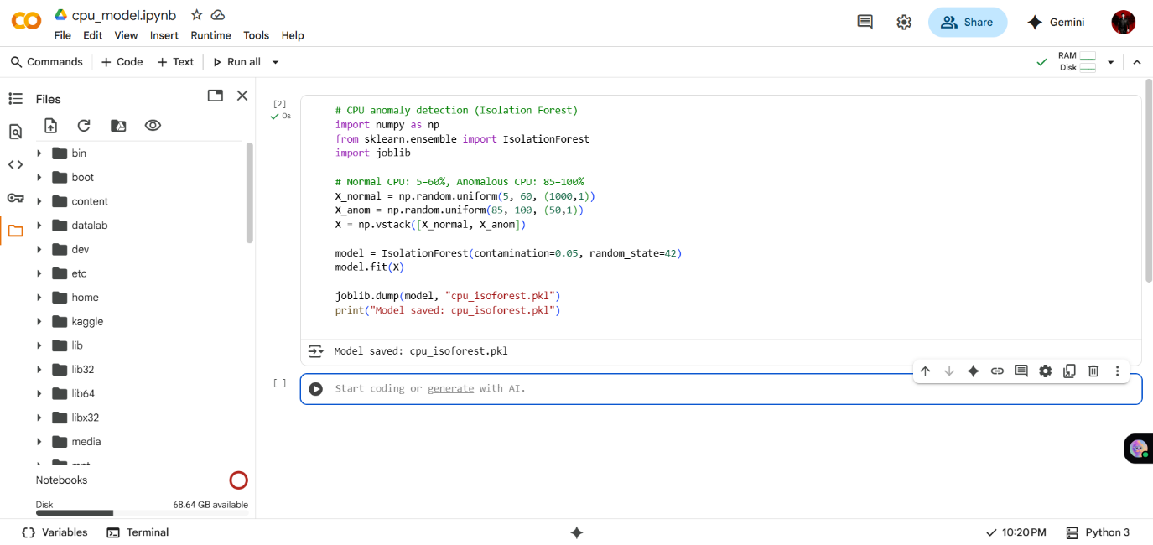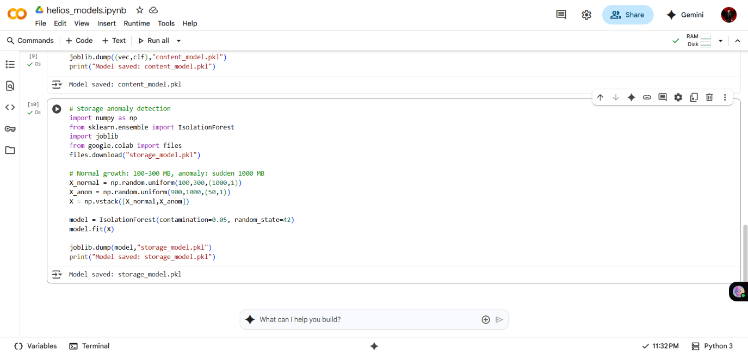

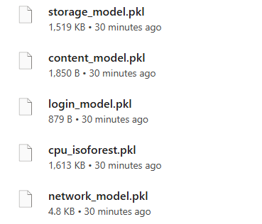

**5. Phase 2: Deployment on AWS EC2**

The trained models were deployed as part of a Flask-based API running on an EC2 instance. The deployment process involved:

• Creating S3 bucket 'helios-nitanshu' with versioning enabled.

• Uploading models into S3 bucket under 'models/' folder.

• Creating EC2 instance 'helios-agent' with required security group rules.

• Installing Python packages (Flask, boto3, scikit-learn, joblib).

• Downloading models from S3 into the EC2 instance.

• Implementing Flask routes for every anomaly type.

• Testing using Postman to ensure anomaly detection APIs.

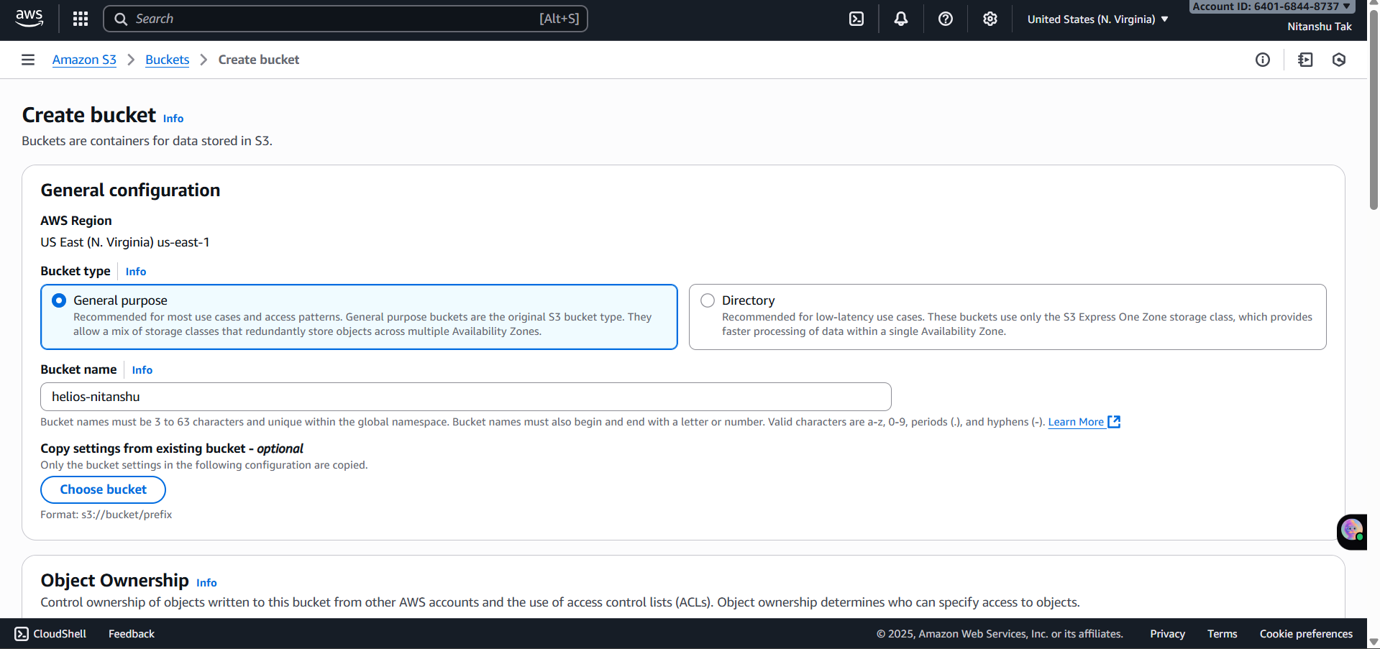

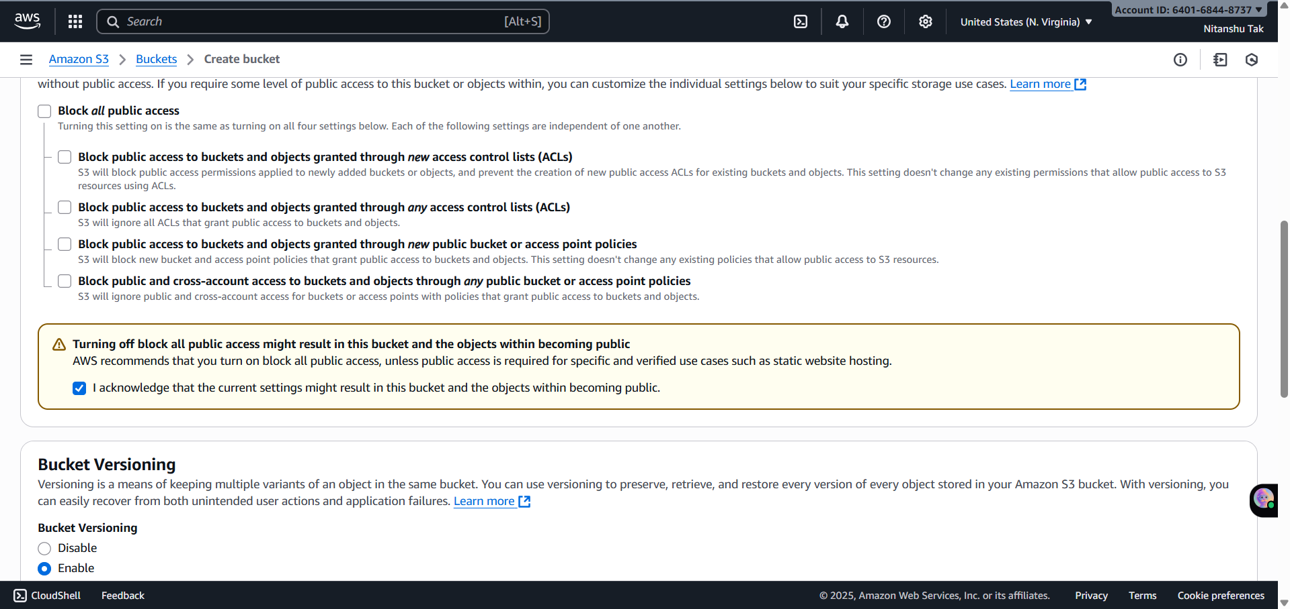

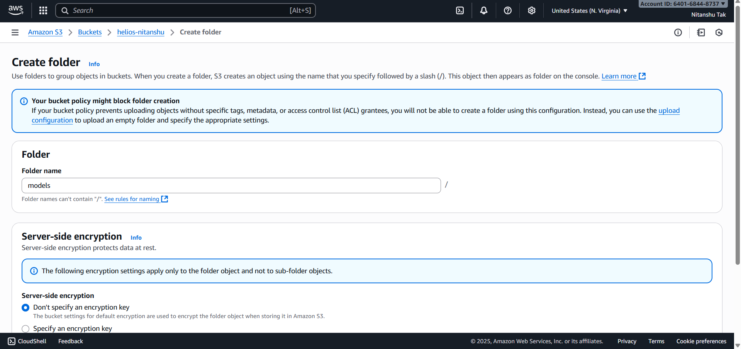

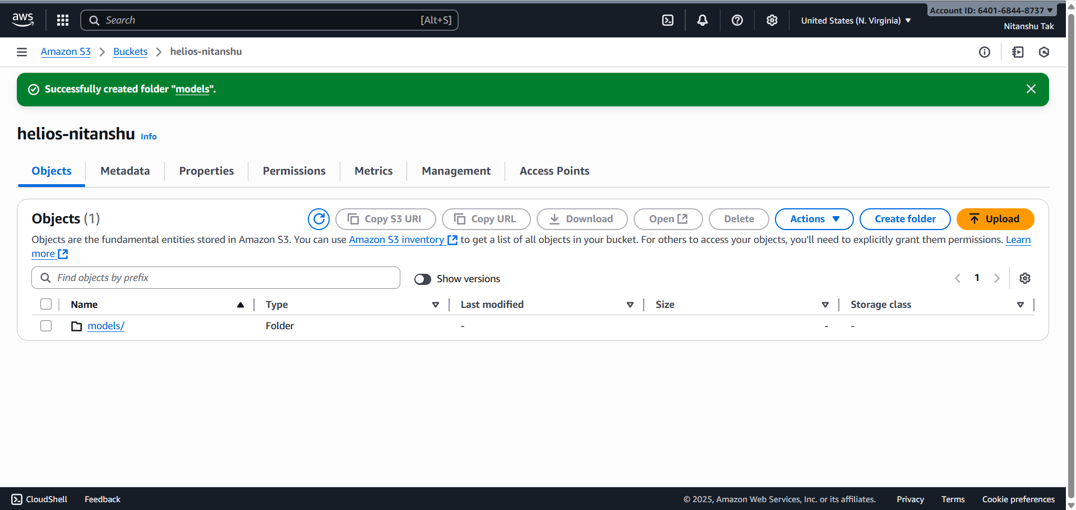

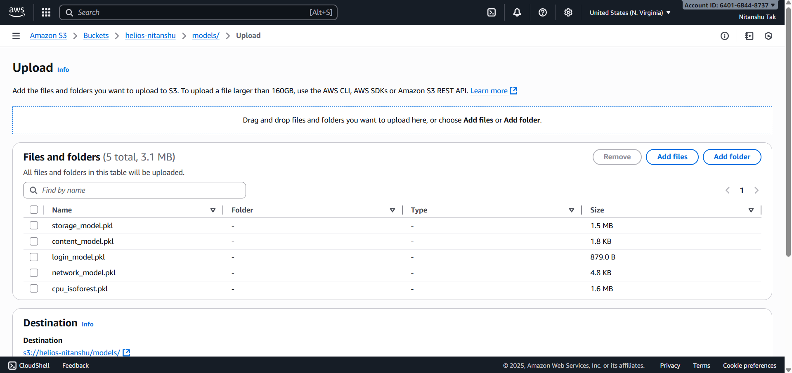

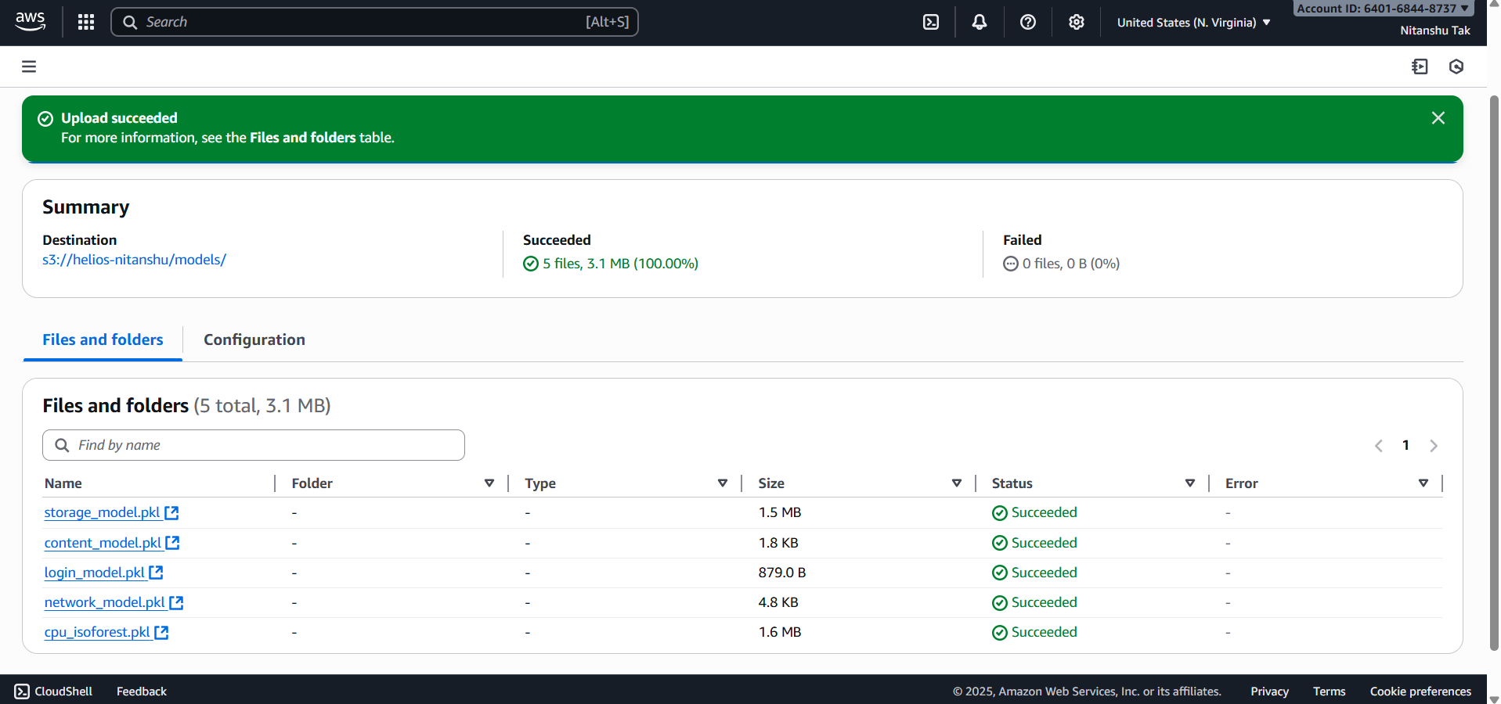

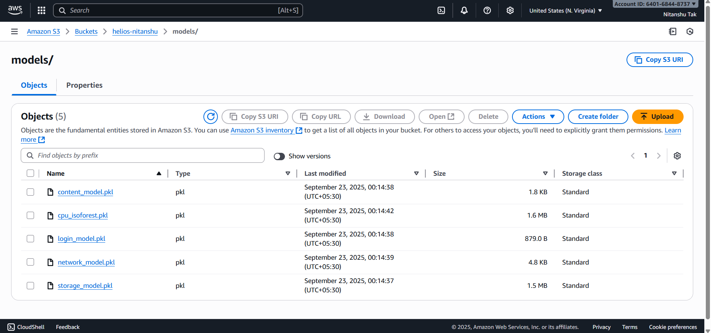

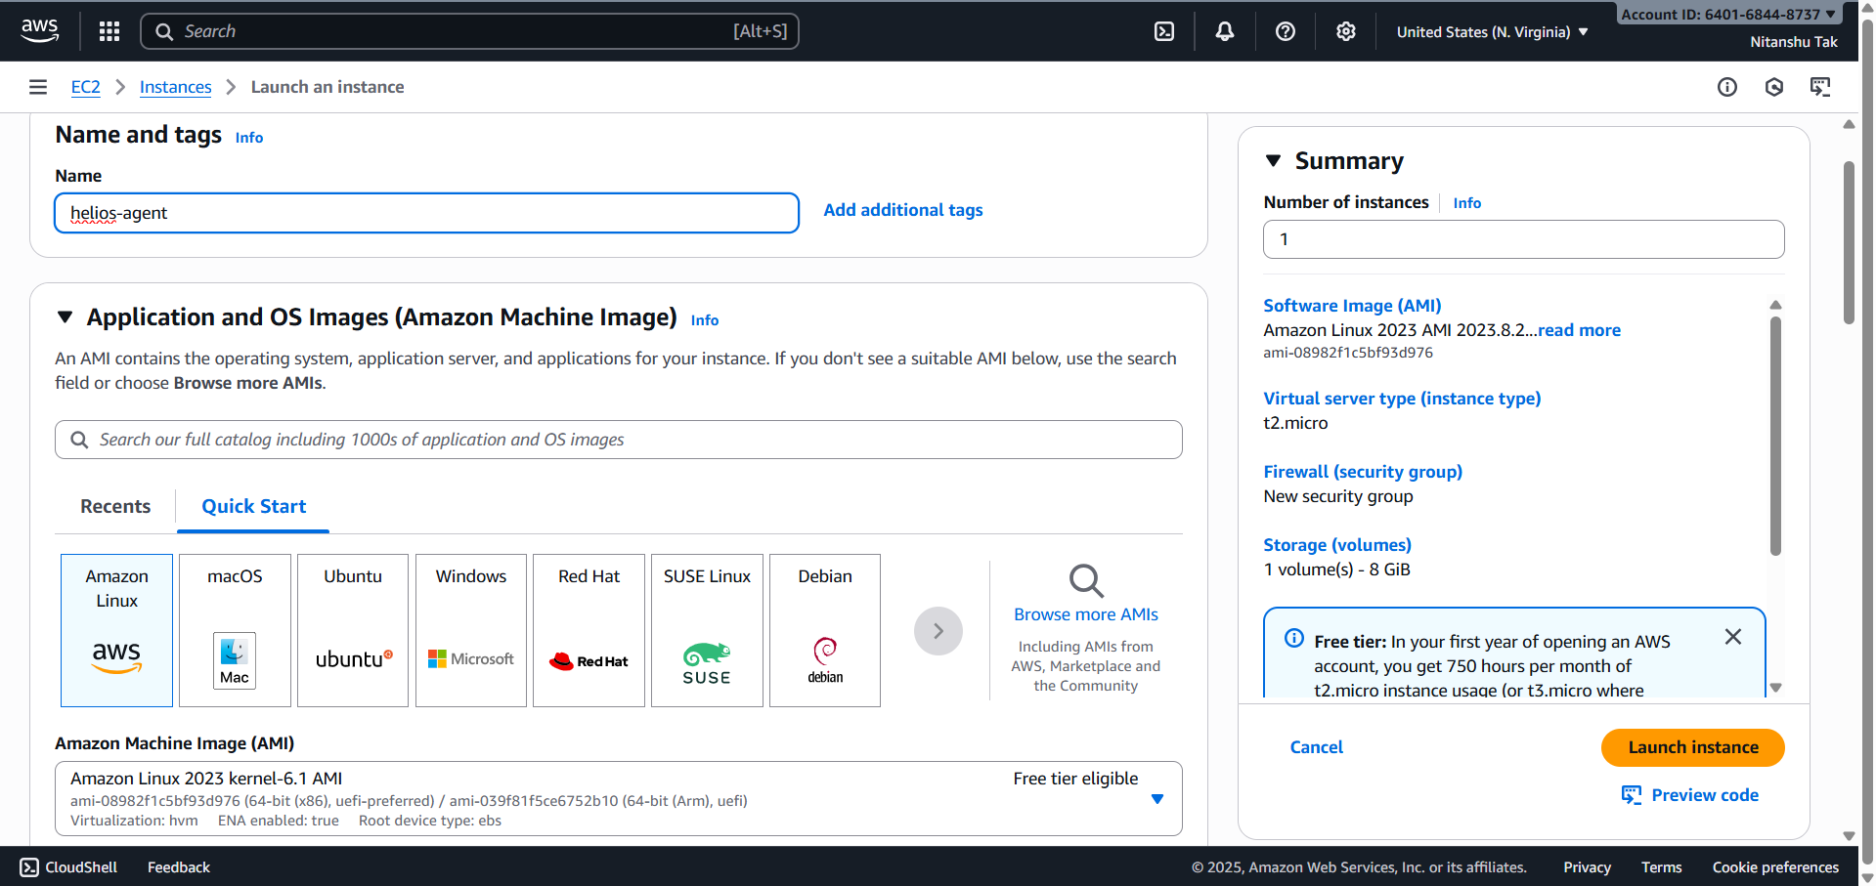

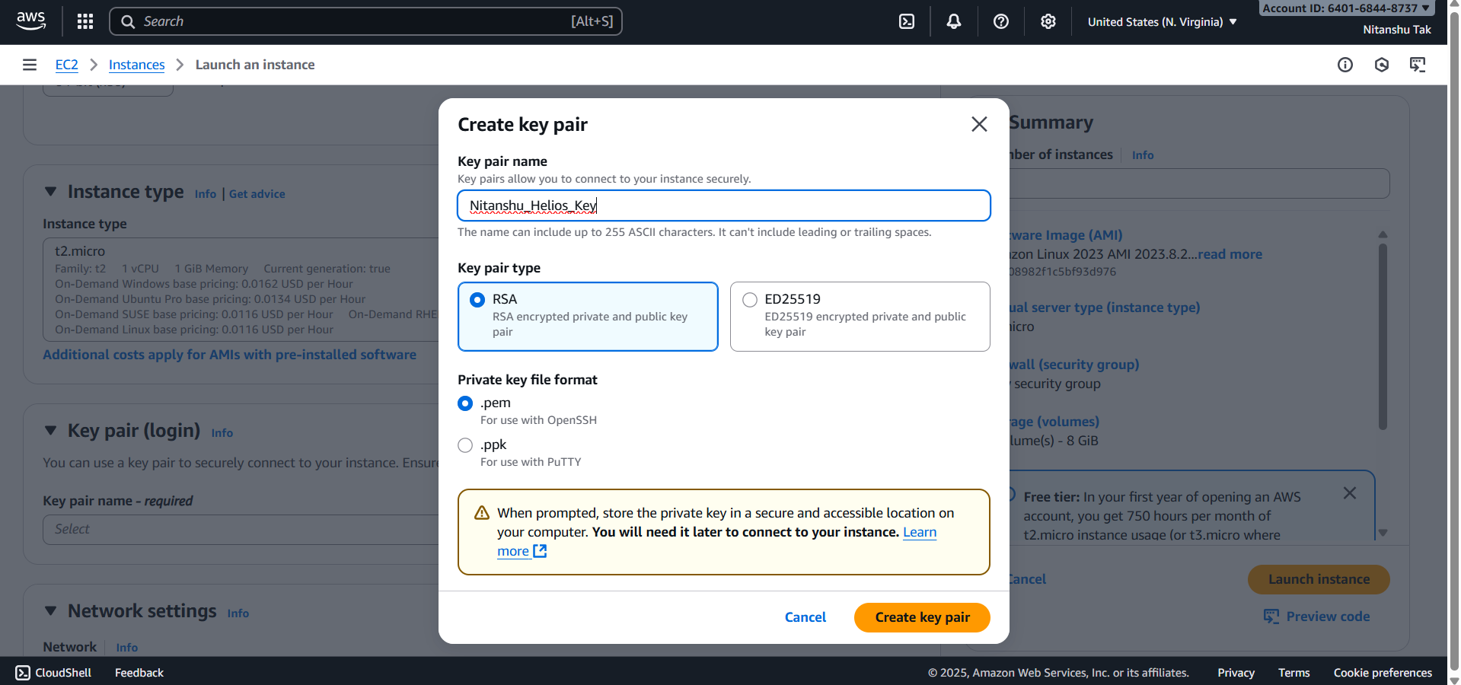

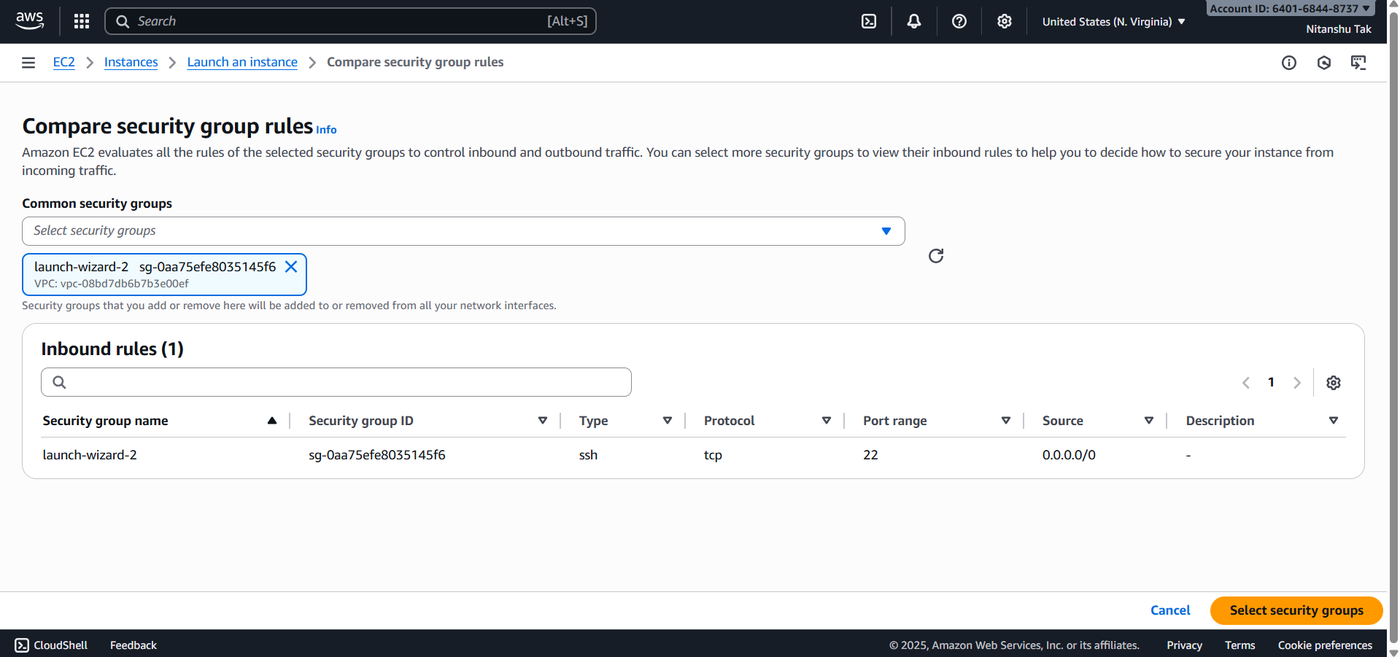

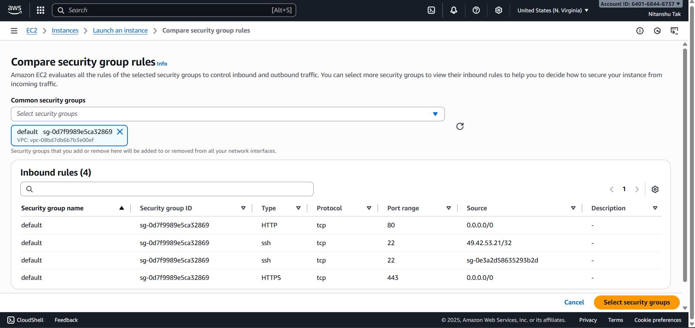

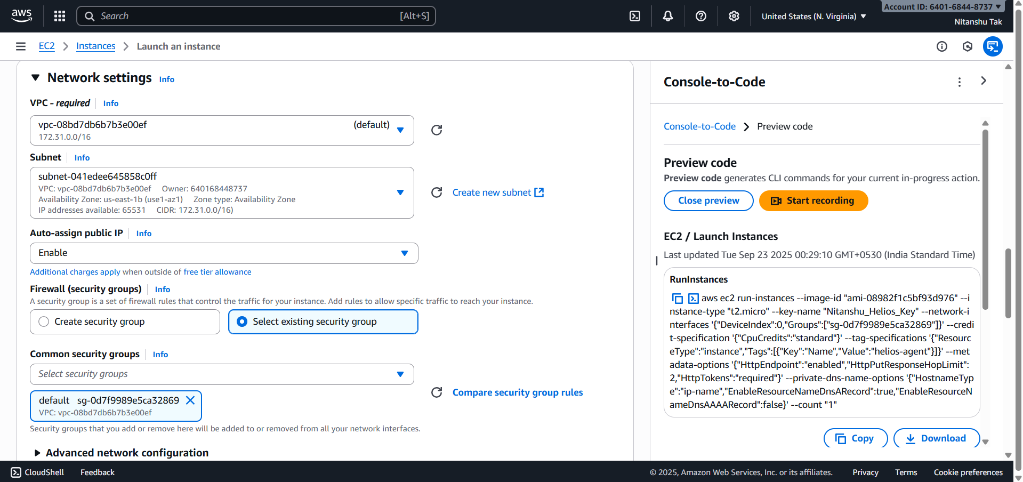

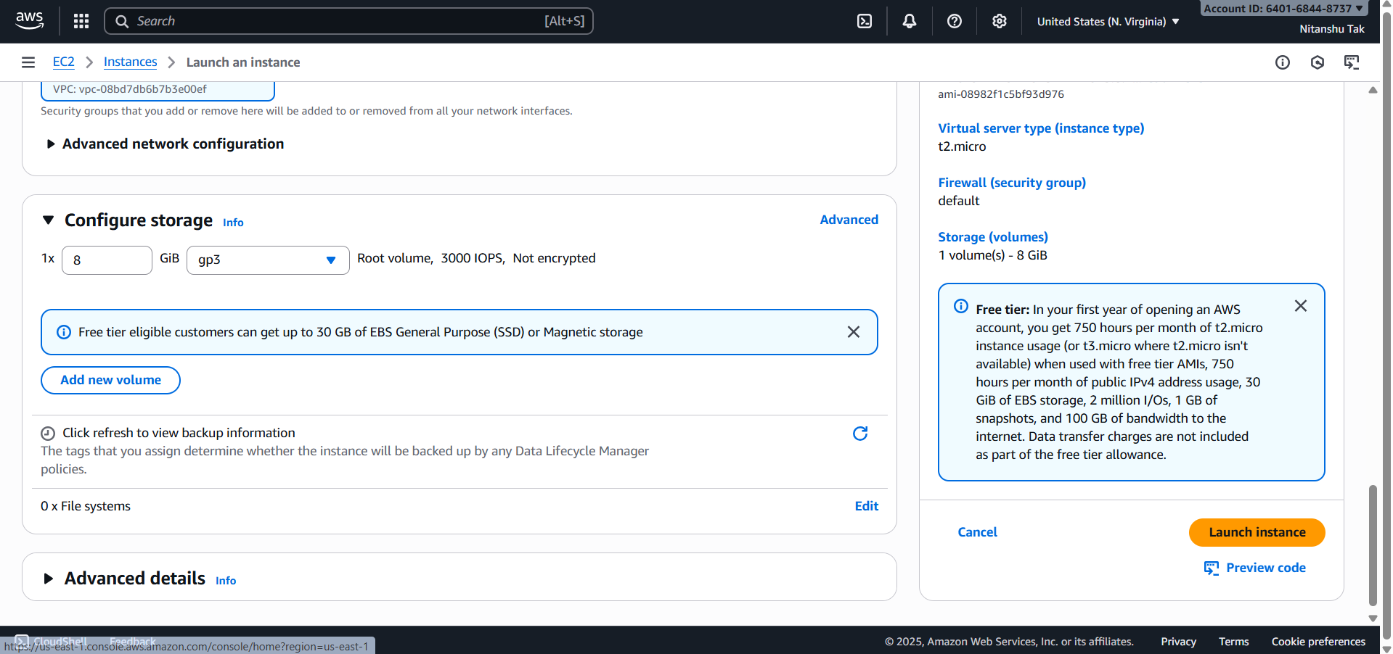

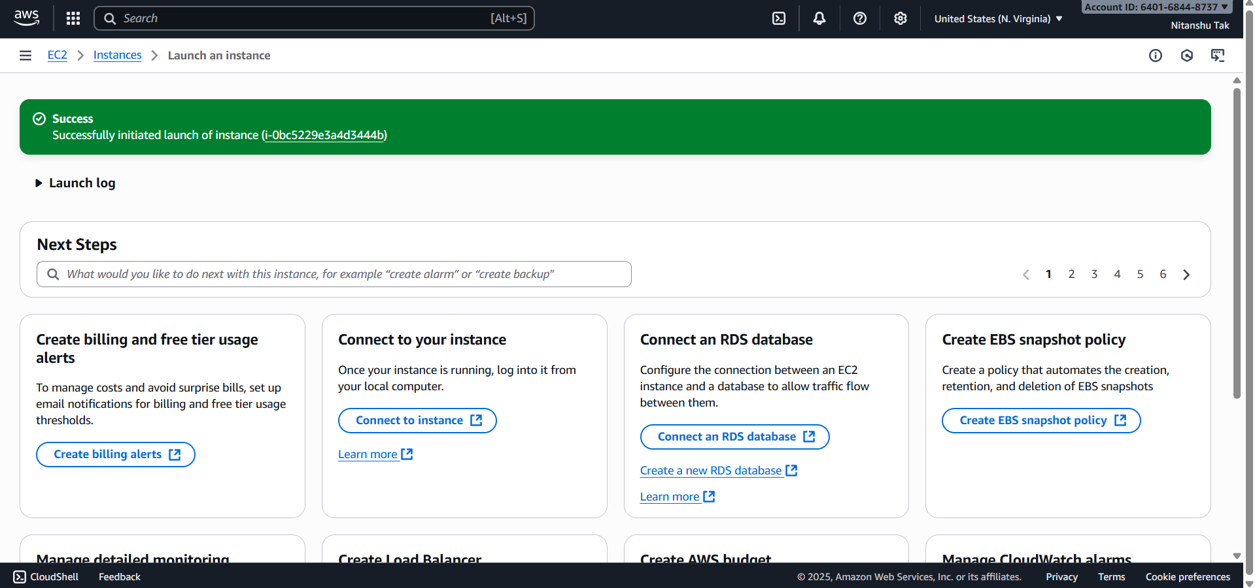

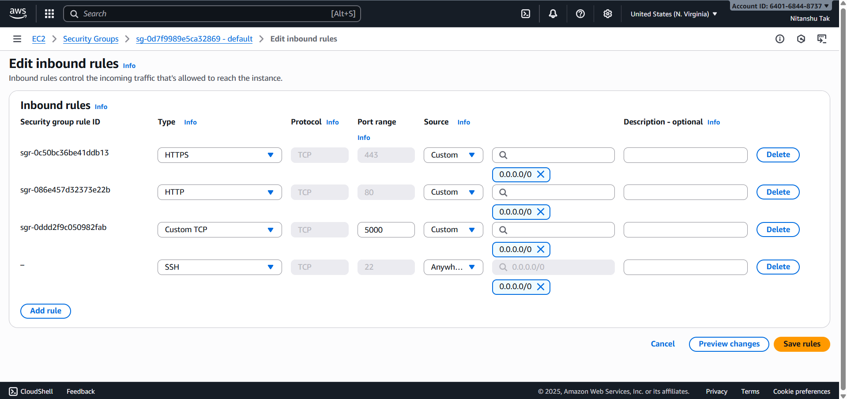

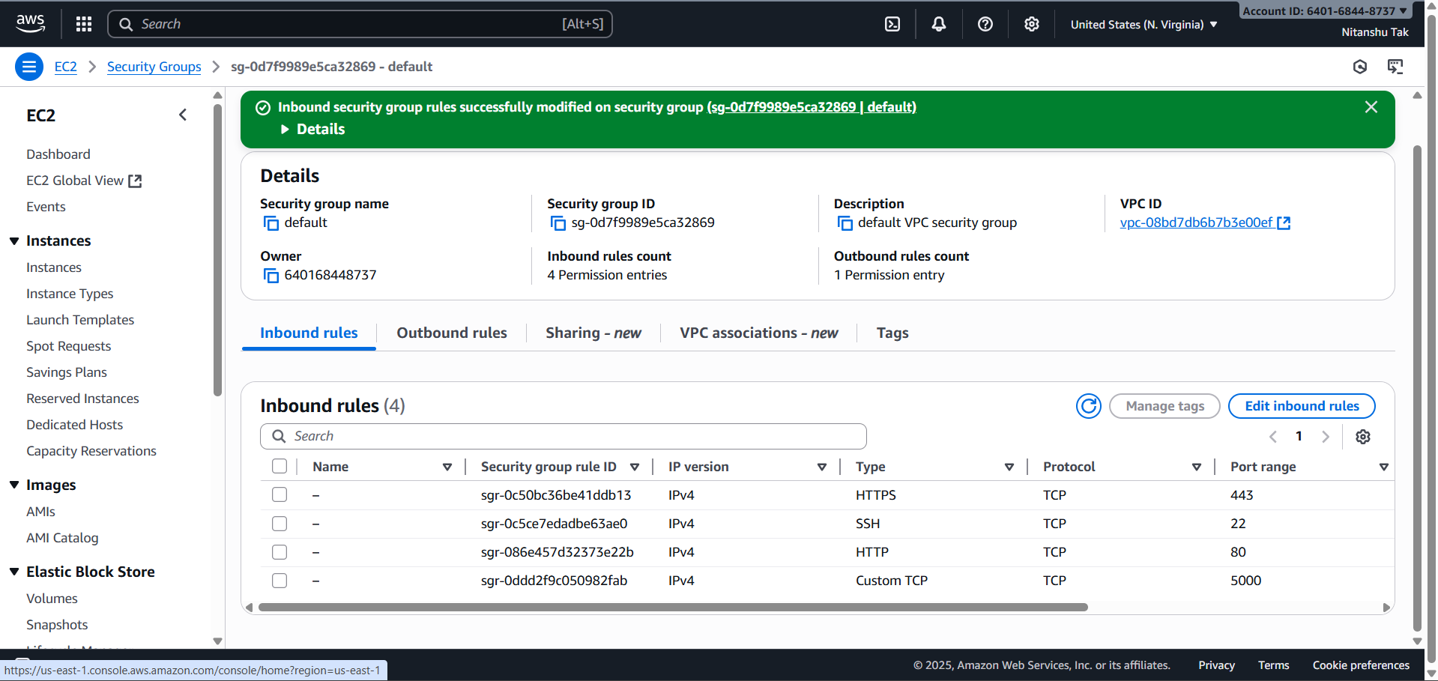

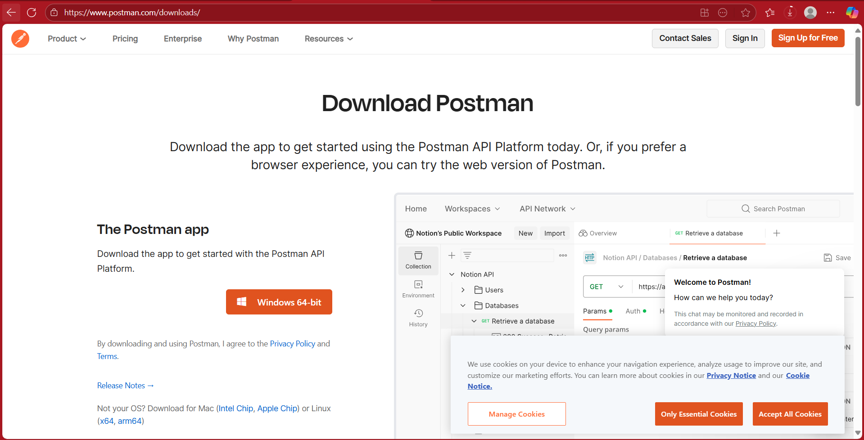

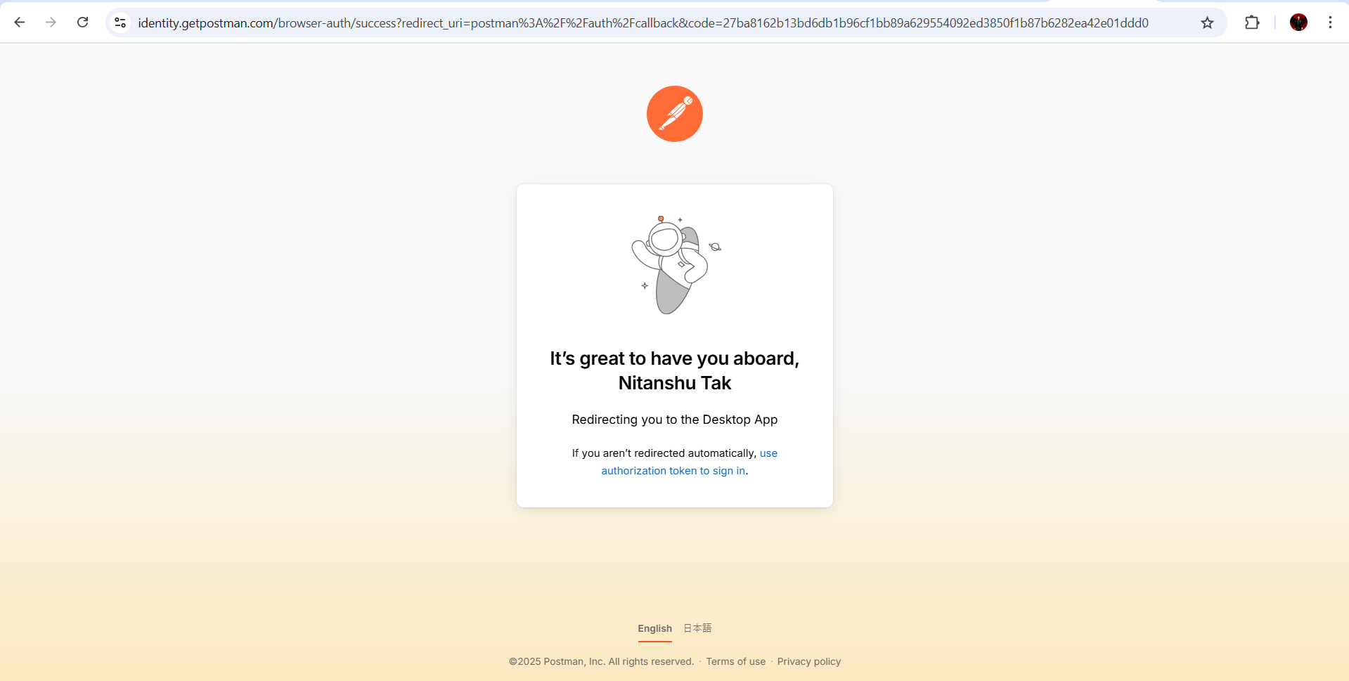

**6. Phase 3: Cloud Monitoring and Alerts**

For achieving real-time monitoring and alerting, AWS CloudWatch and SNS were utilized. The steps followed:

• SNS Topic 'HeliosAlerts' creation and subscribing through email.

• CloudWatch Alarms creation on CPU usage metrics.

• Alarm actions configuration to trigger SNS alerts.

• CloudWatch Dashboard 'HeliosDashboard' creation with CPU, Network, and Disk widgets.

• Successful receipt of email alerts on threshold violations.

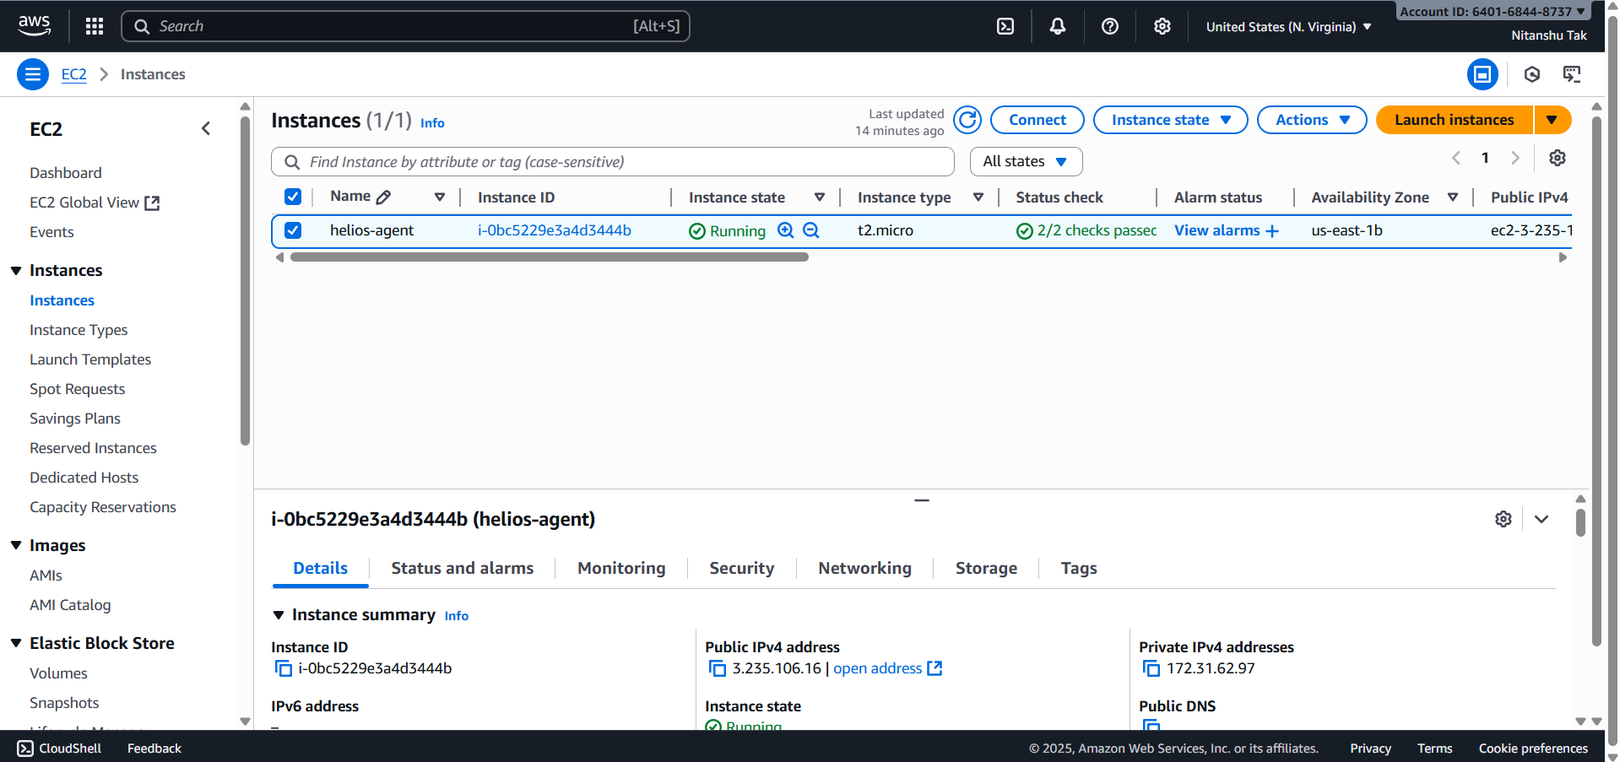

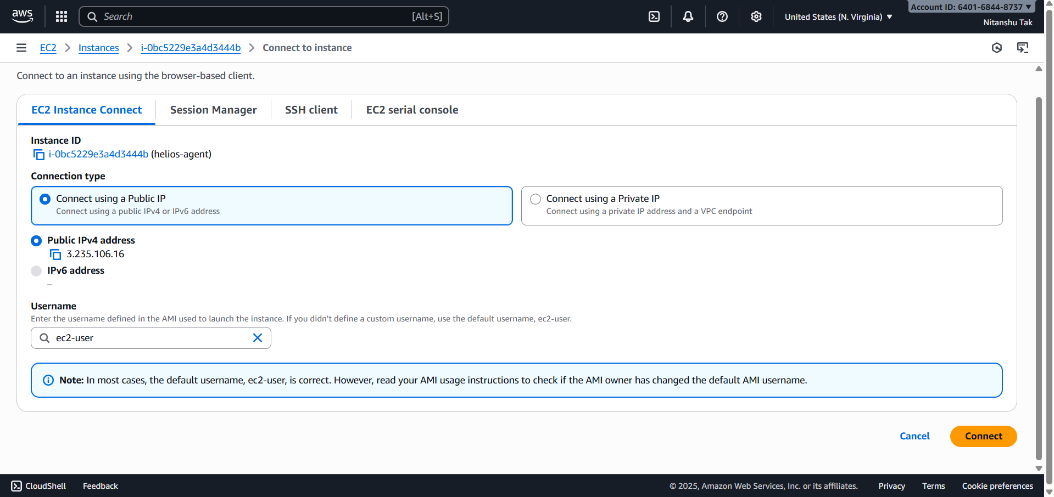

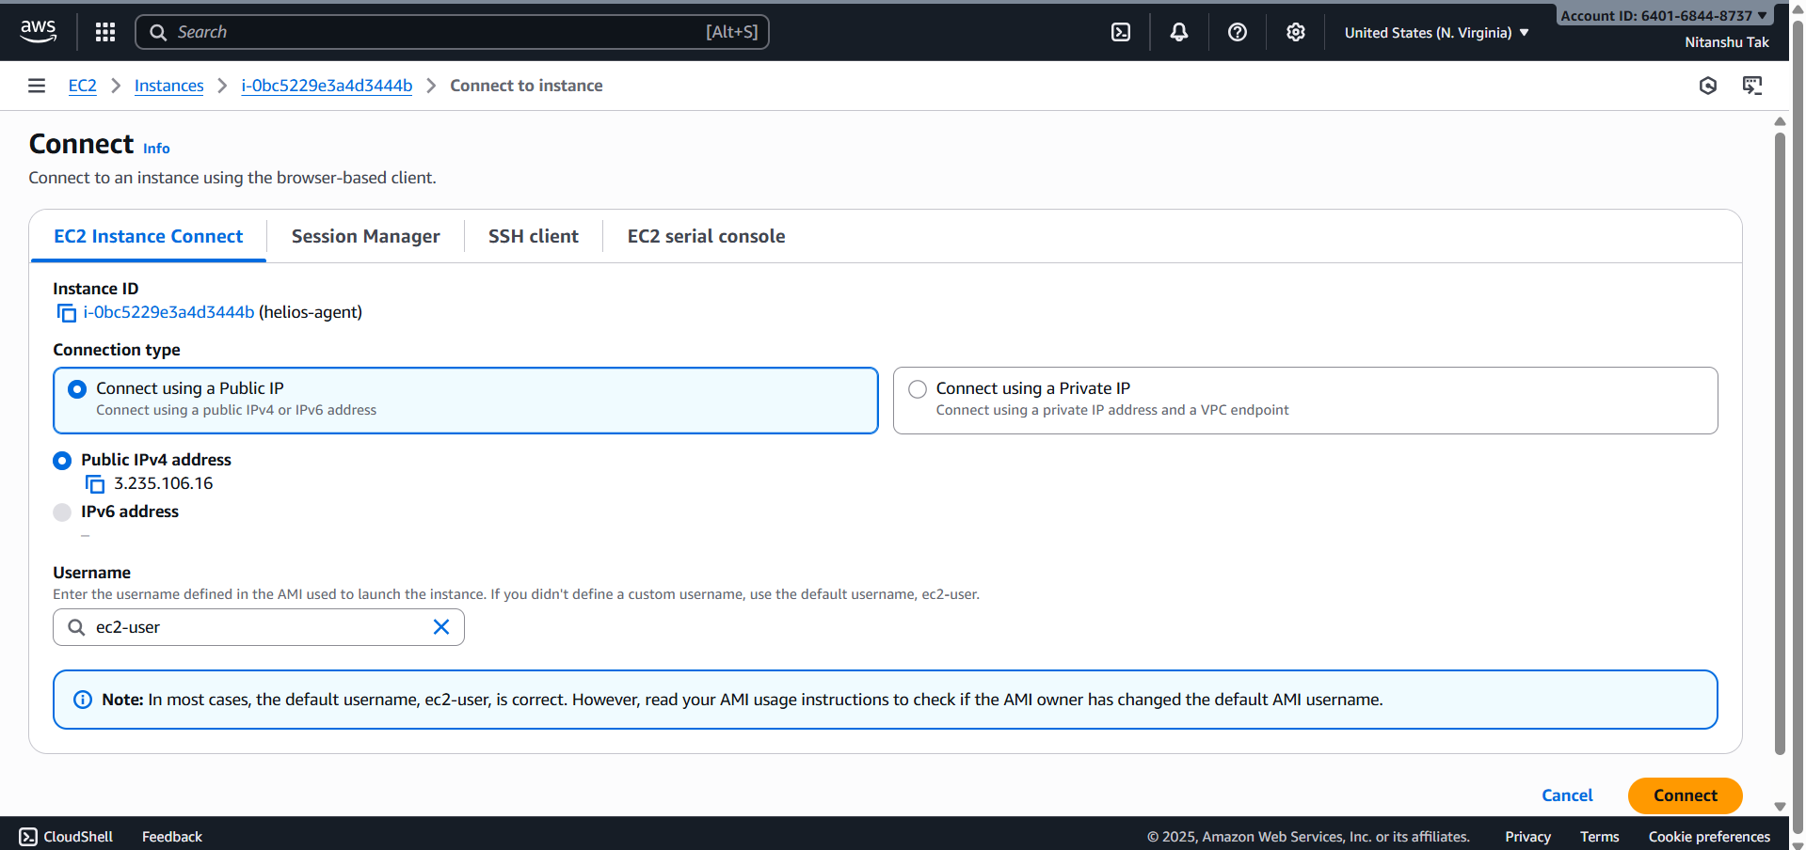

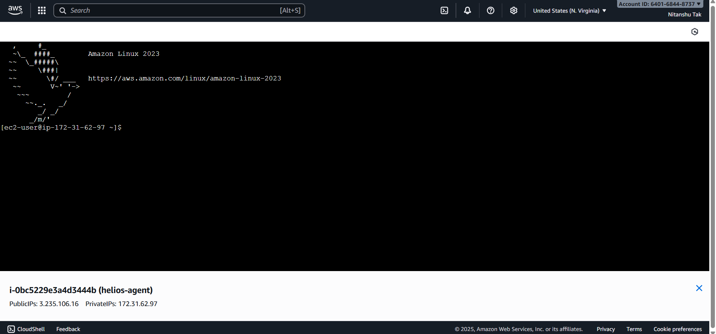

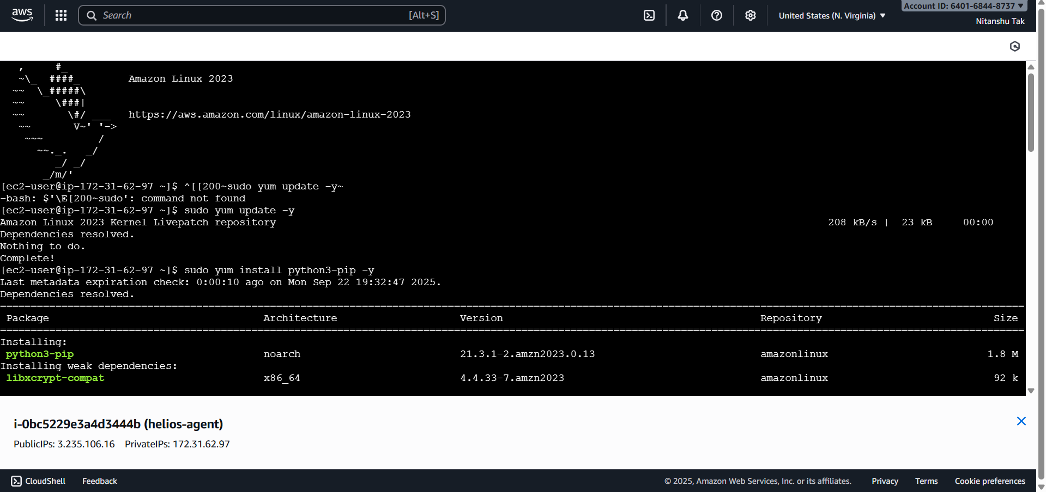

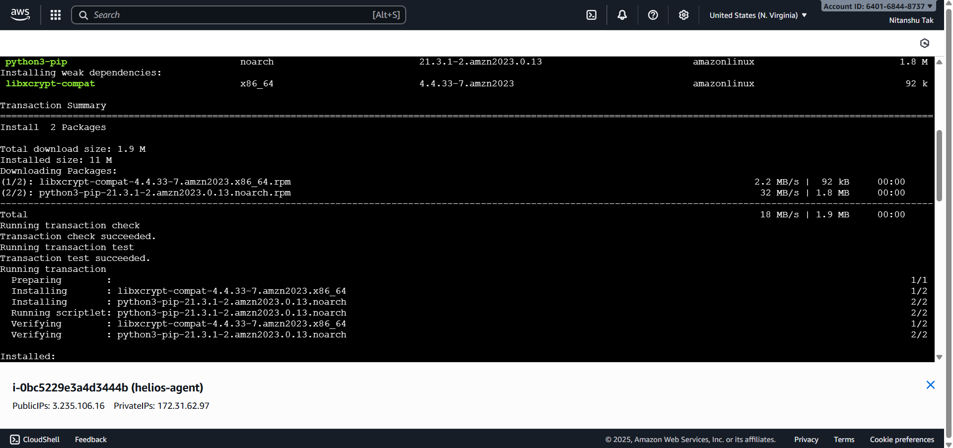

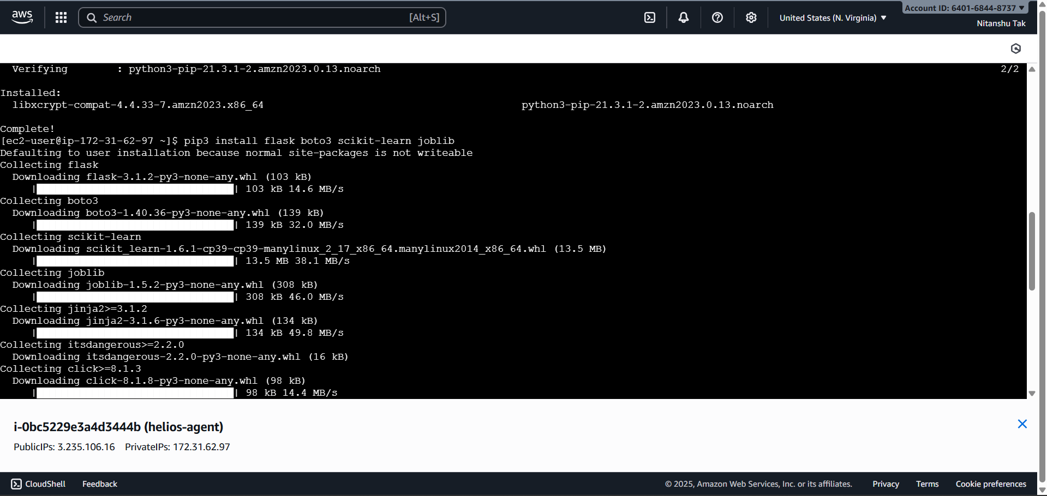

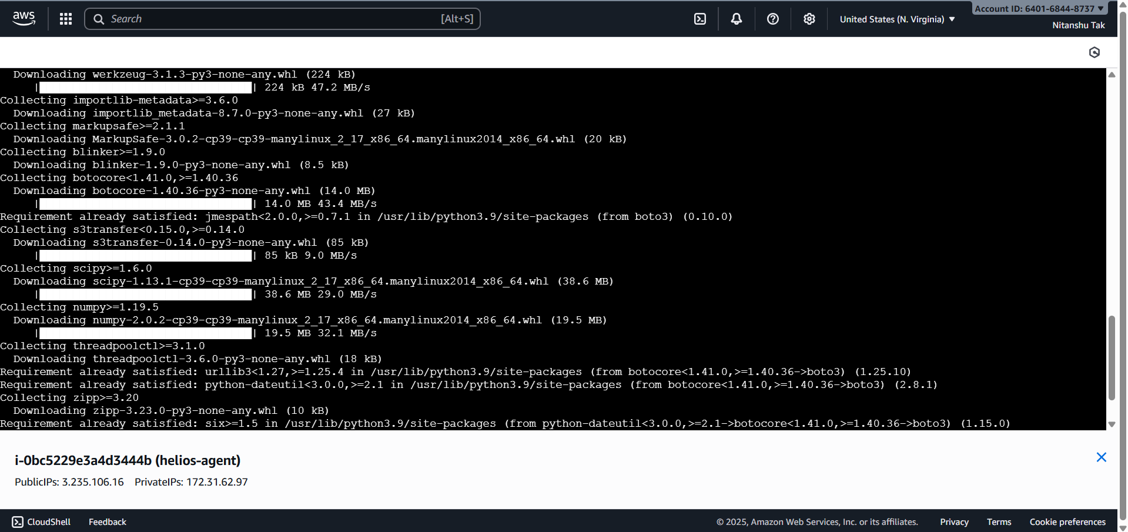

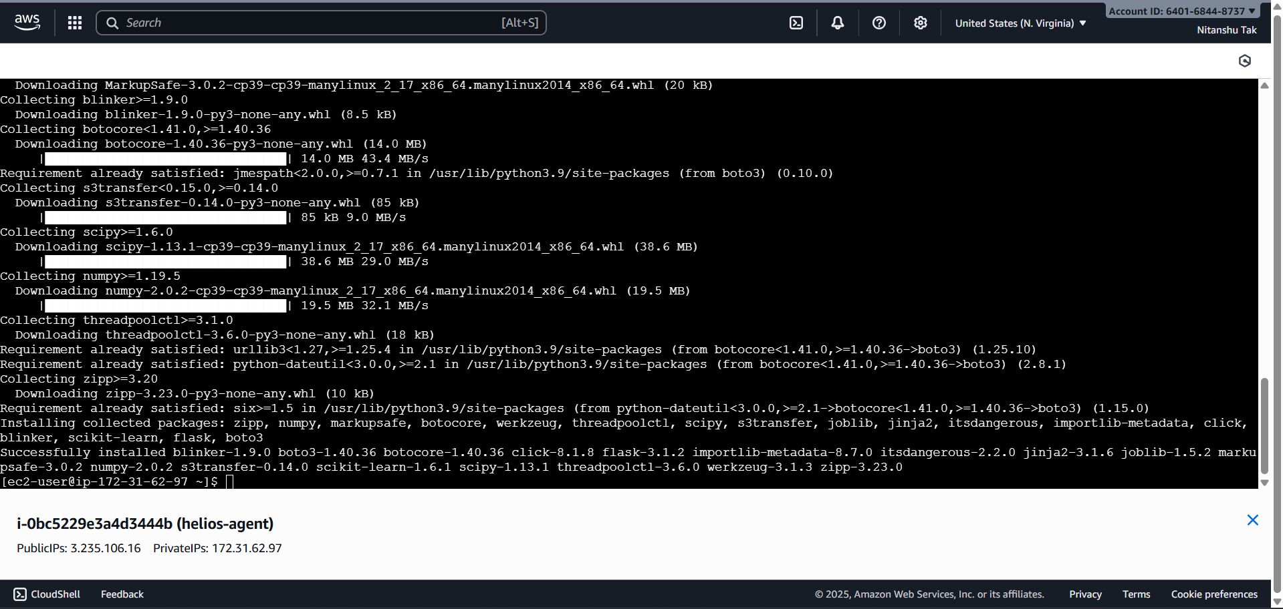

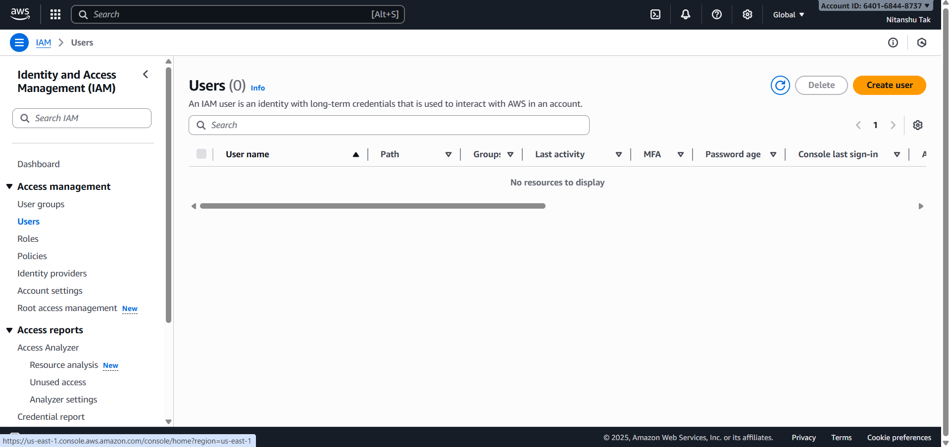

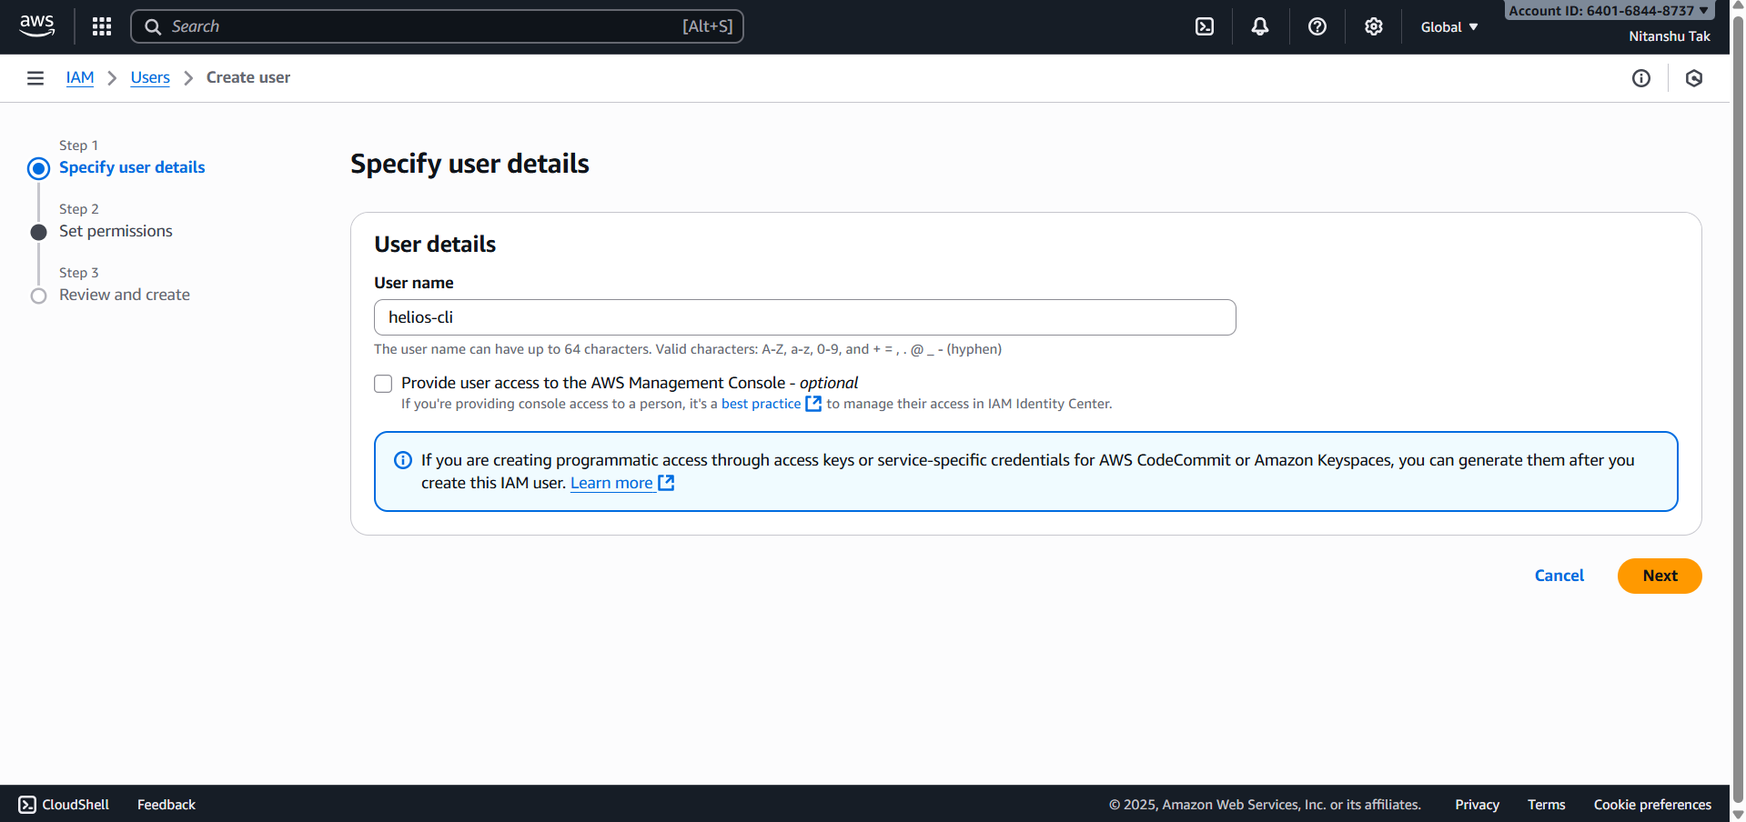

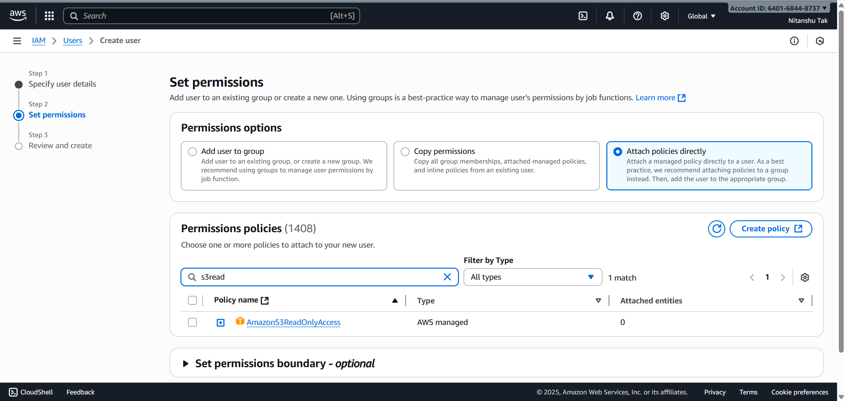

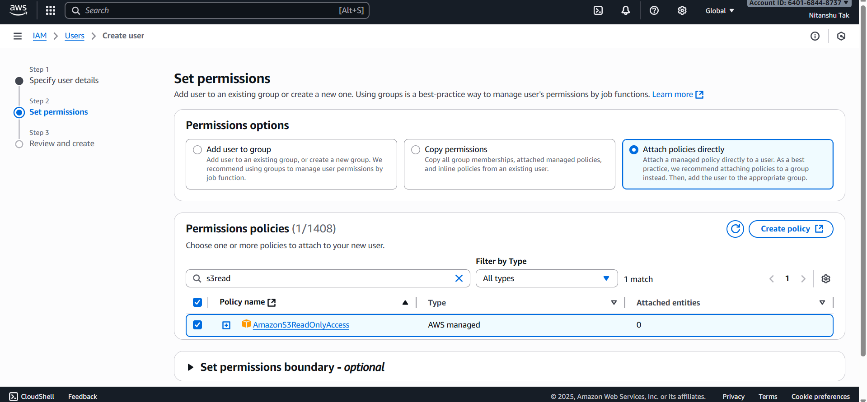

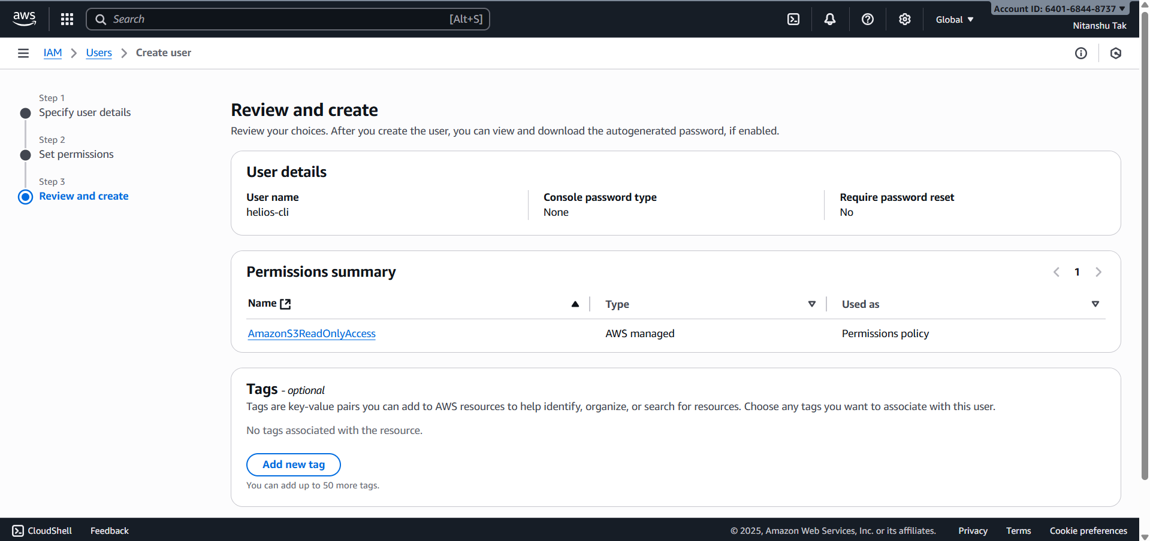

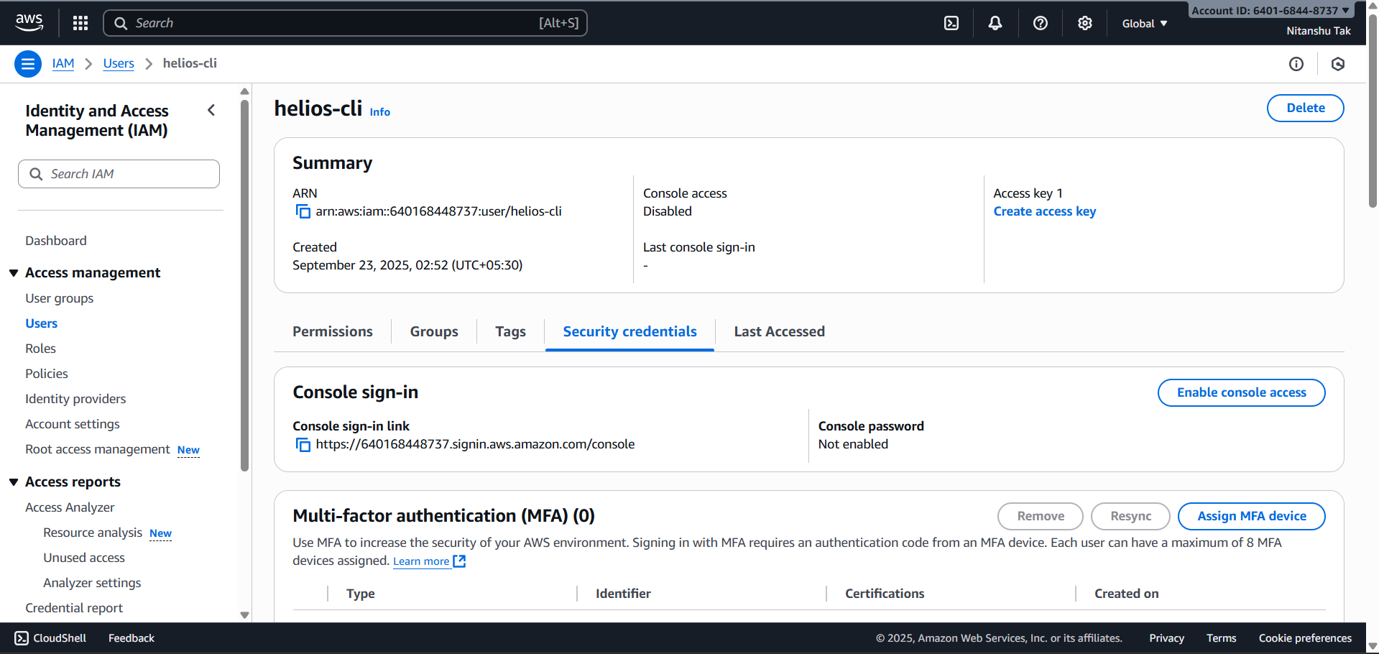

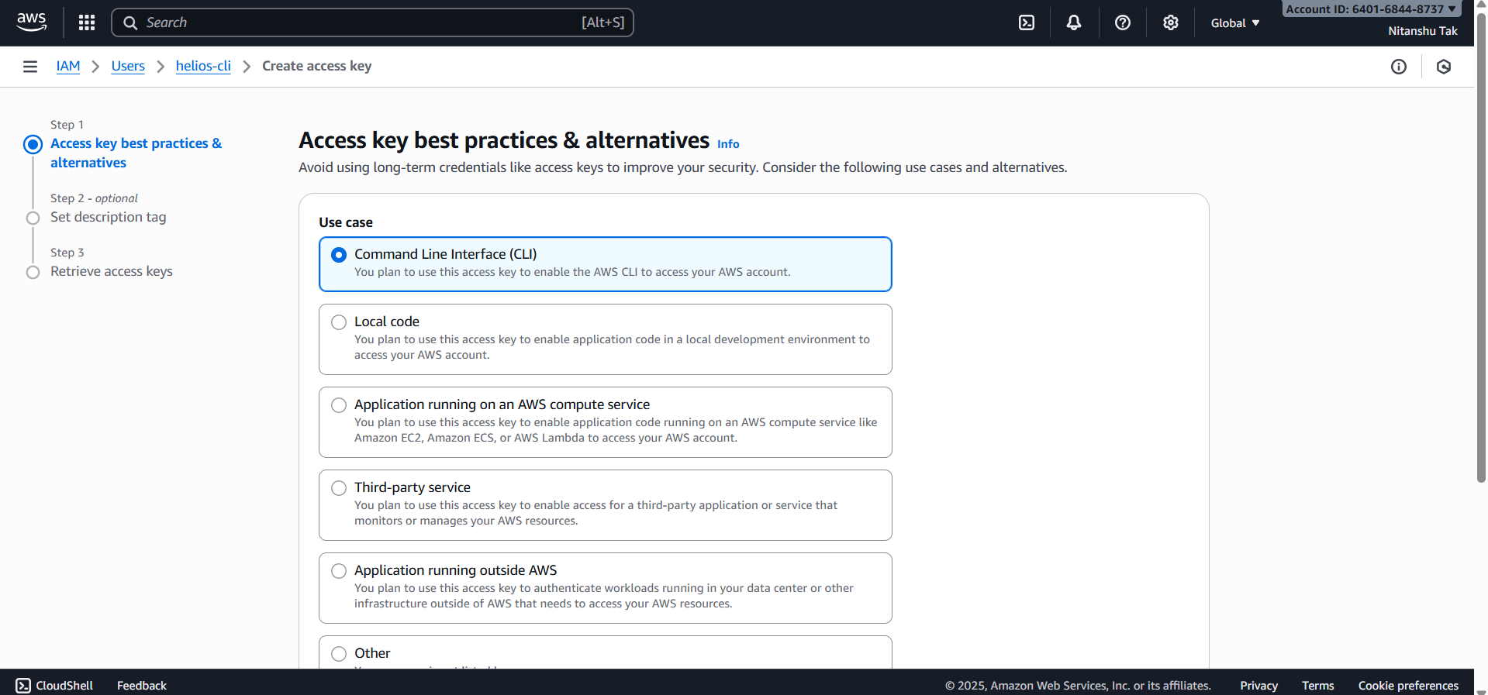

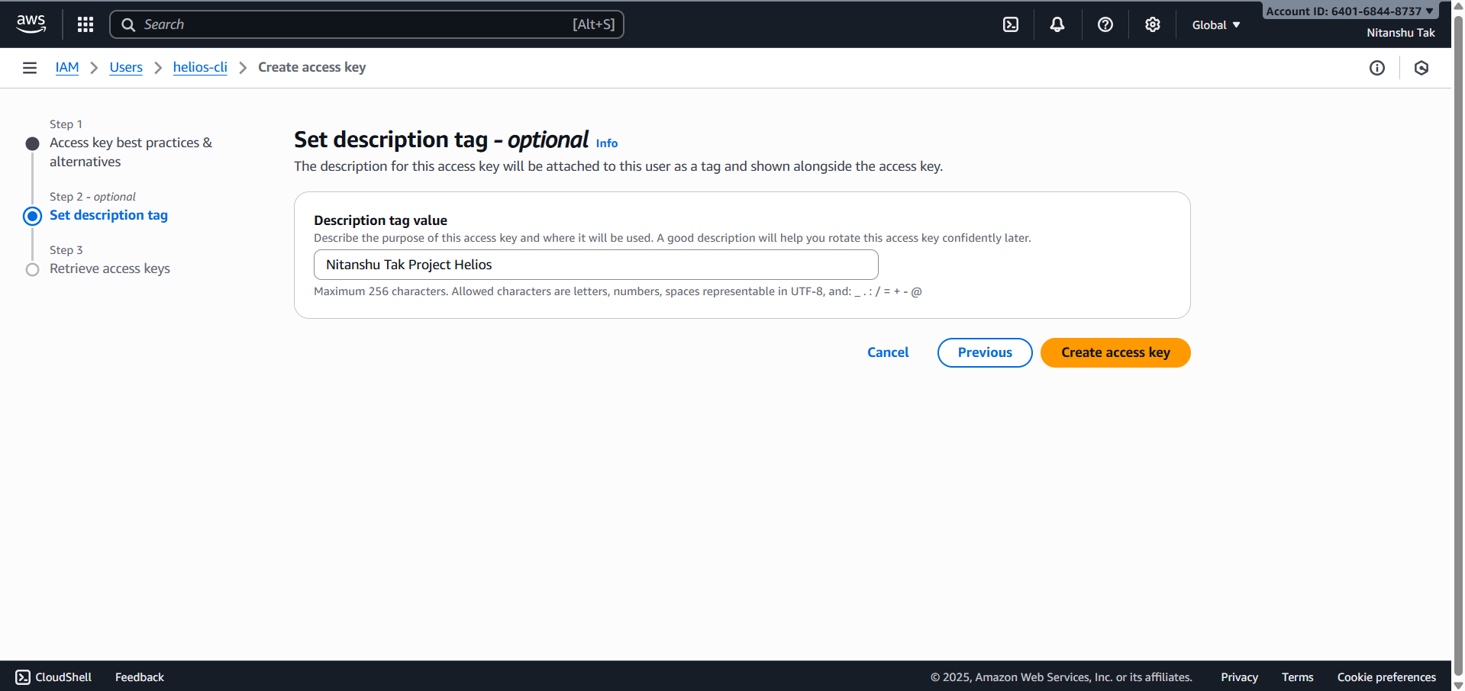

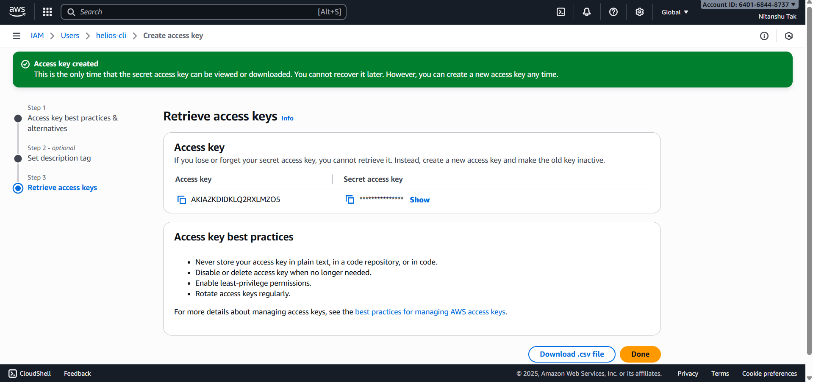

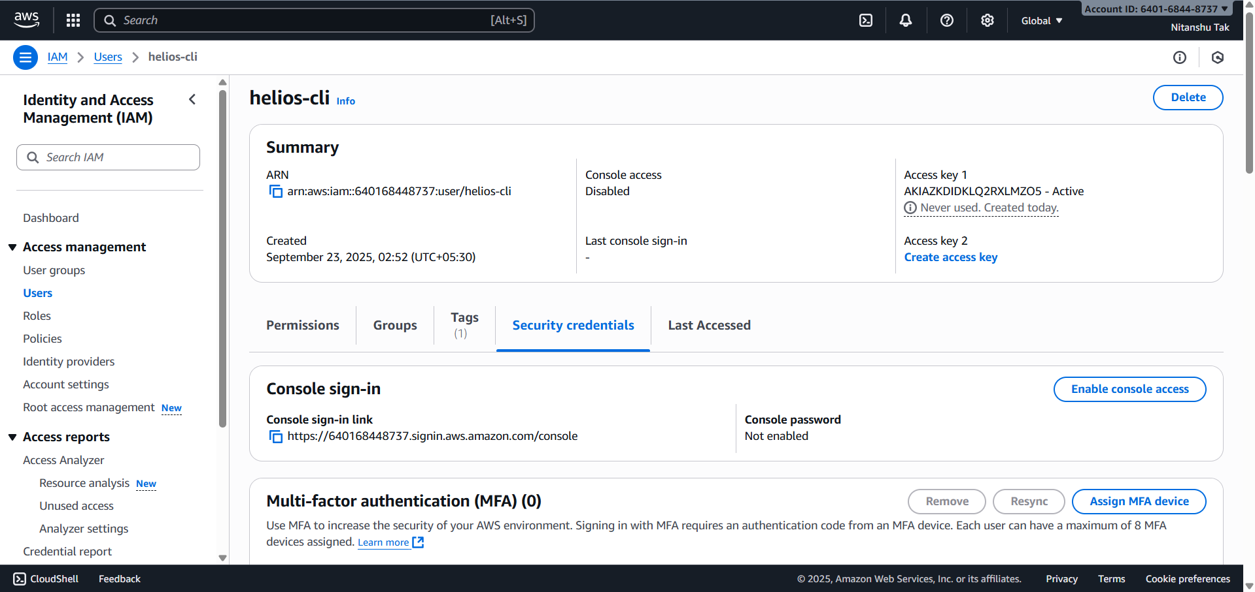

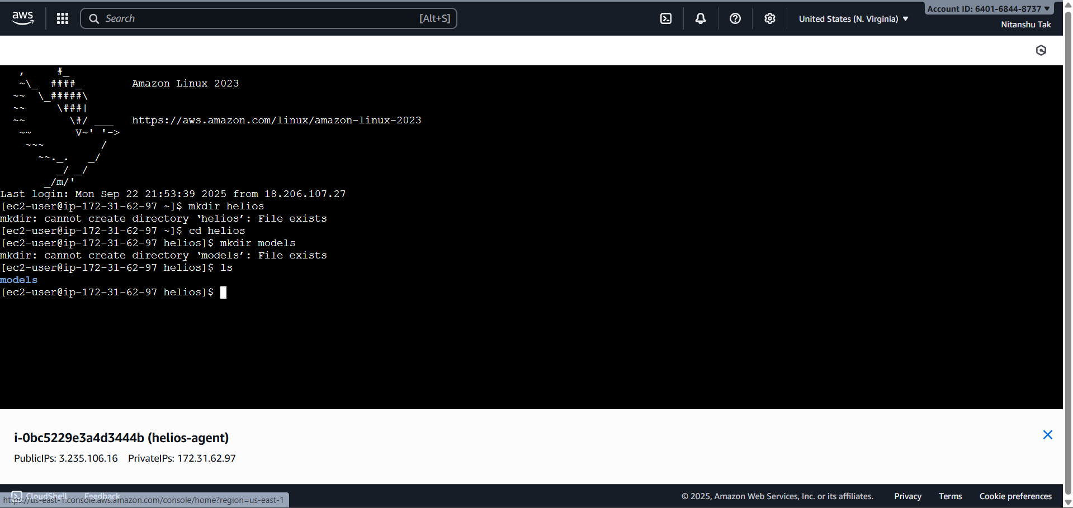

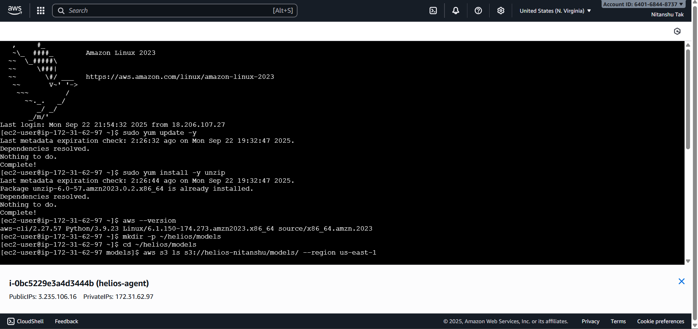

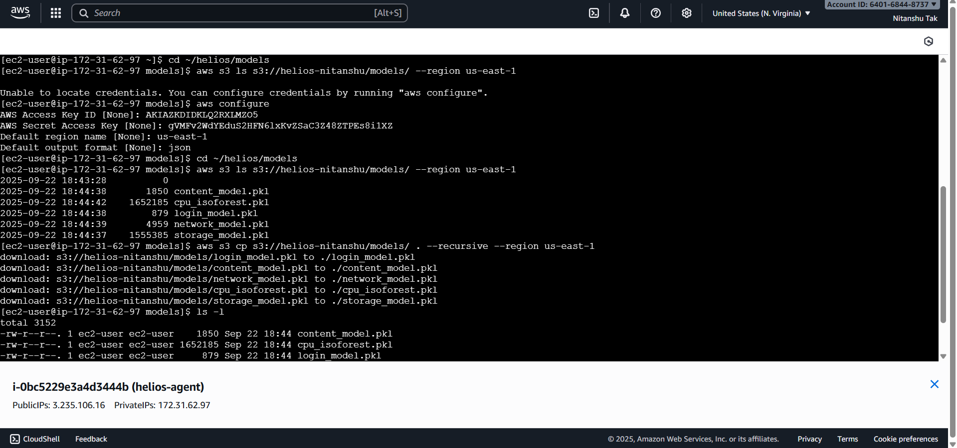

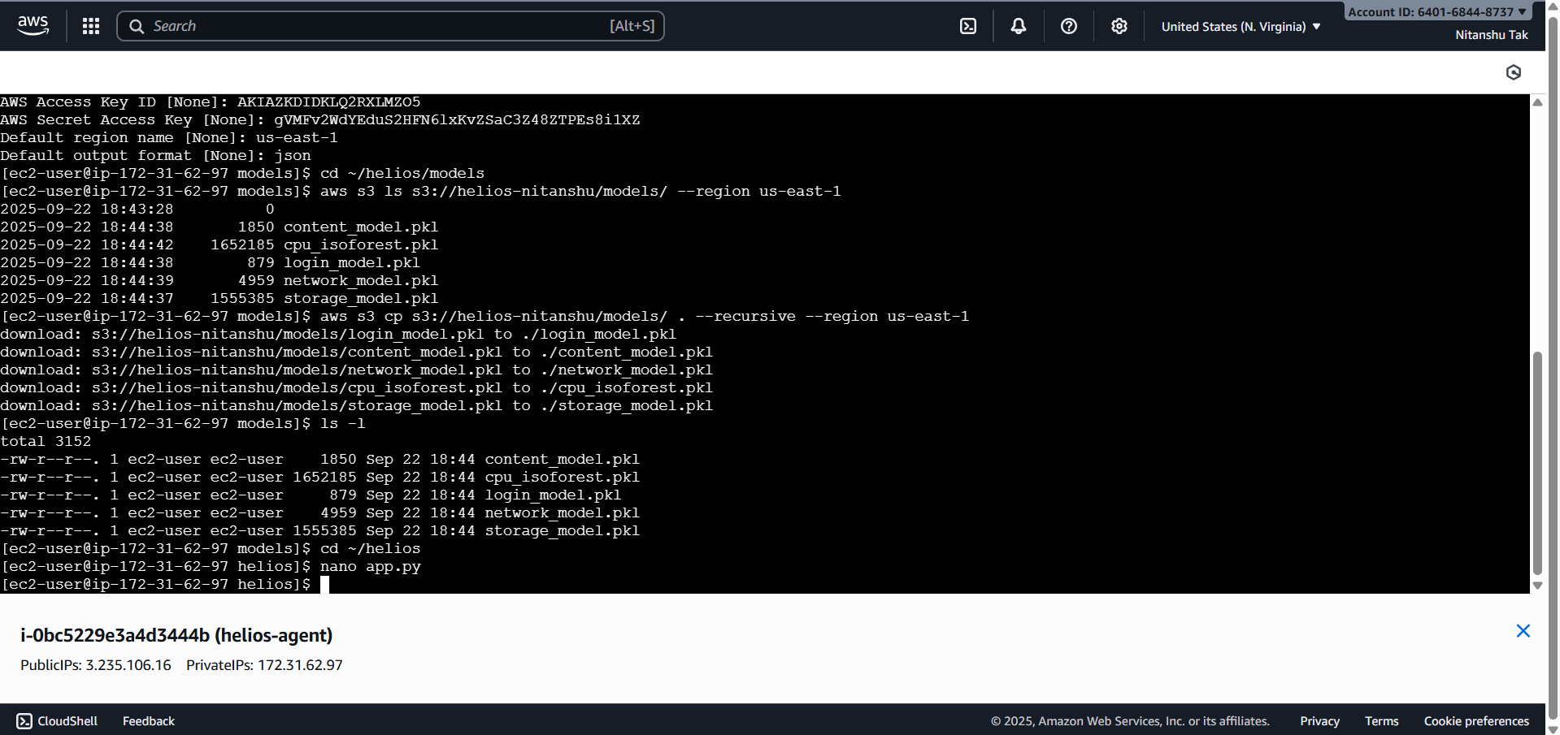

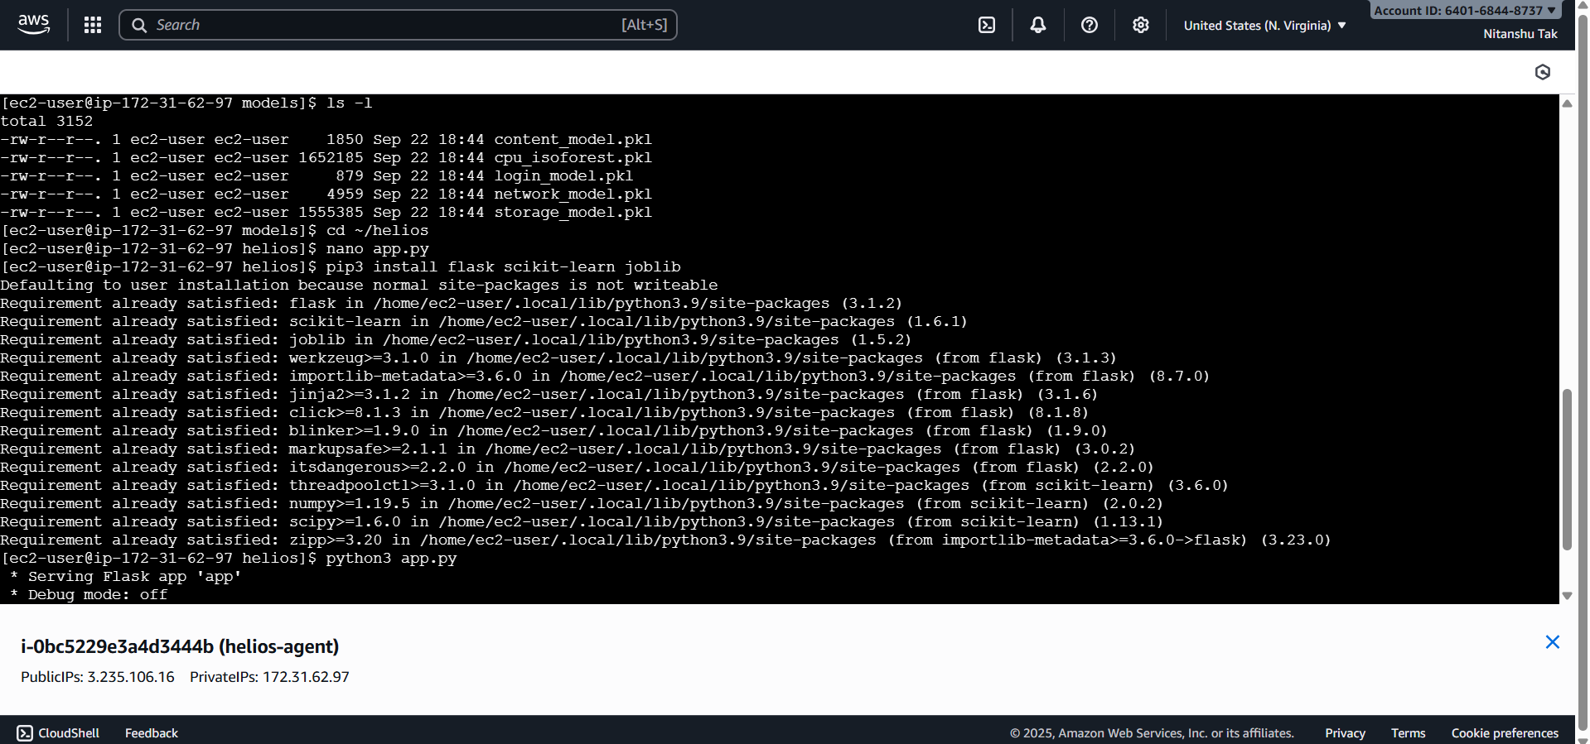

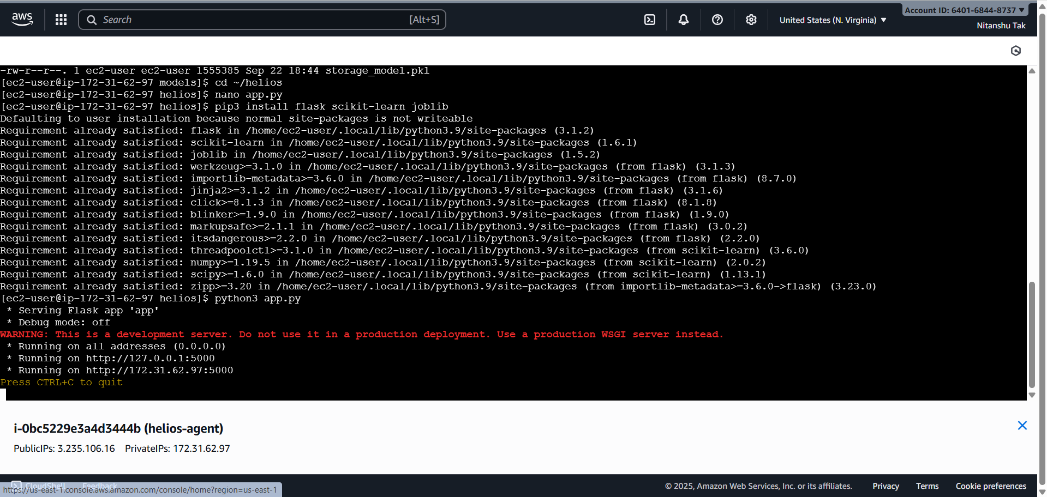

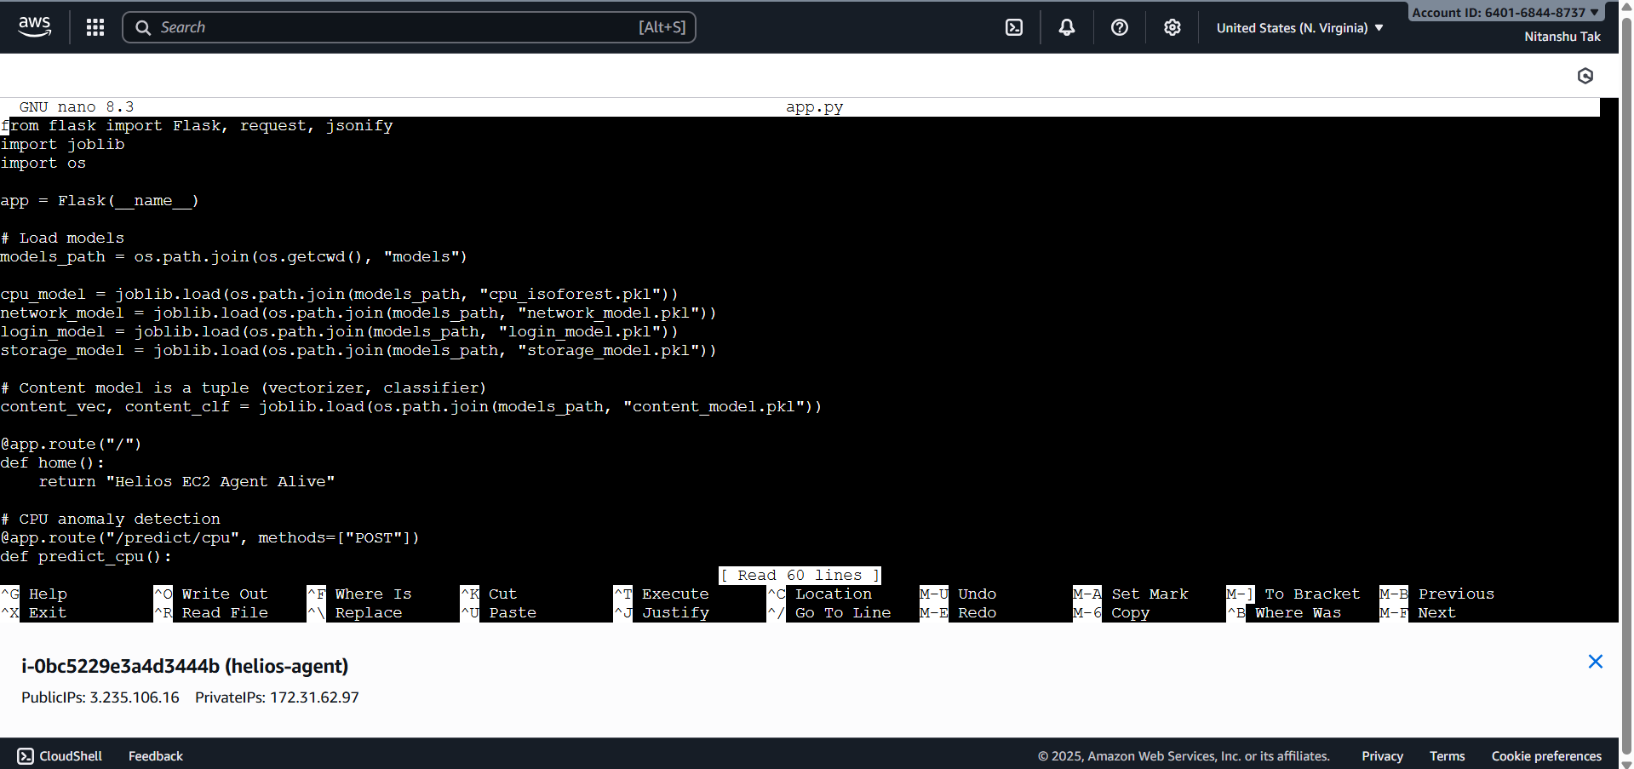

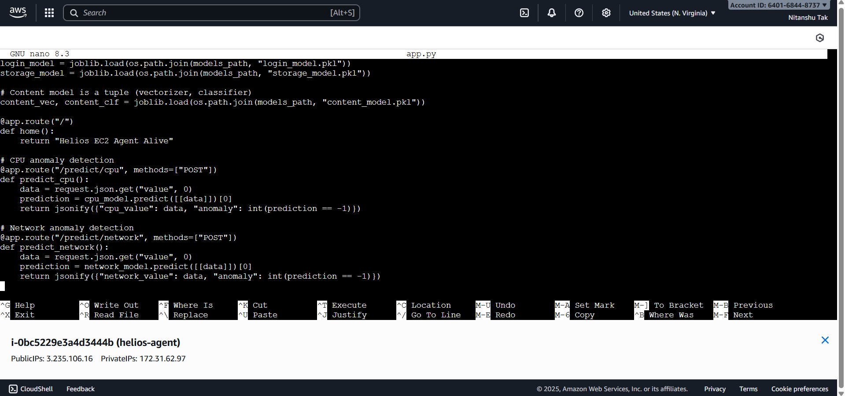

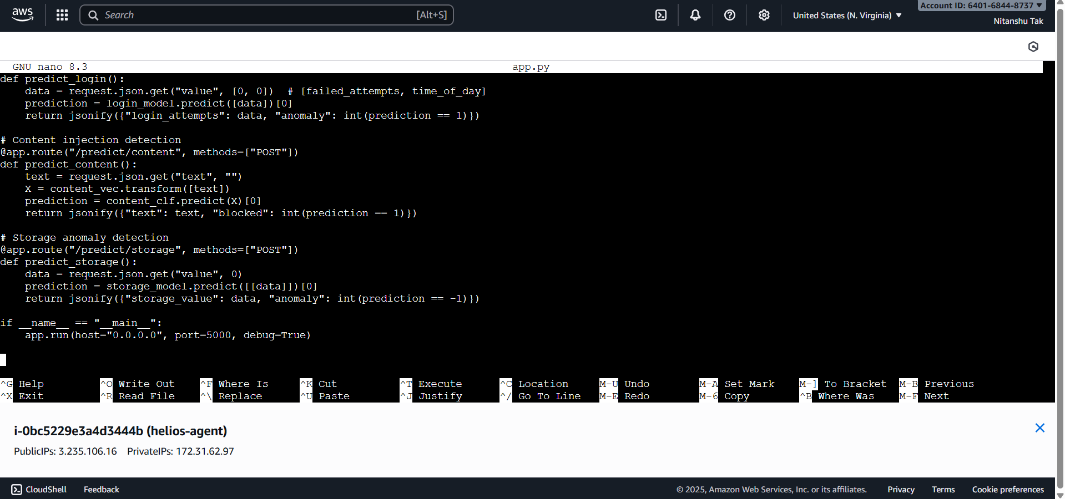

**7. Phase 4: End-to-End Testing**

The end-to-end pipeline was confirmed via testing:

• Flask endpoints successfully identified anomalies in real time (CPU, Network, Login, Content, Storage).

• CloudWatch alarms fired due to CPU spikes.

• SNS sent real-time anomaly alerts to subscribed email addresses.

• CloudWatch Dashboard displayed live metrics.

This validated Helios as a working AI-powered anomaly detection and alerting system.

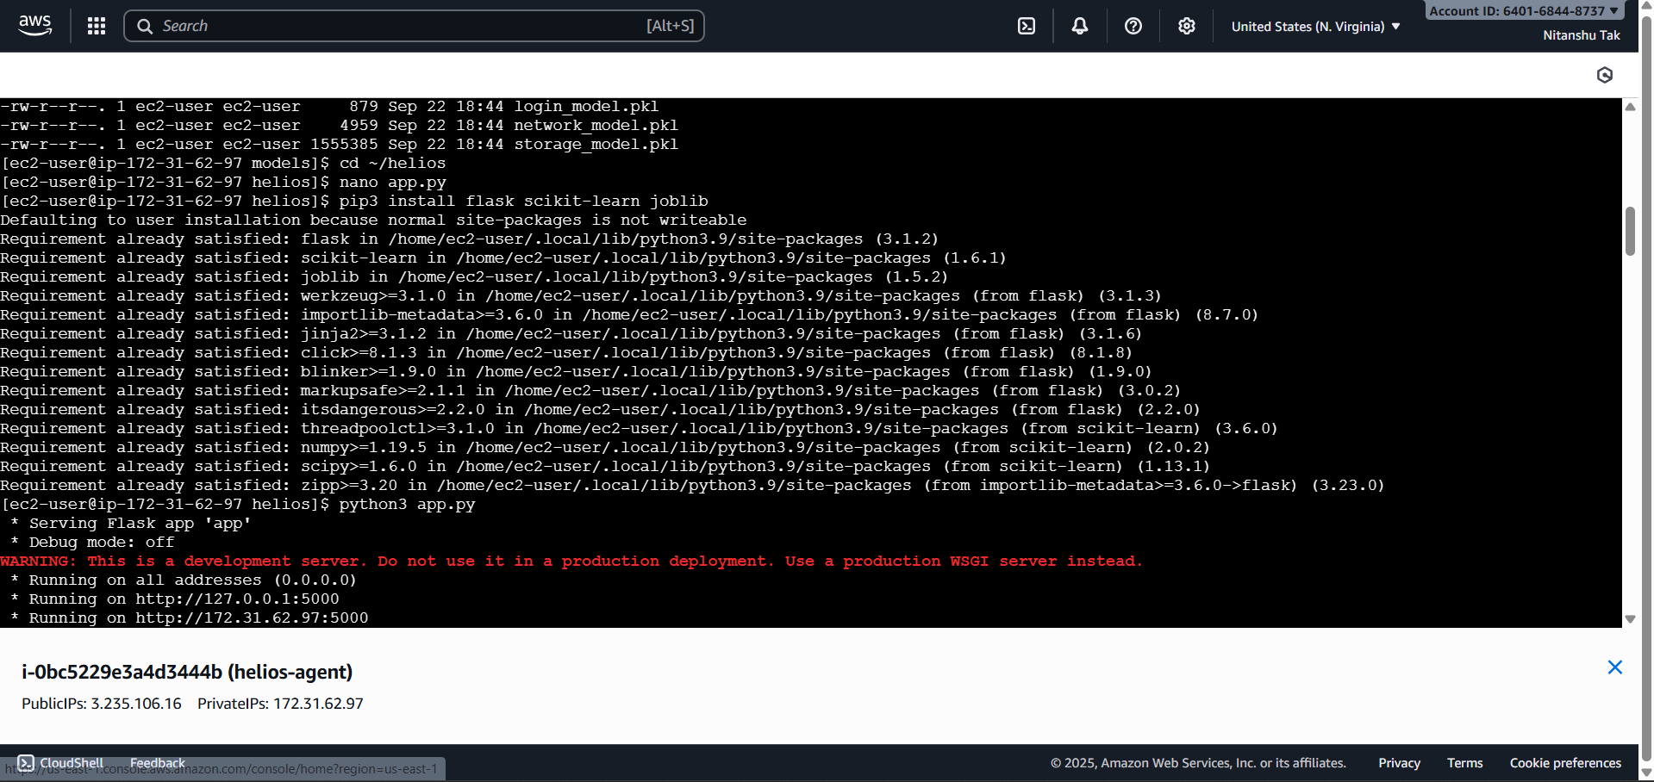

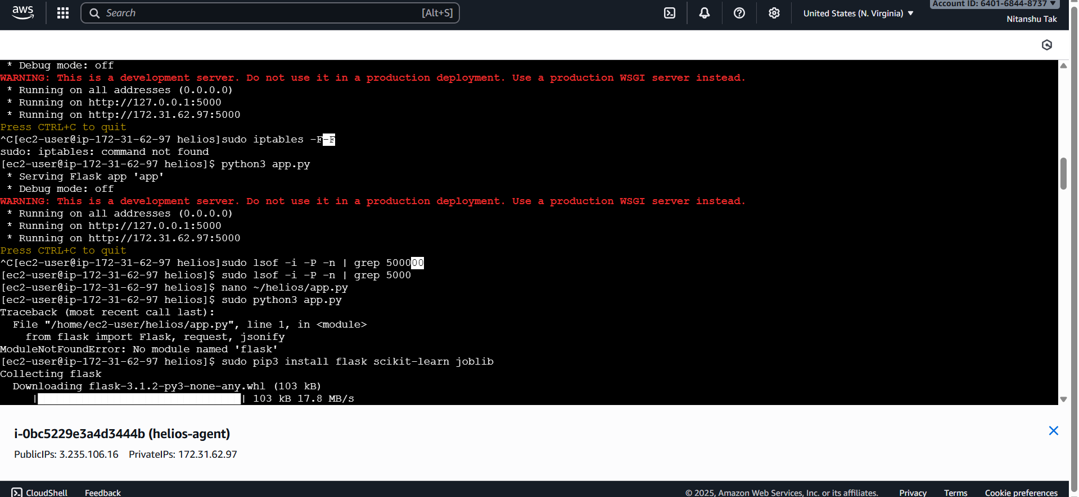

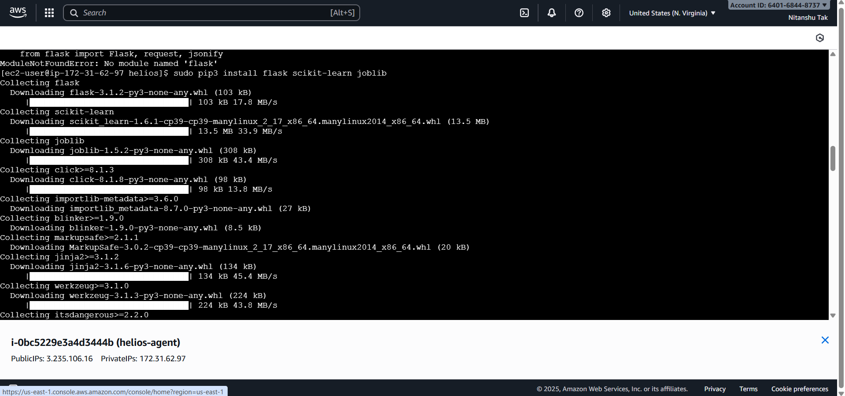

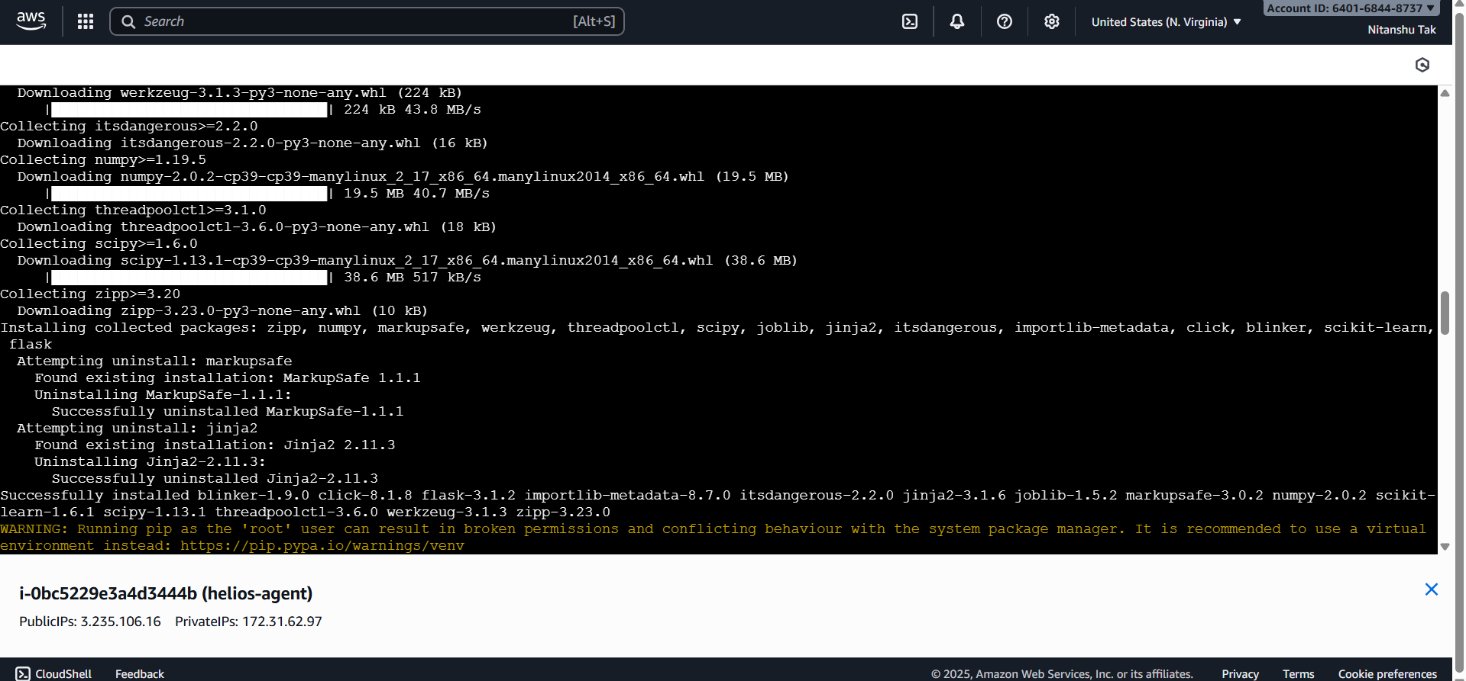

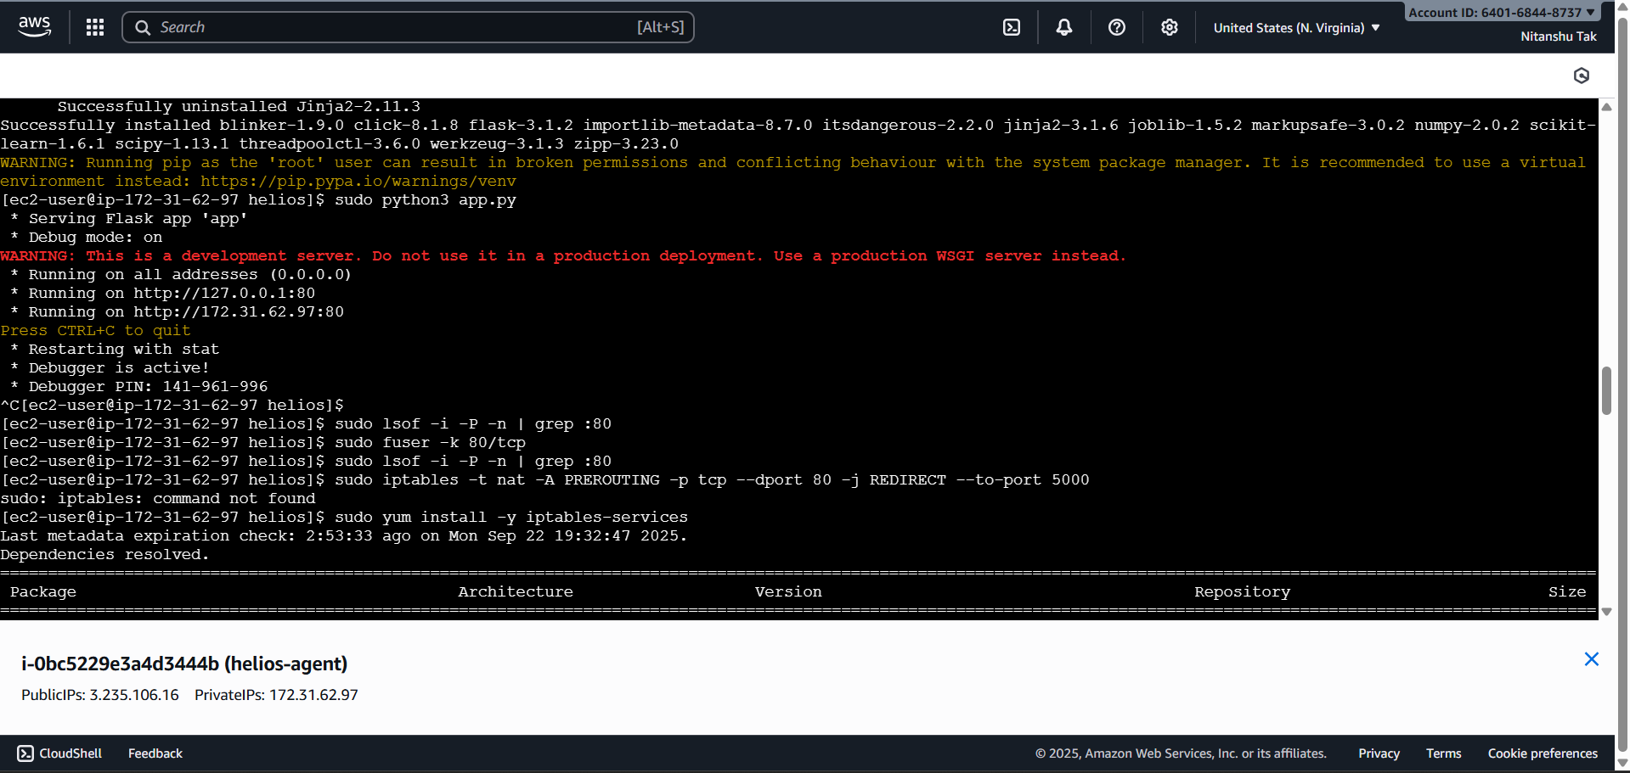

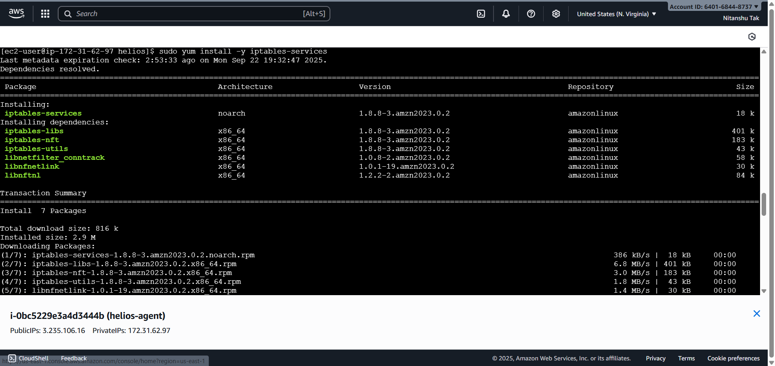

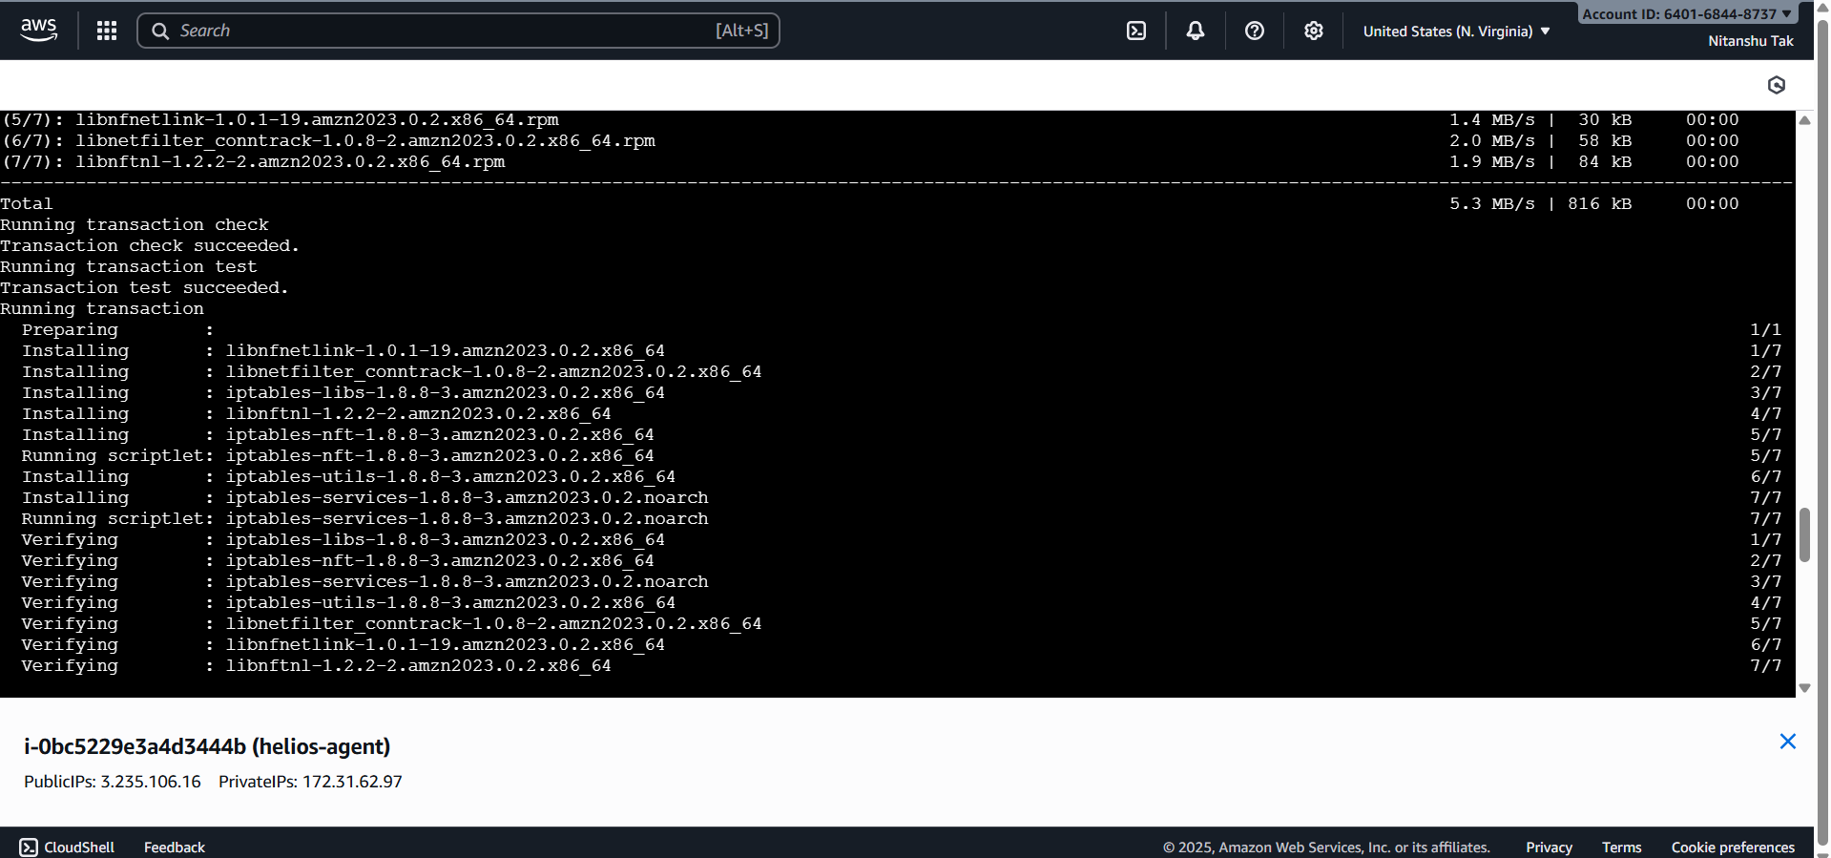

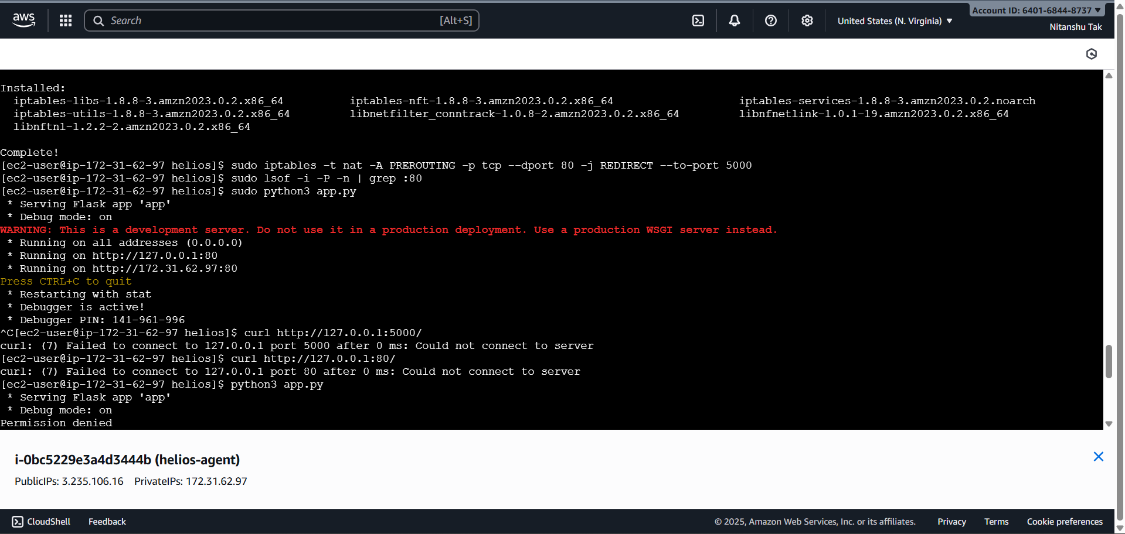

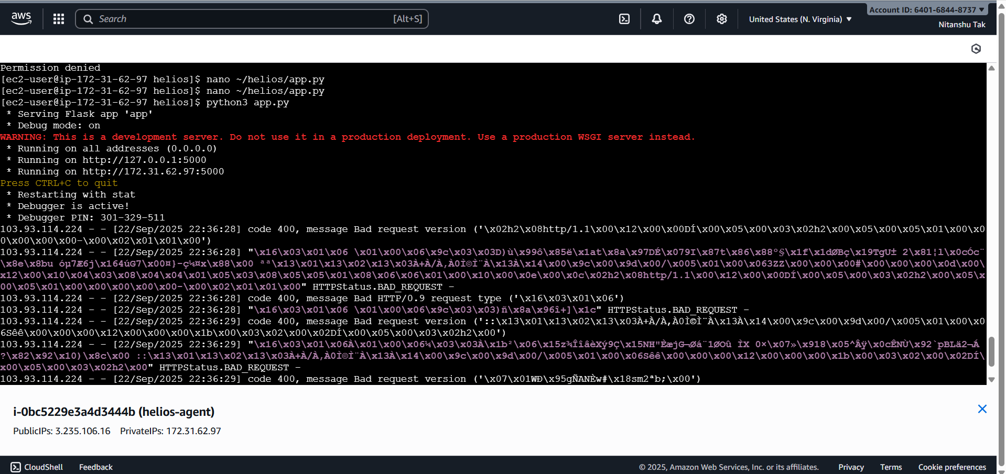

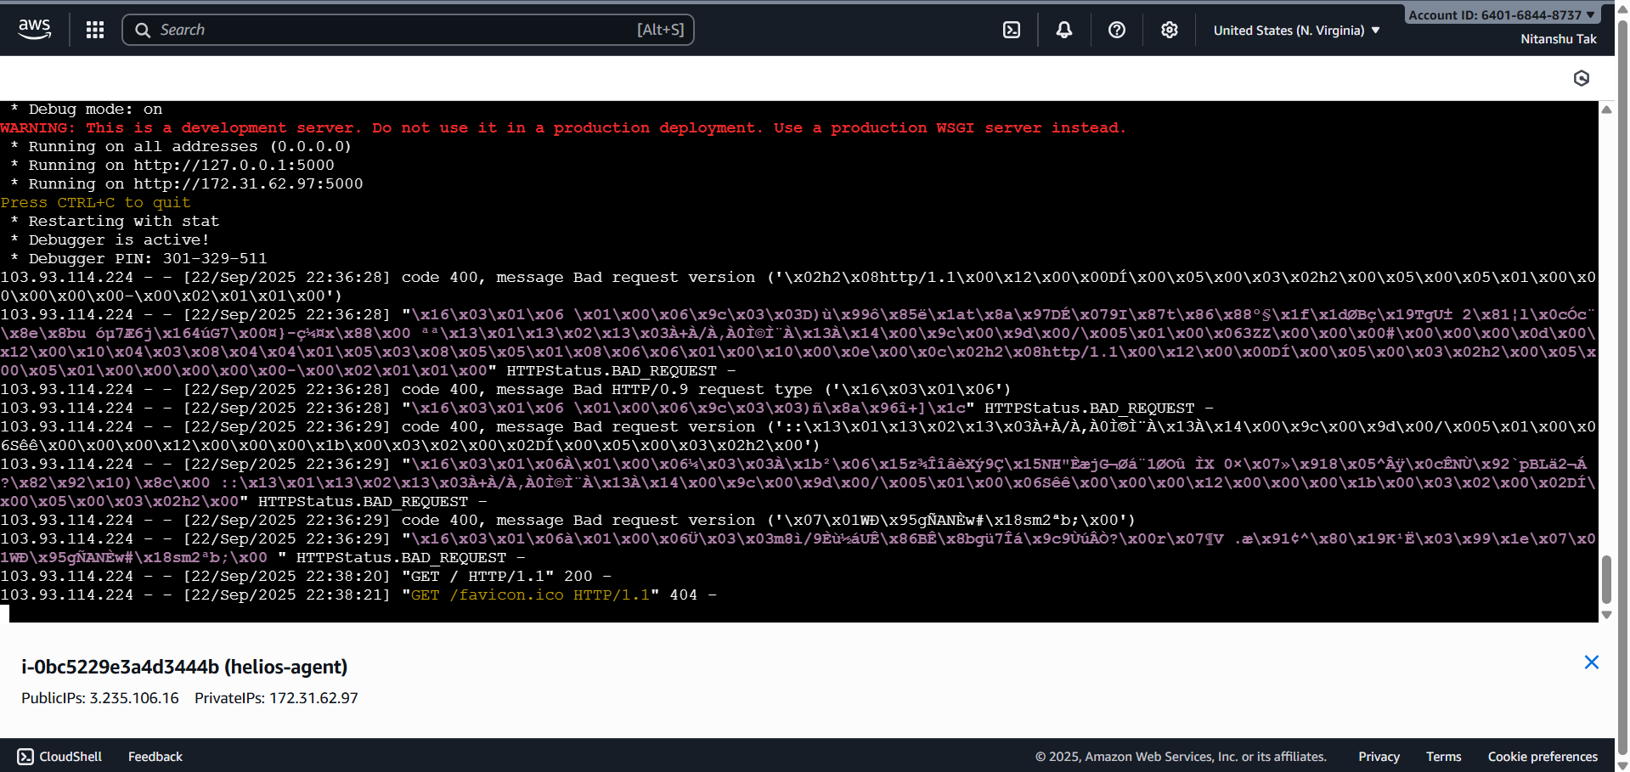

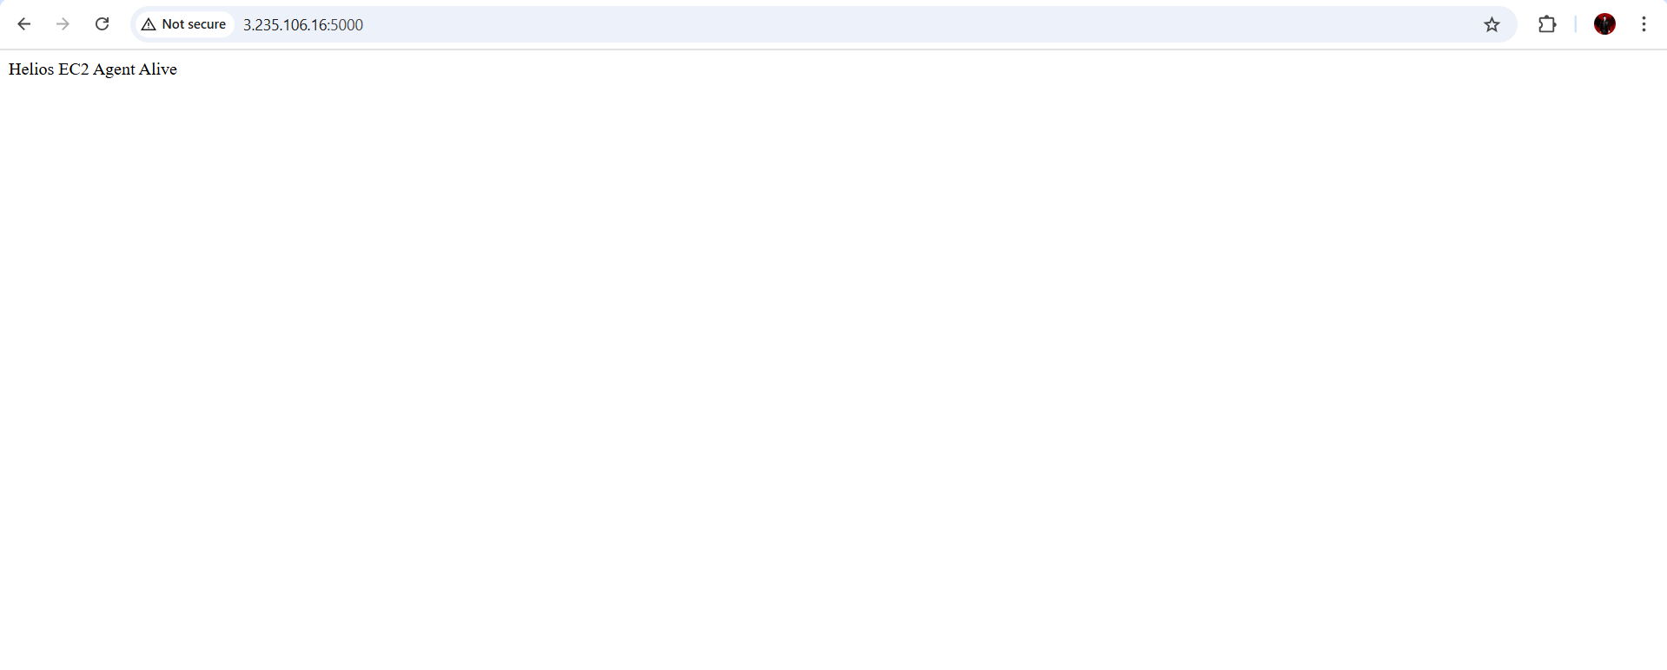

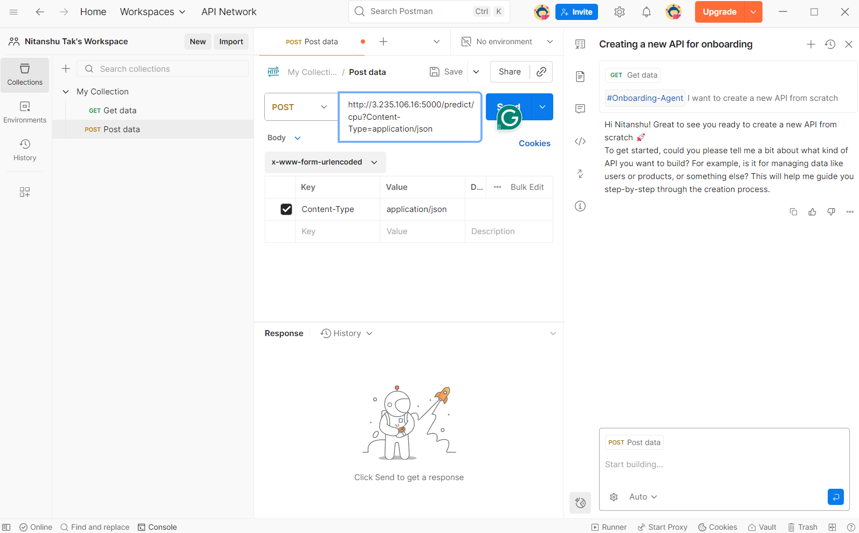

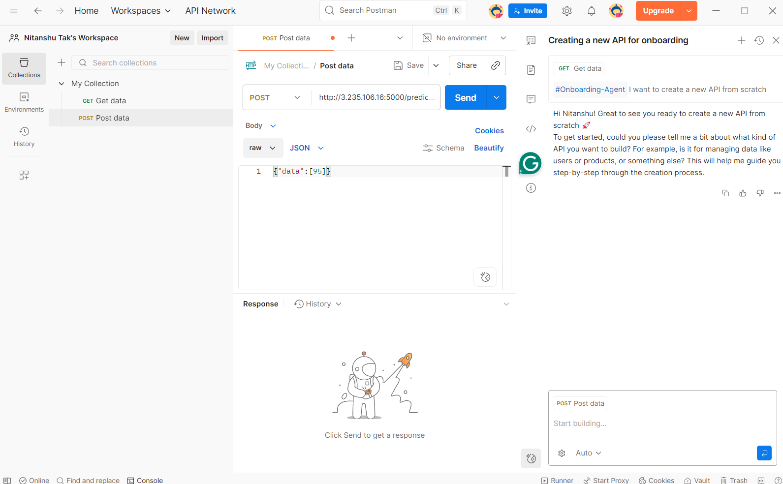

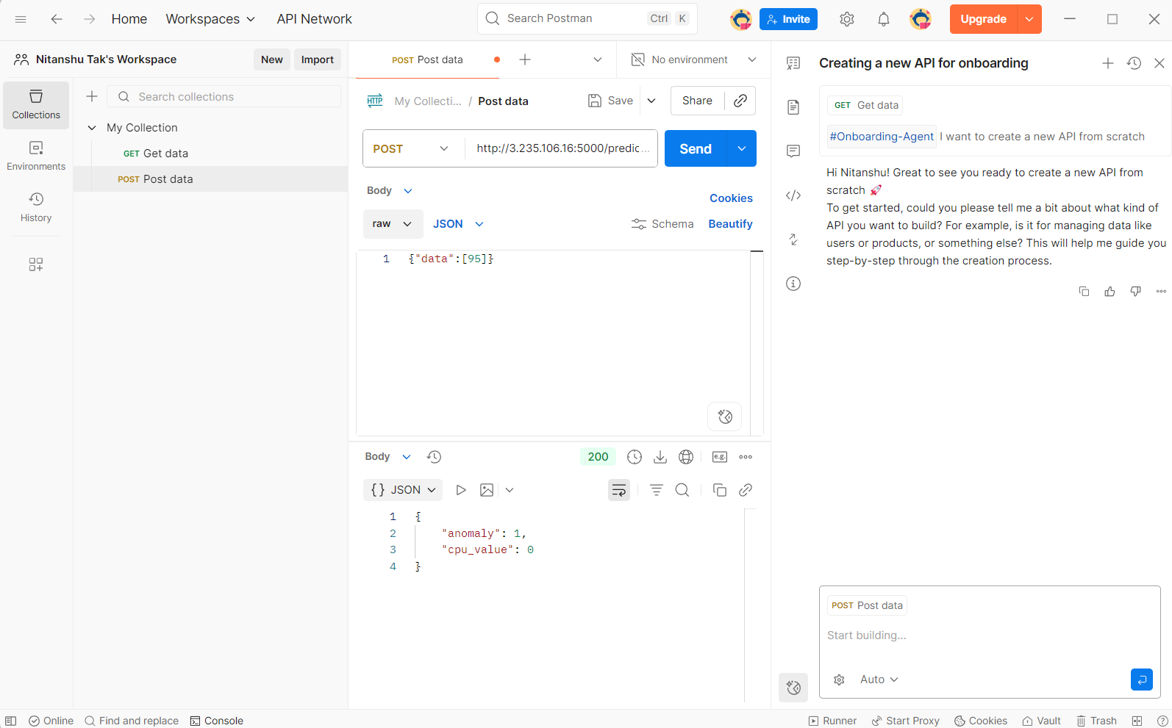

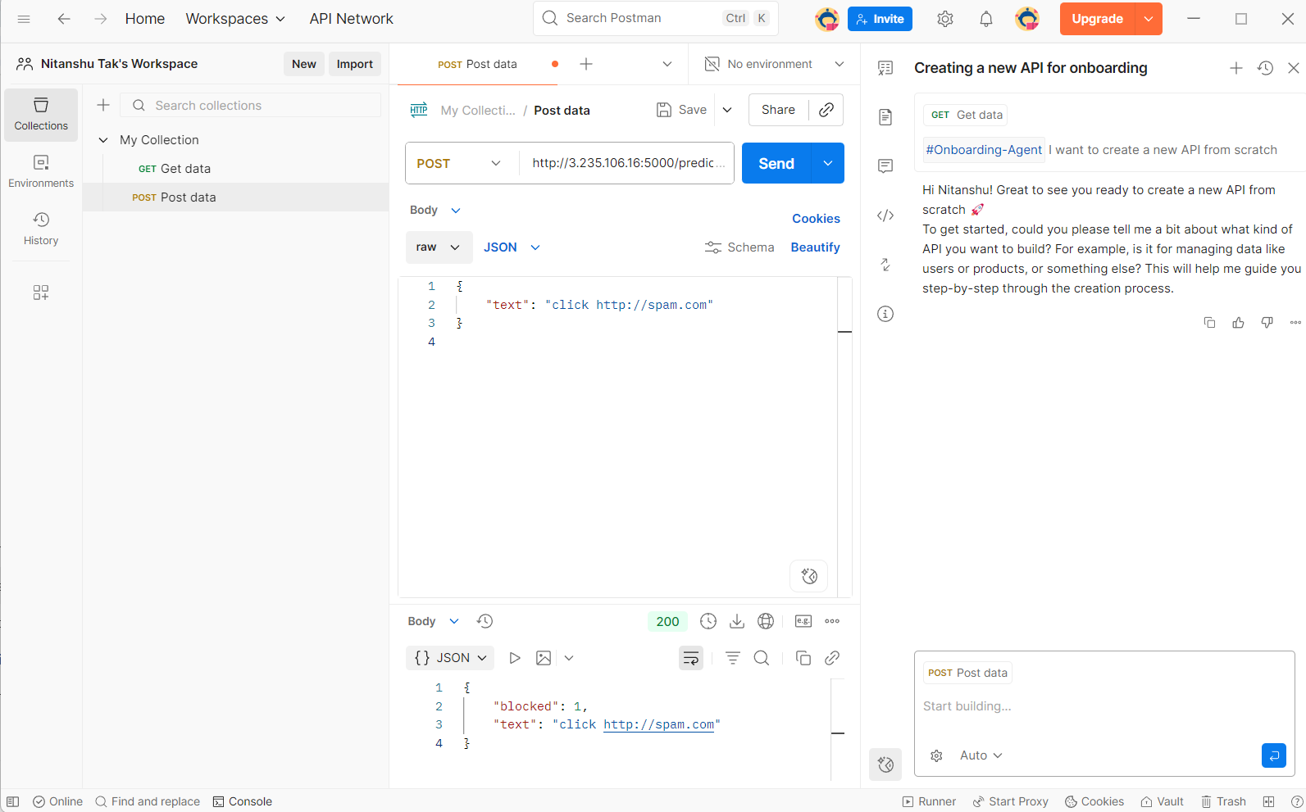

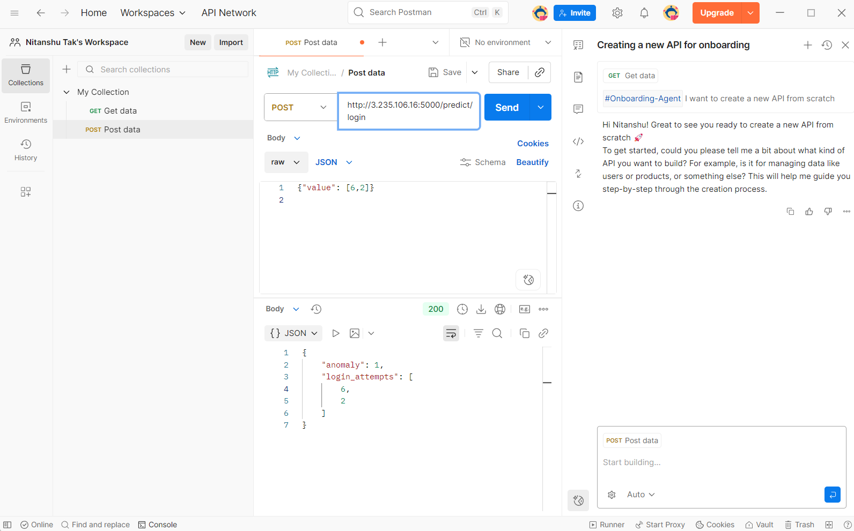

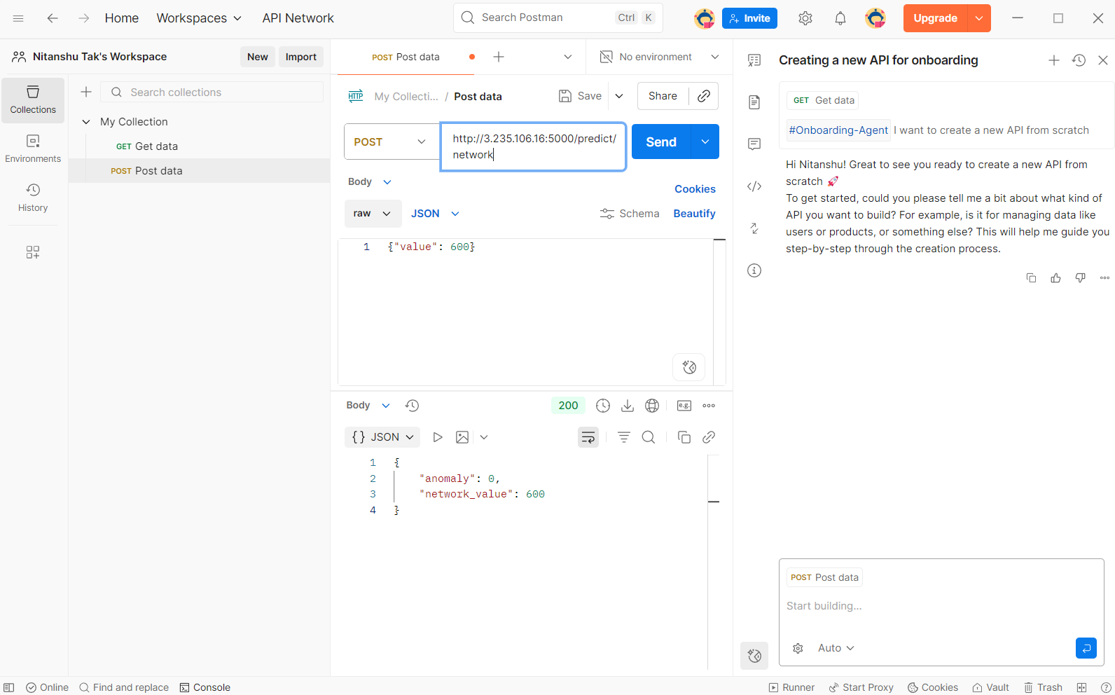

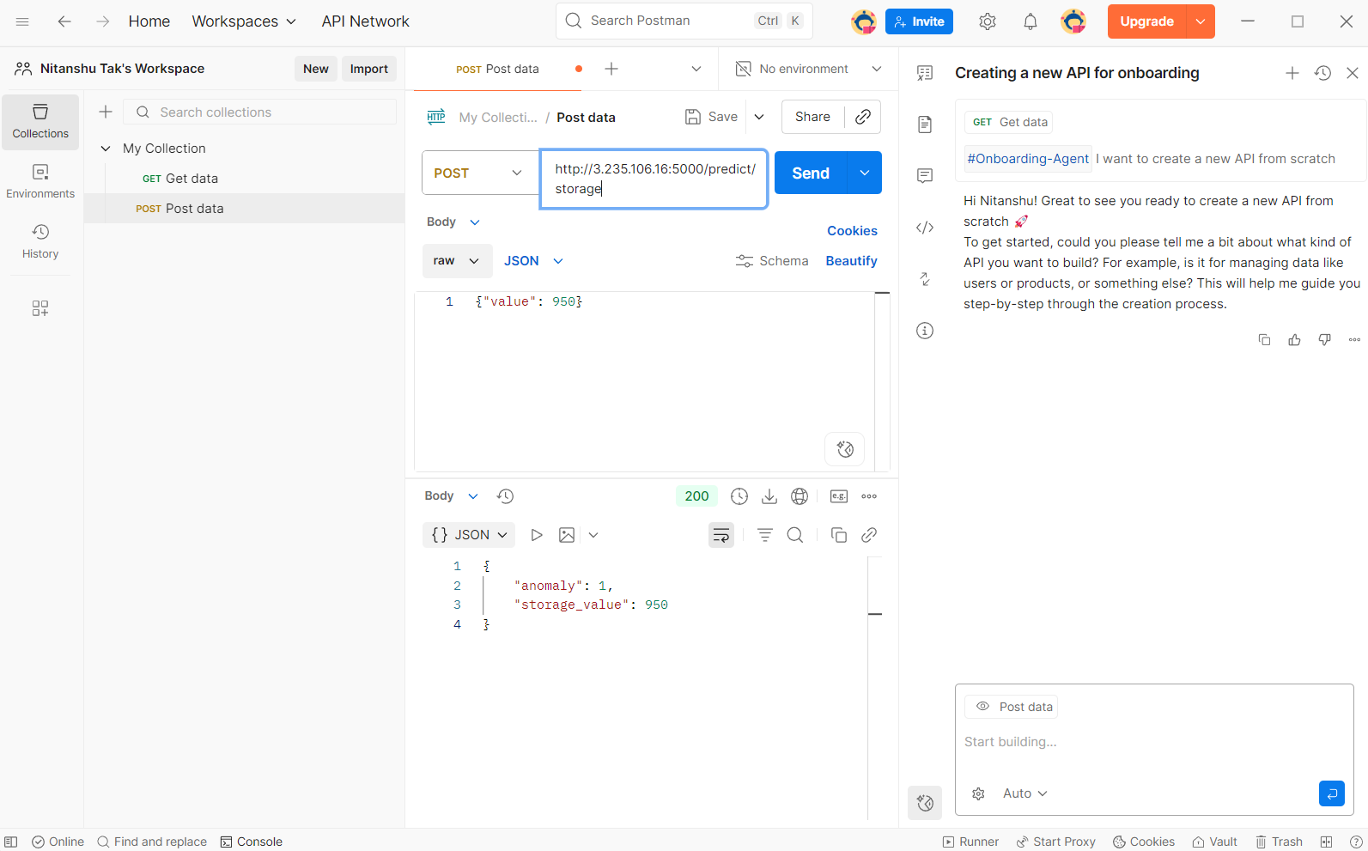

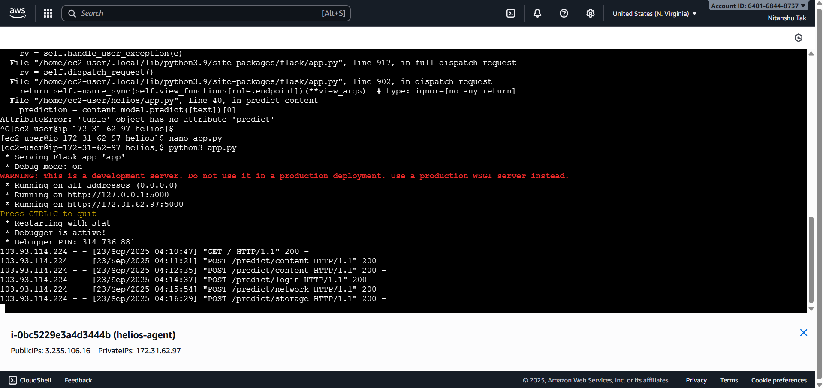

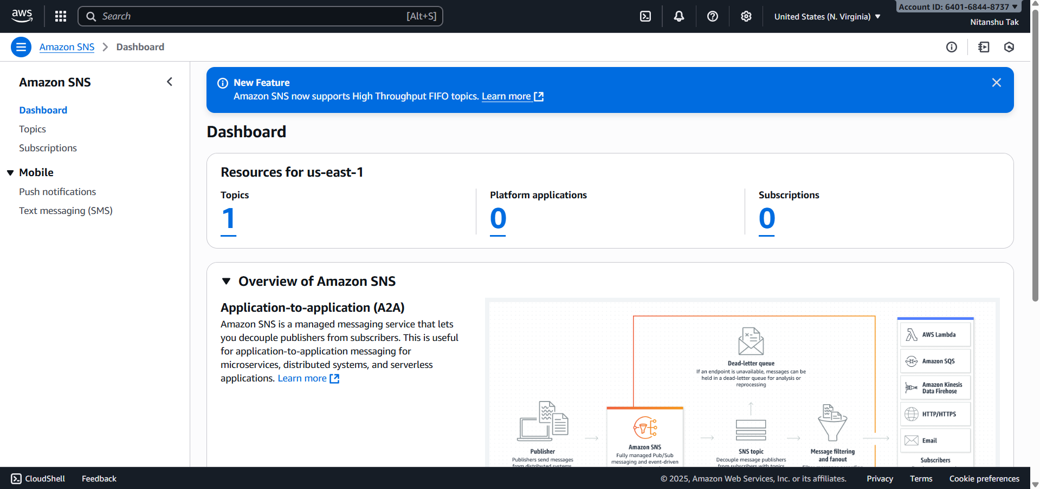

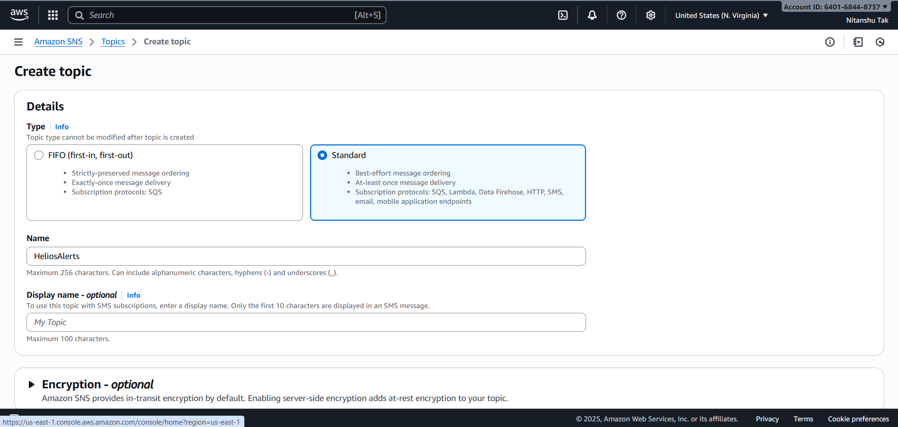

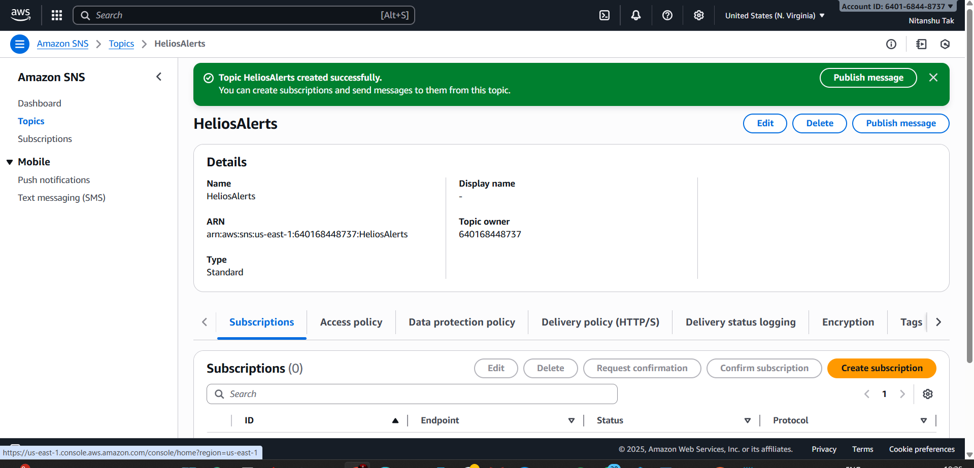

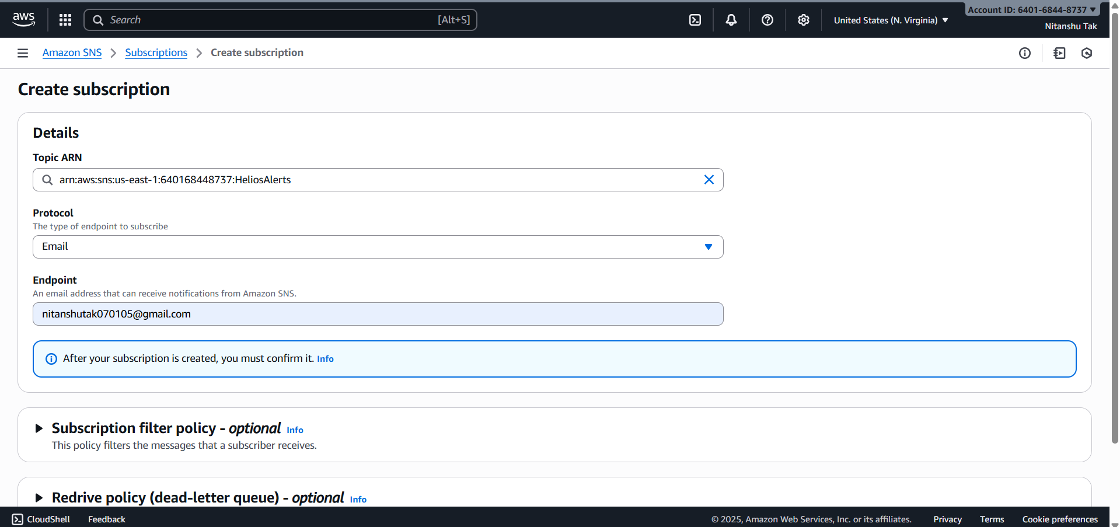

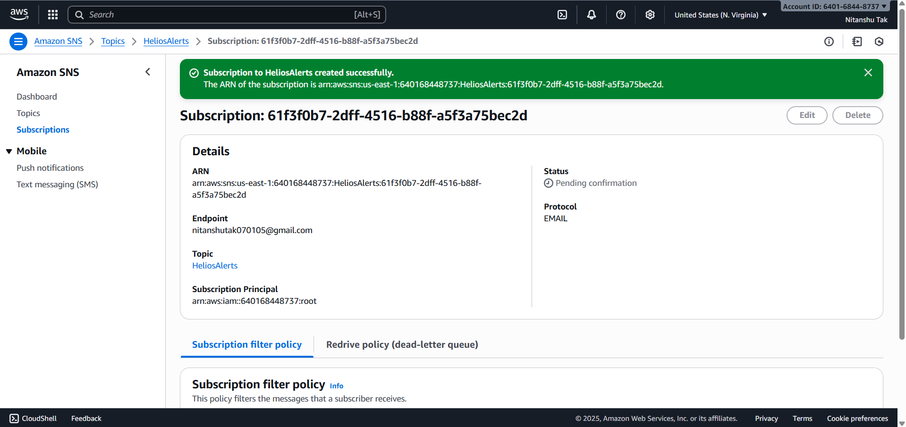

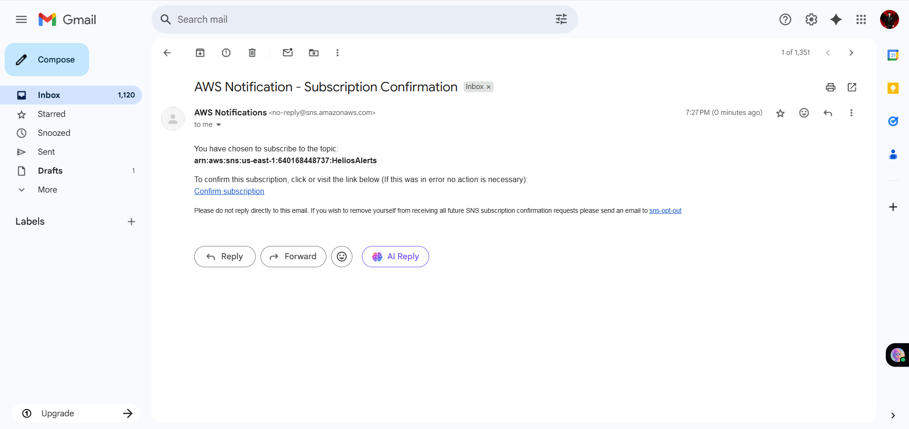

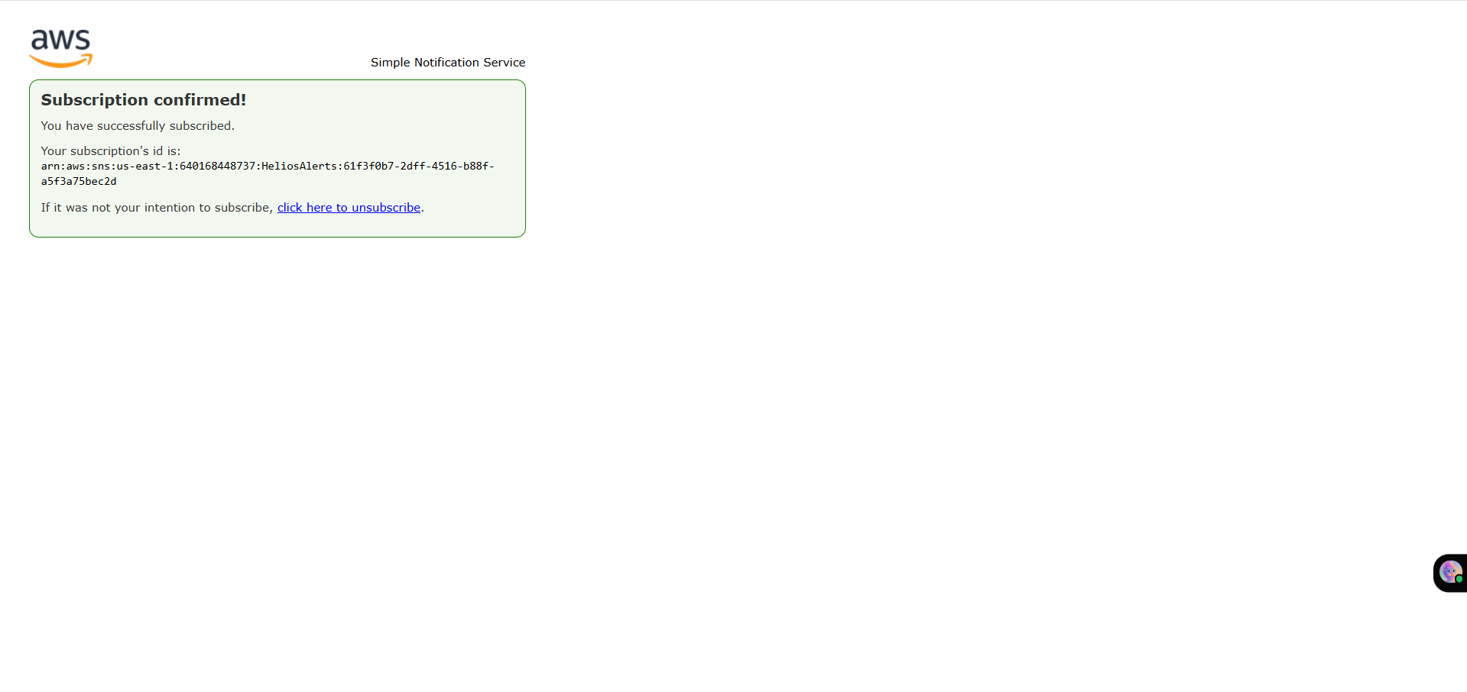

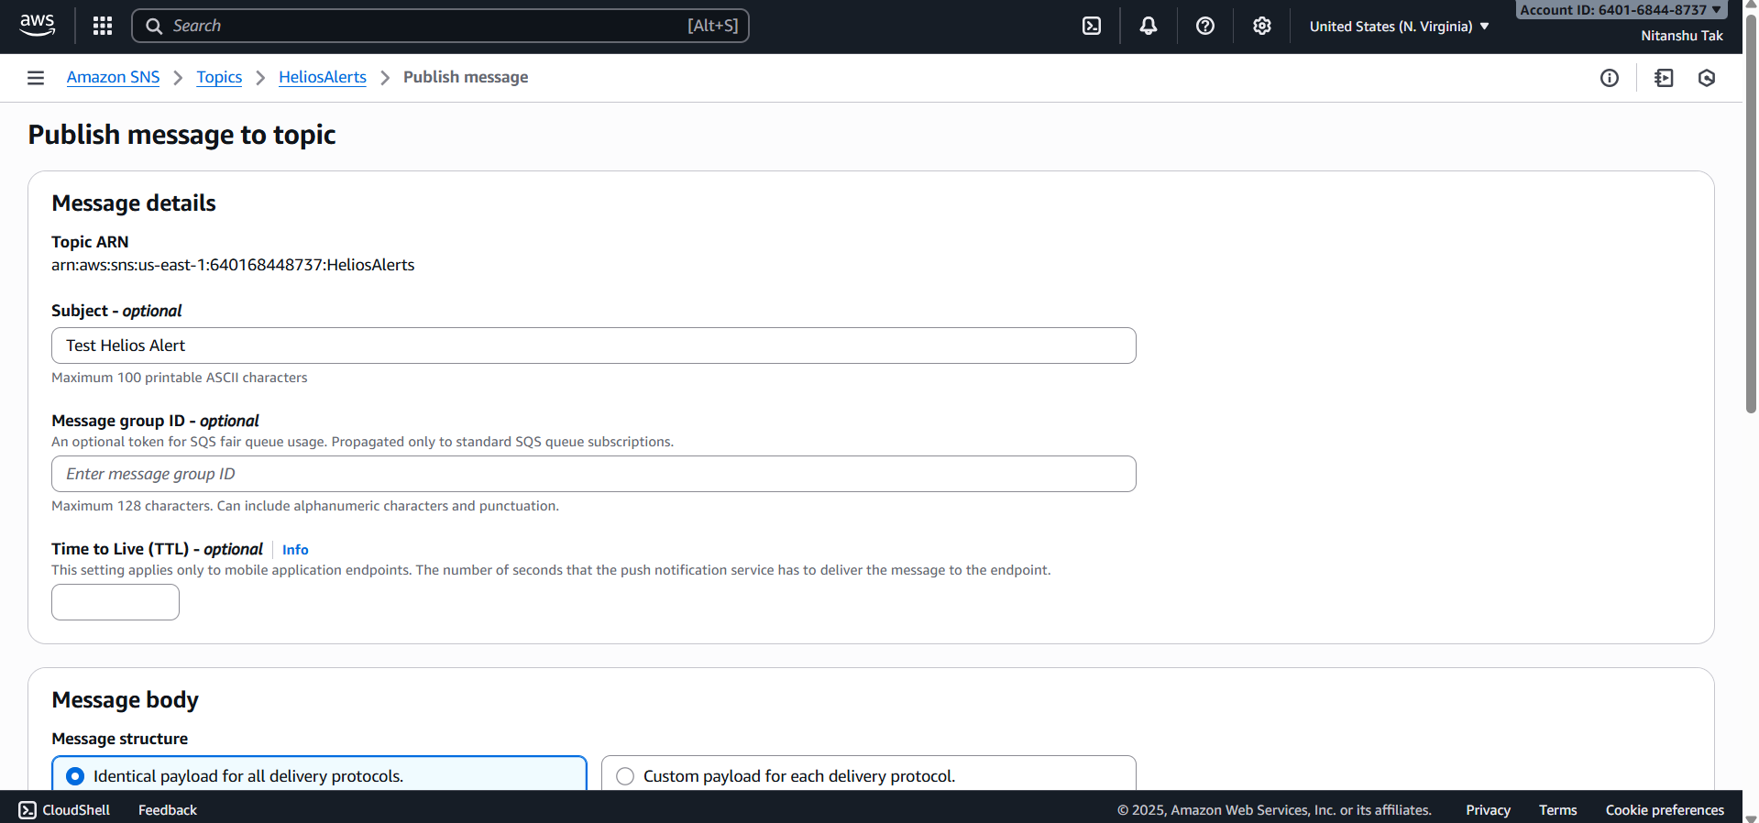

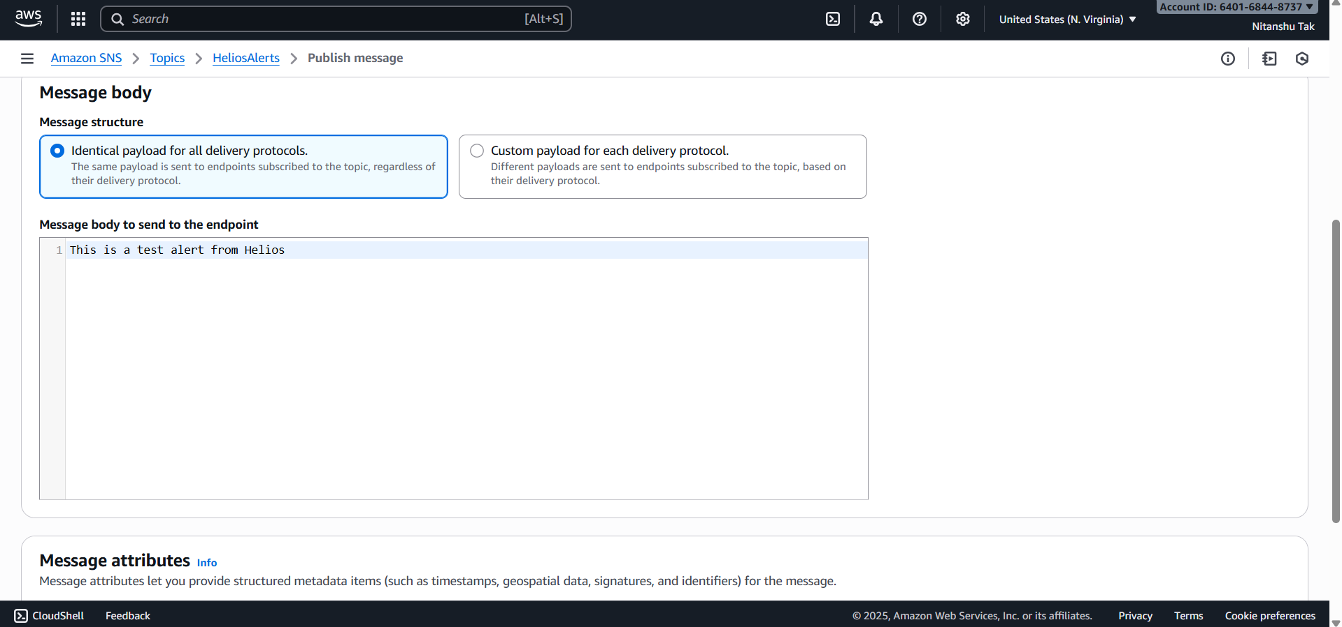

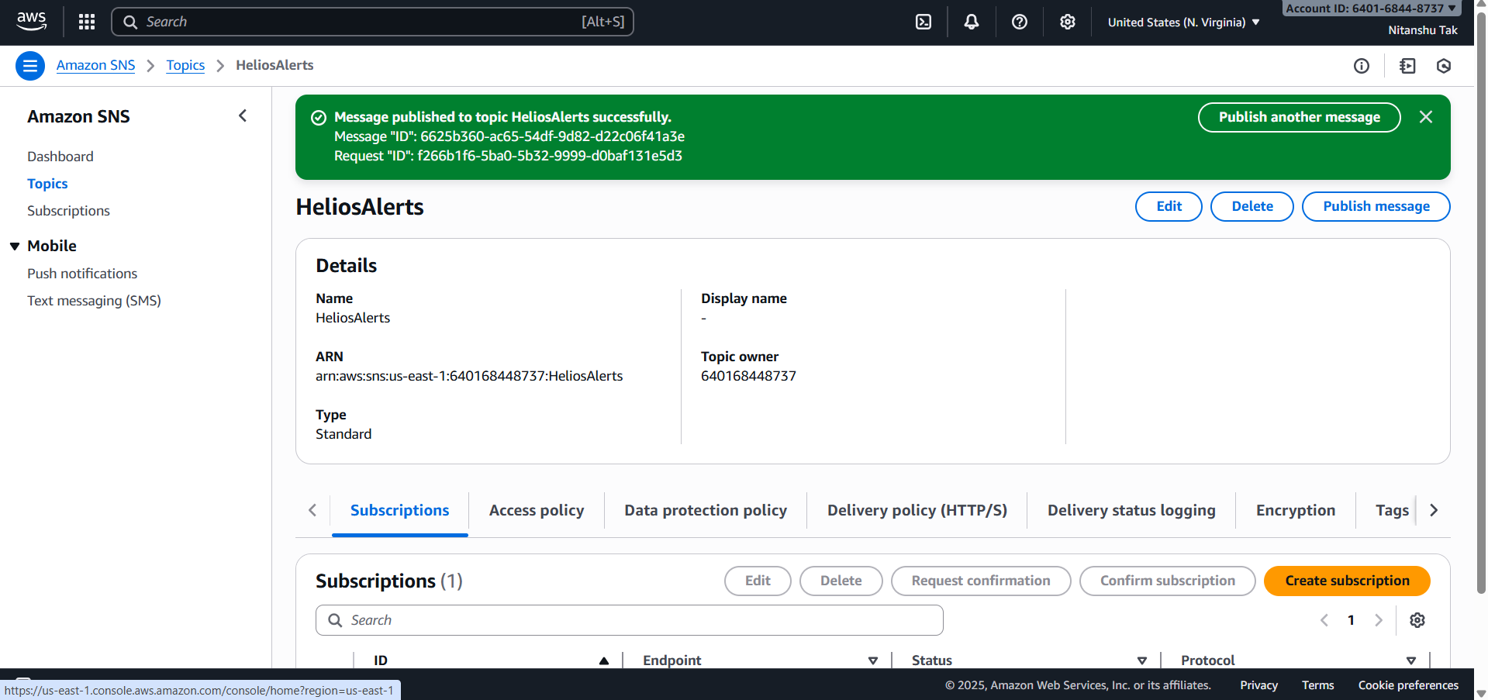

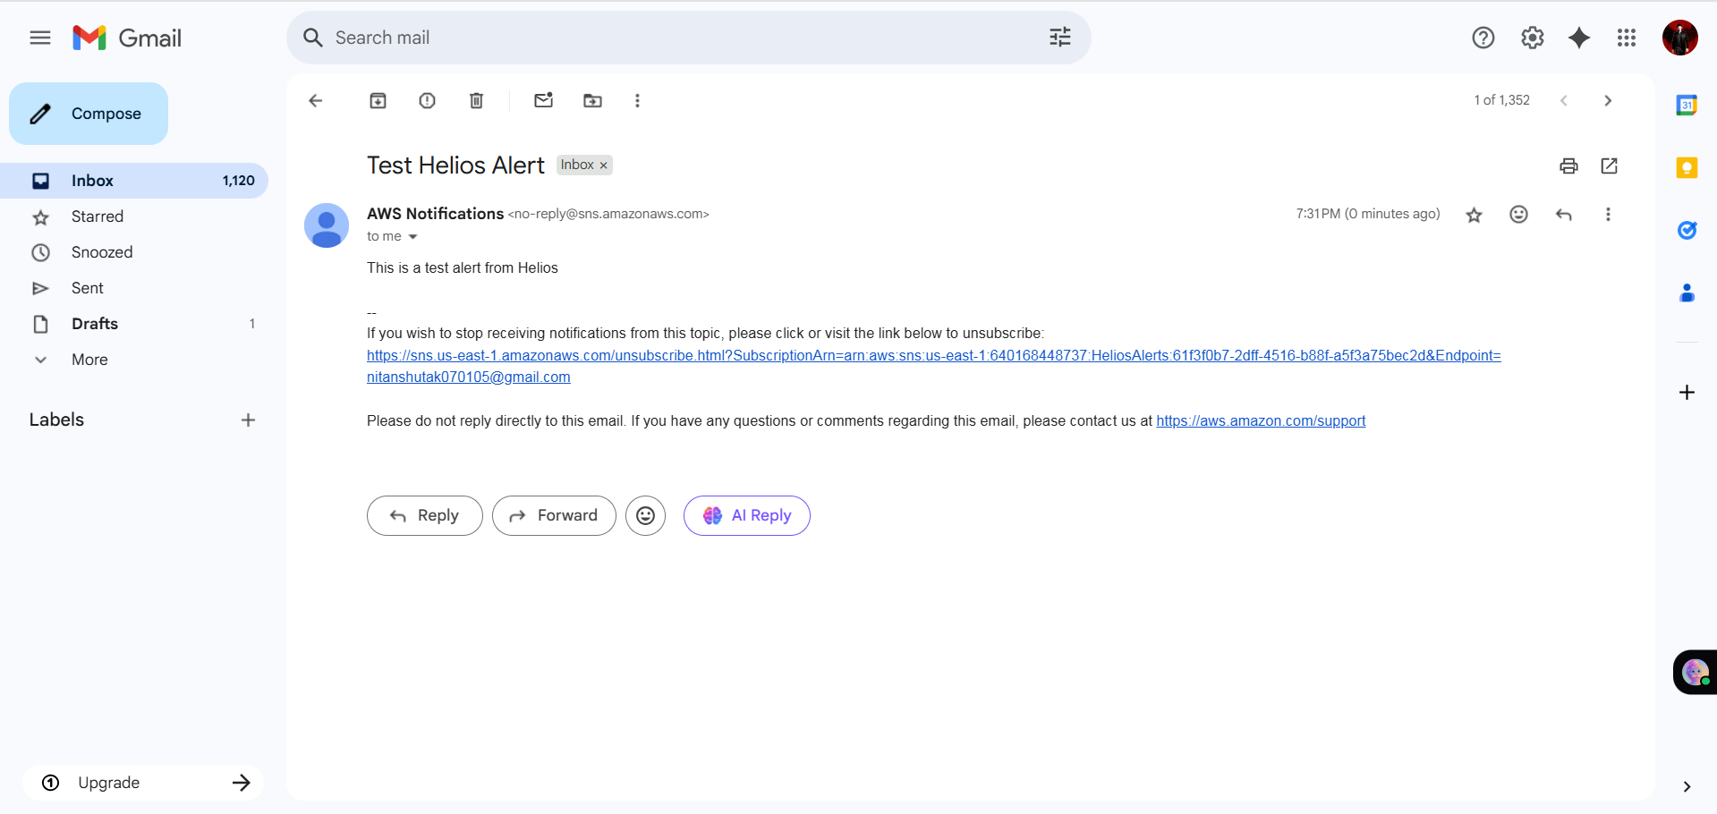

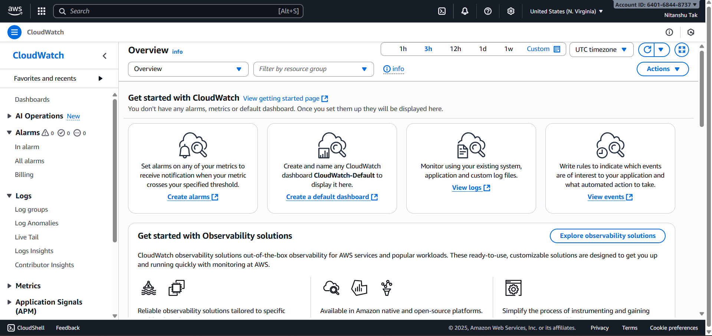

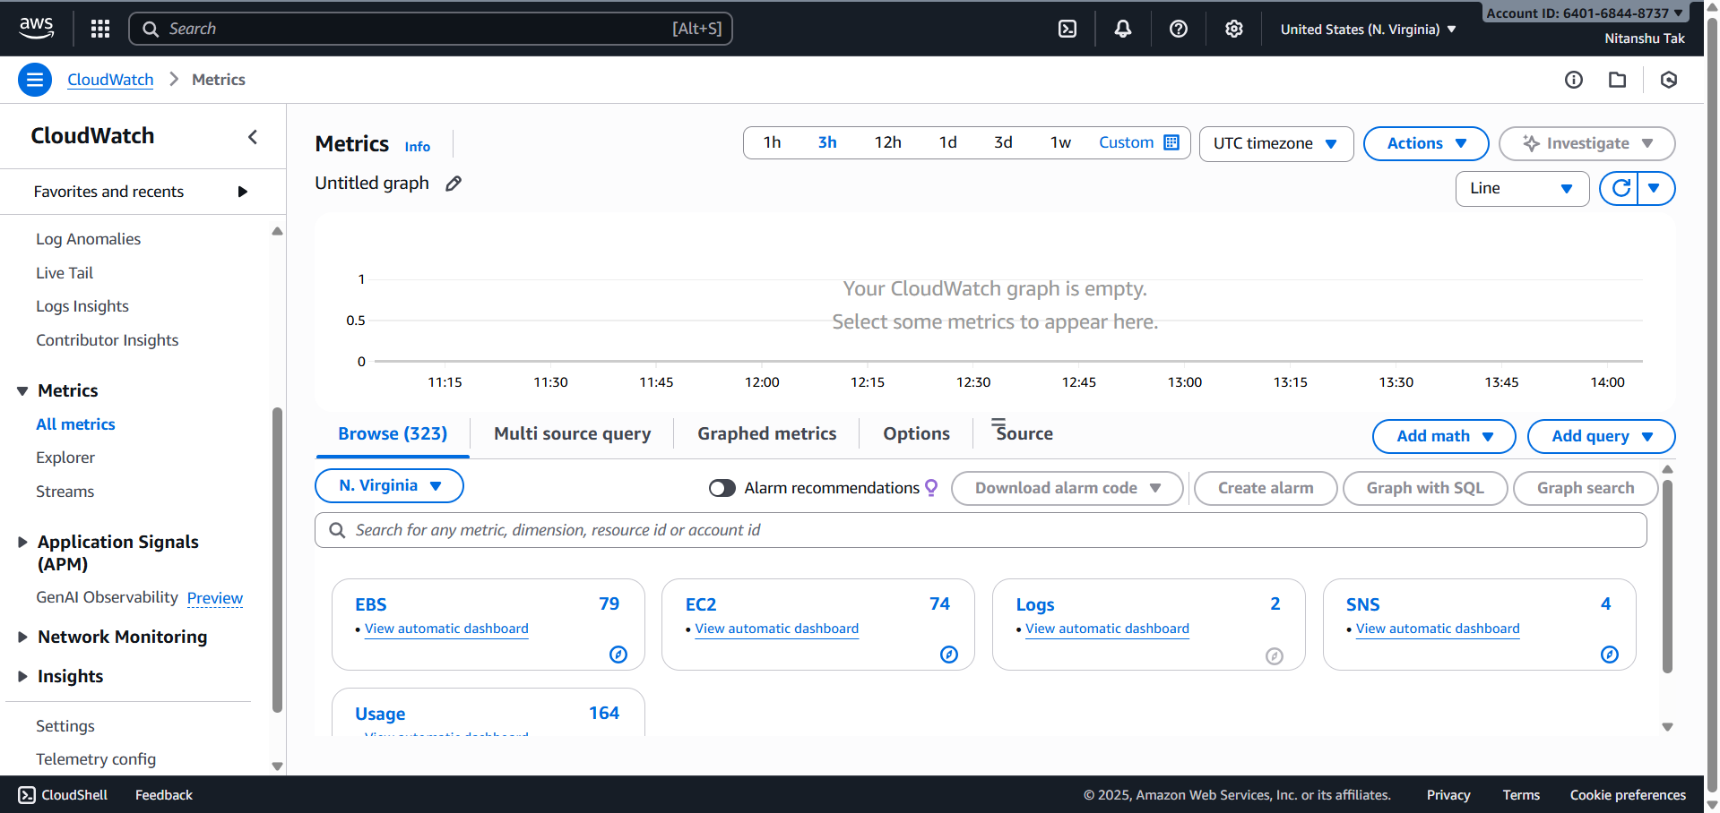

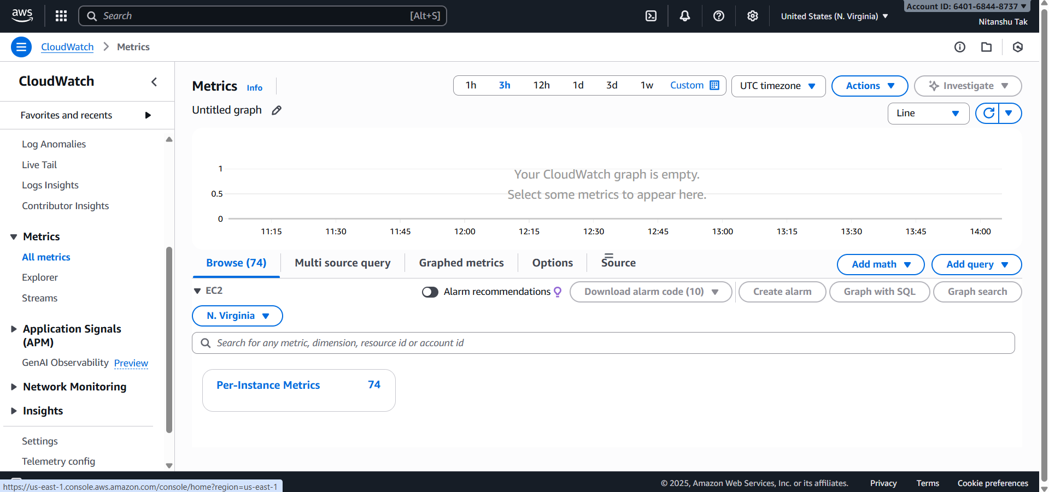

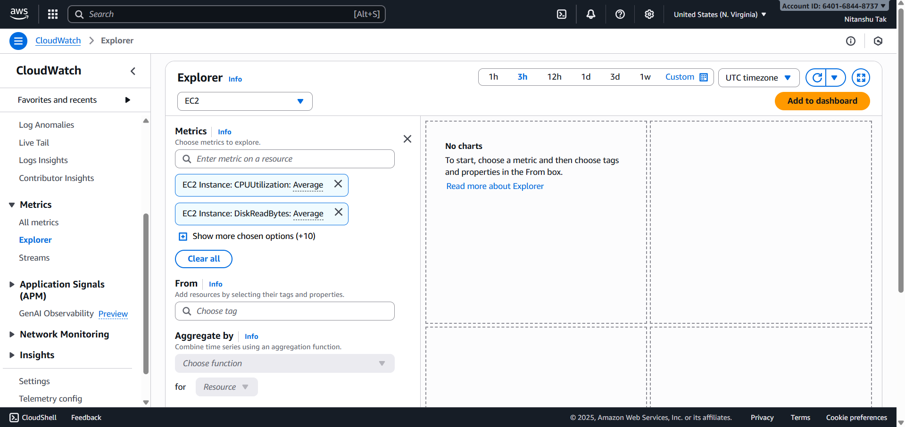

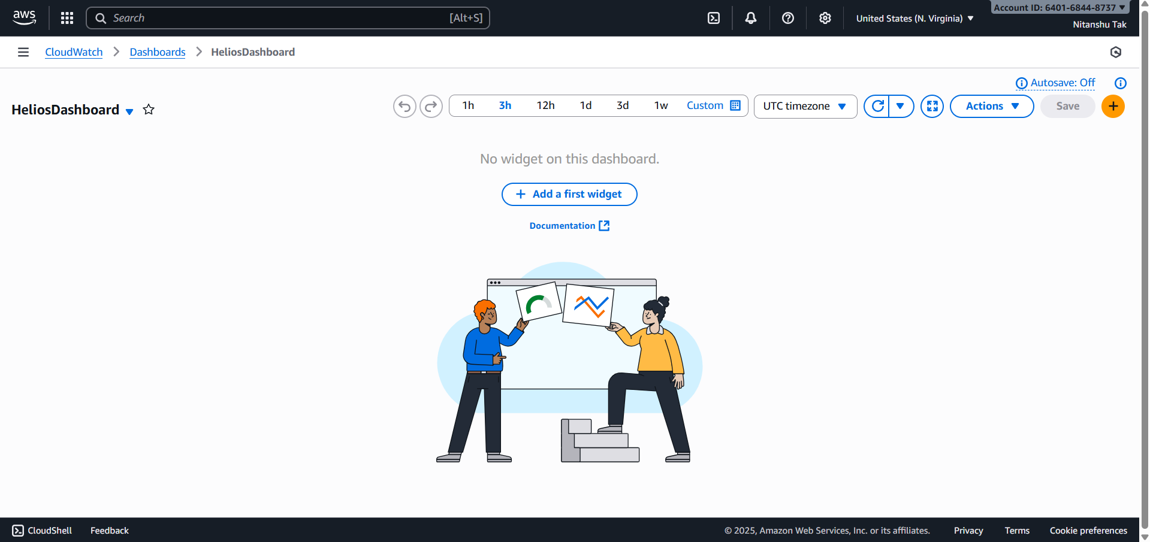

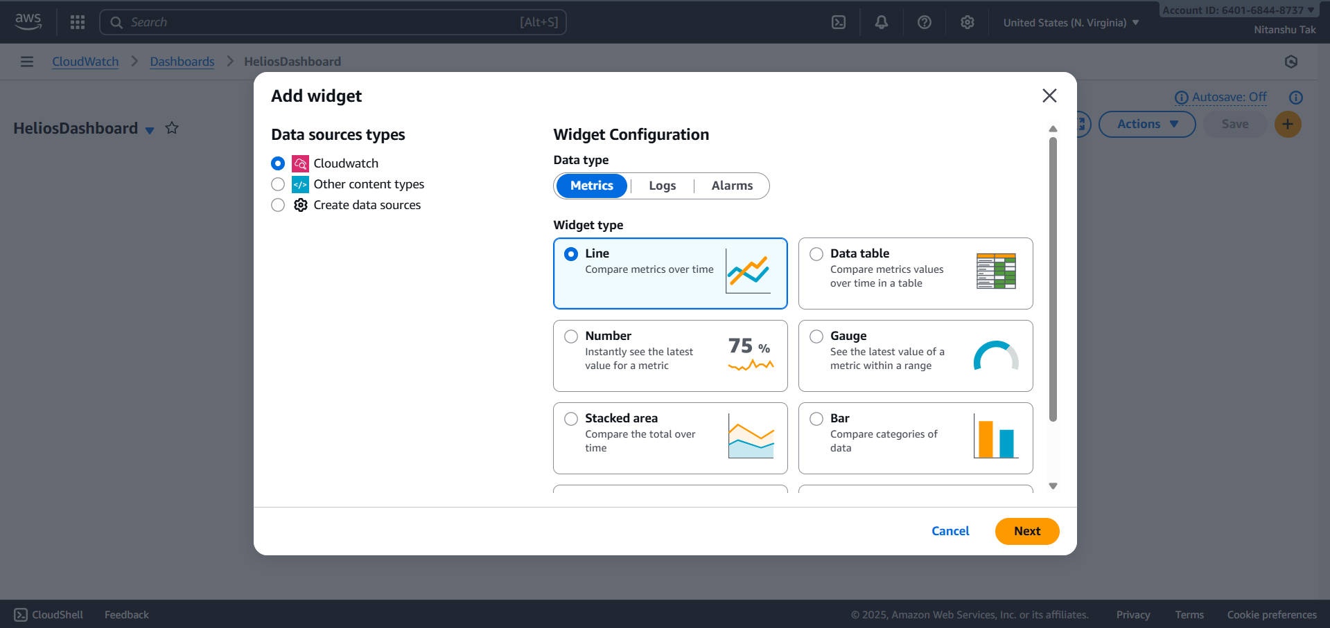

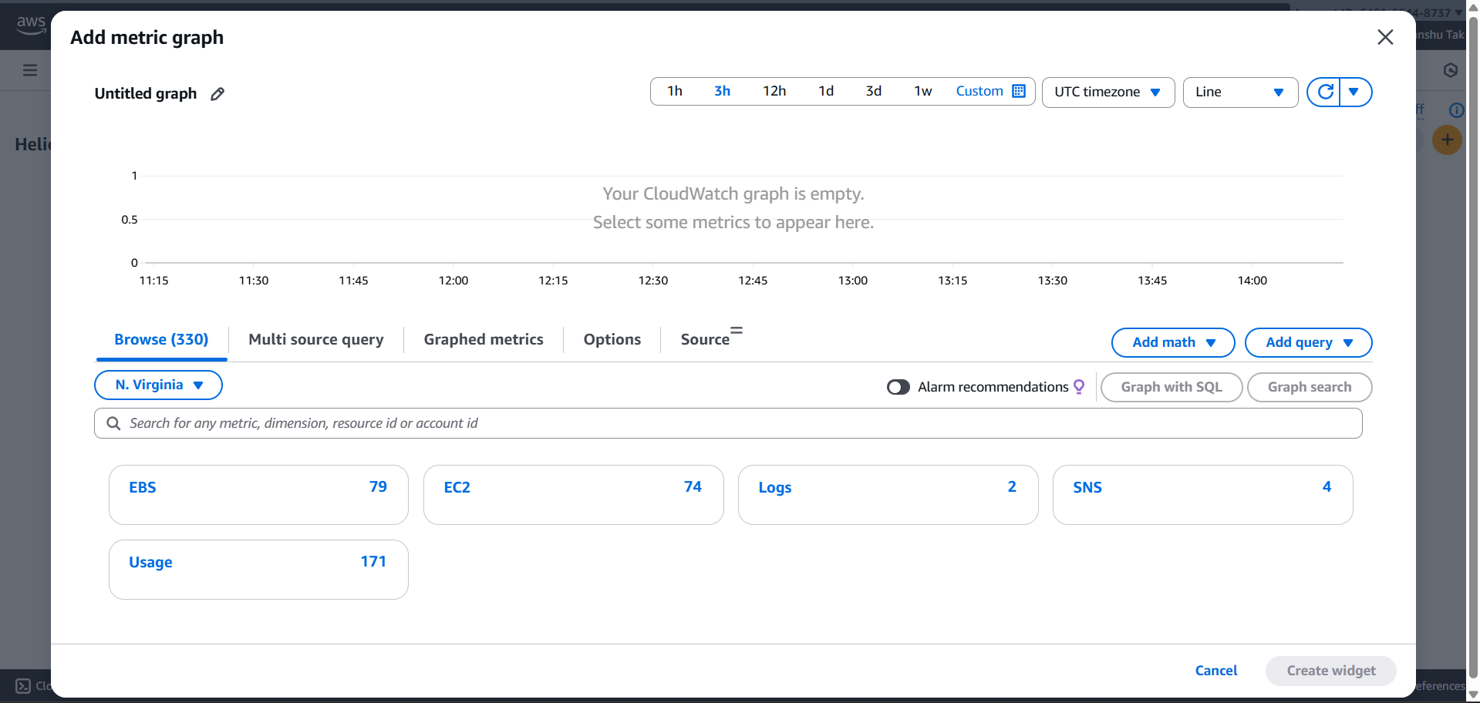

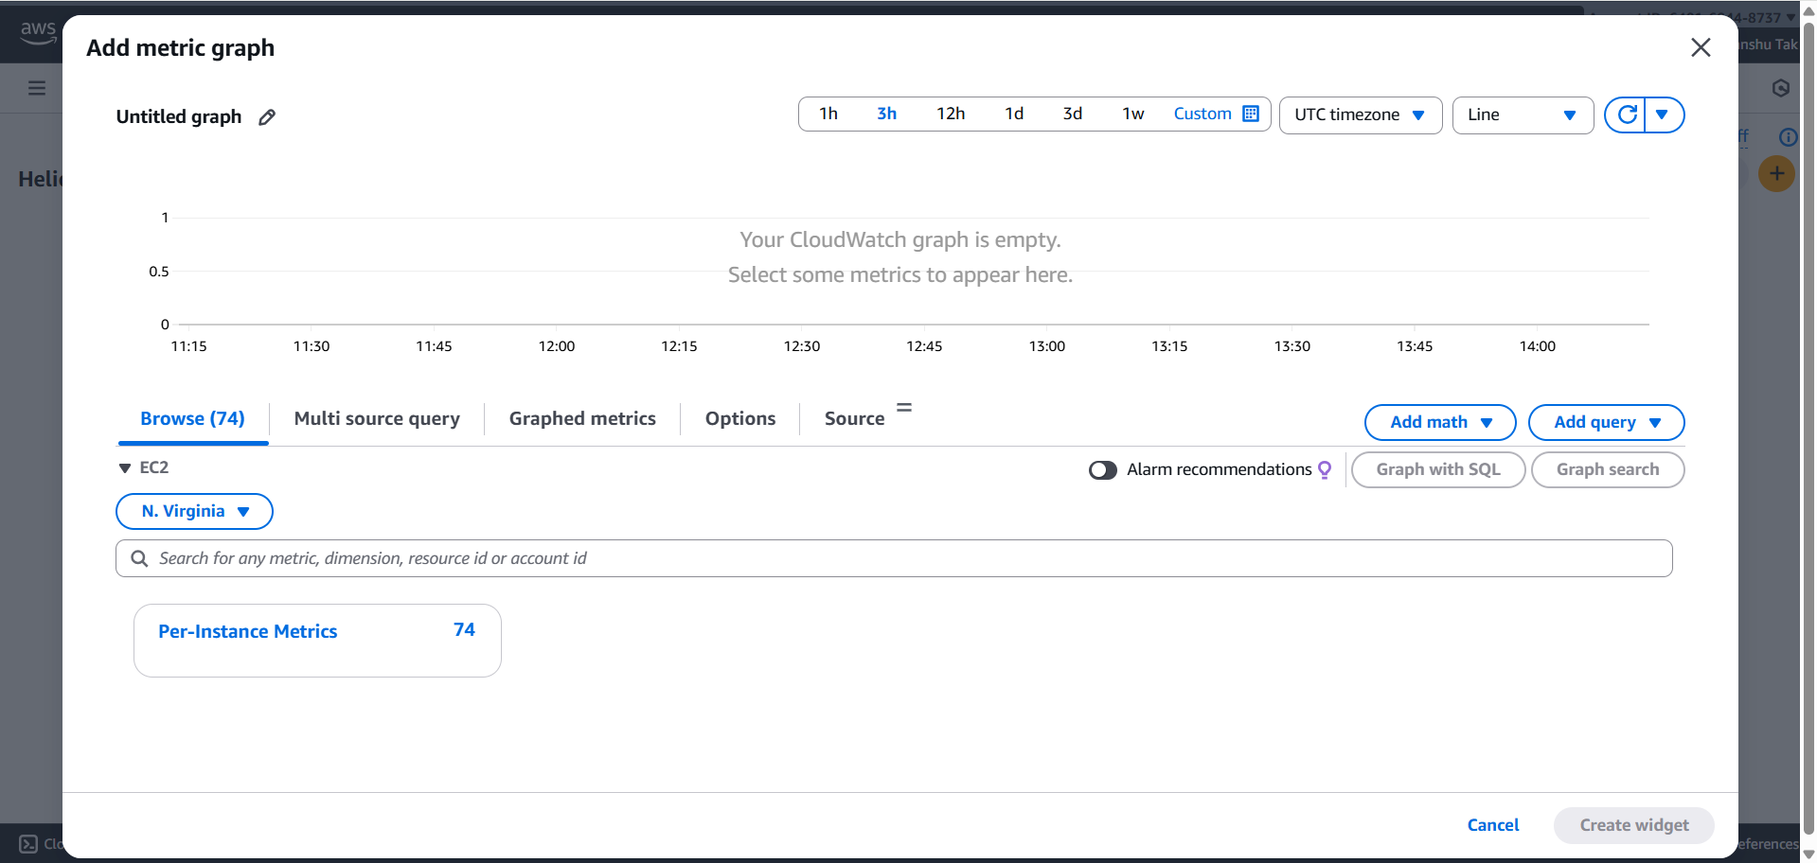

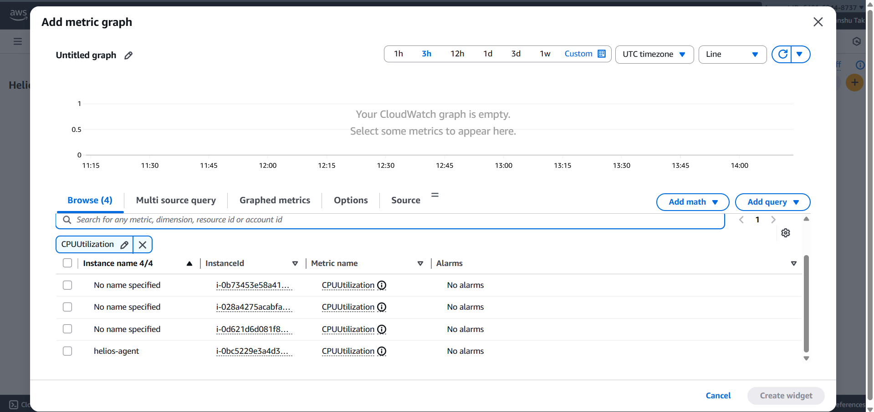

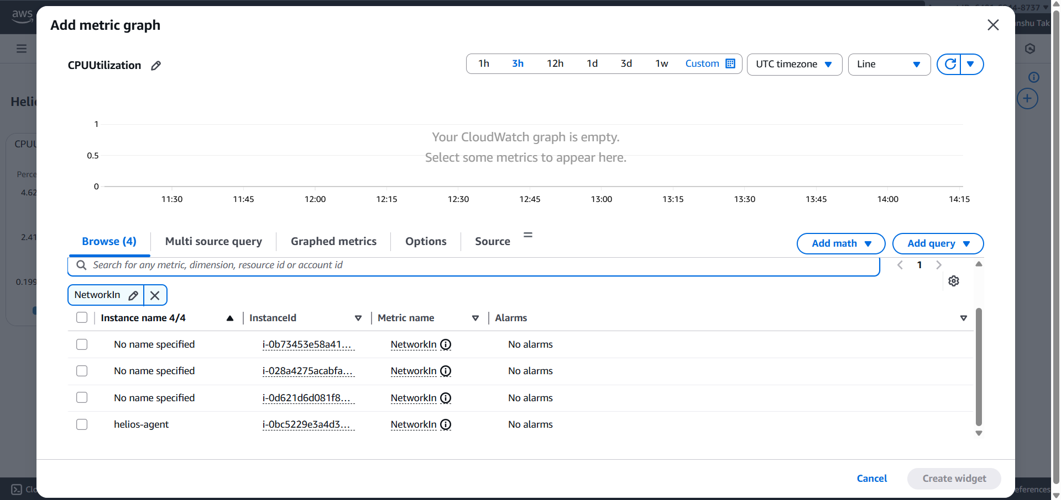

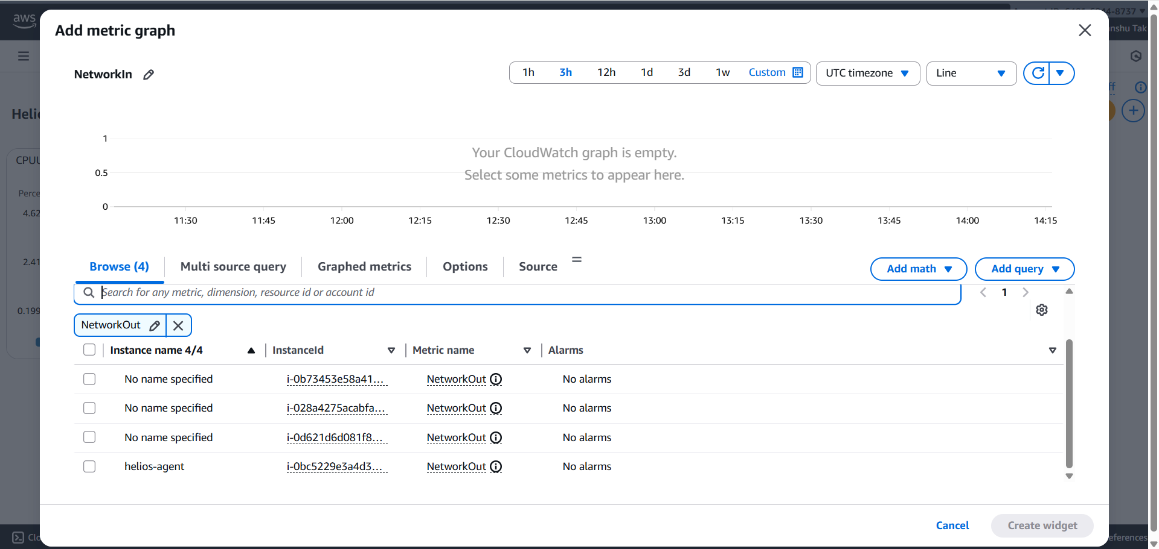

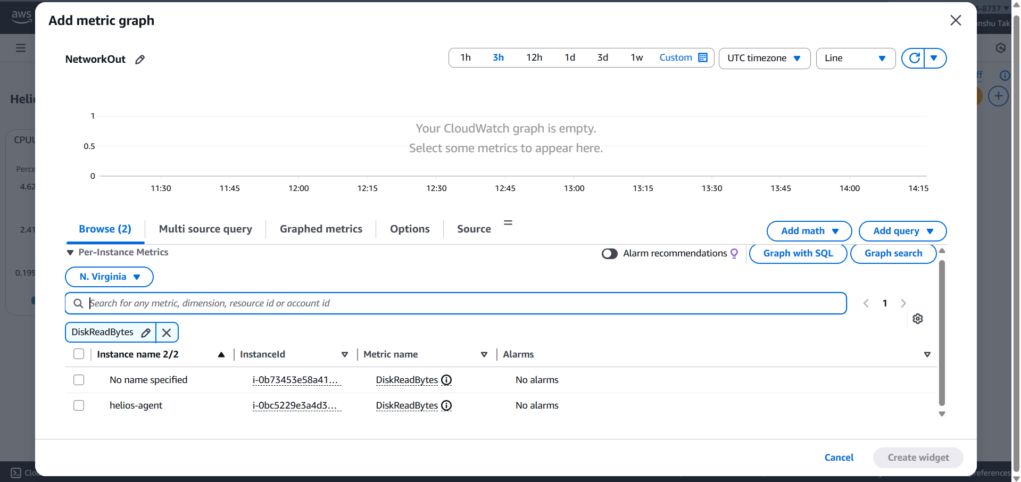

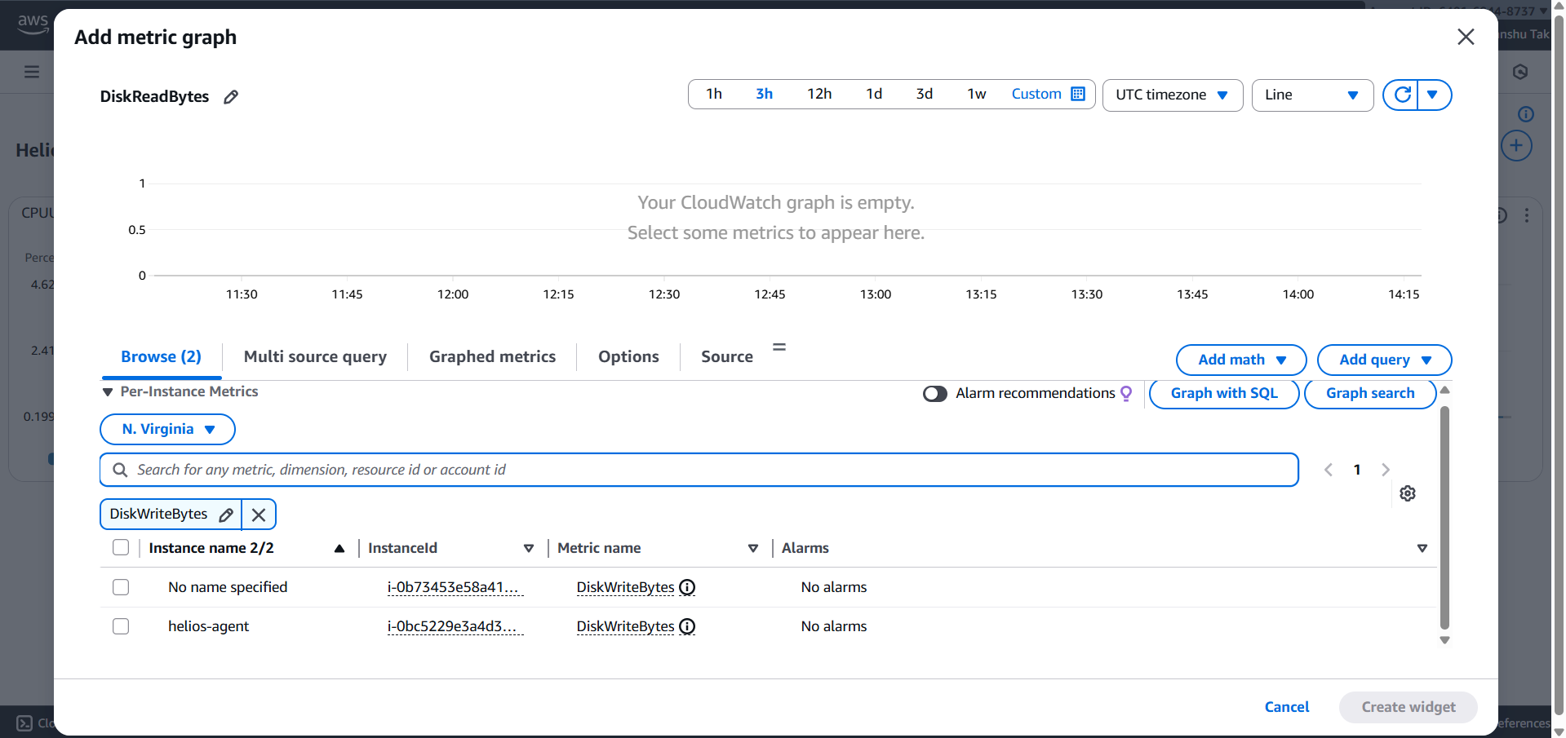

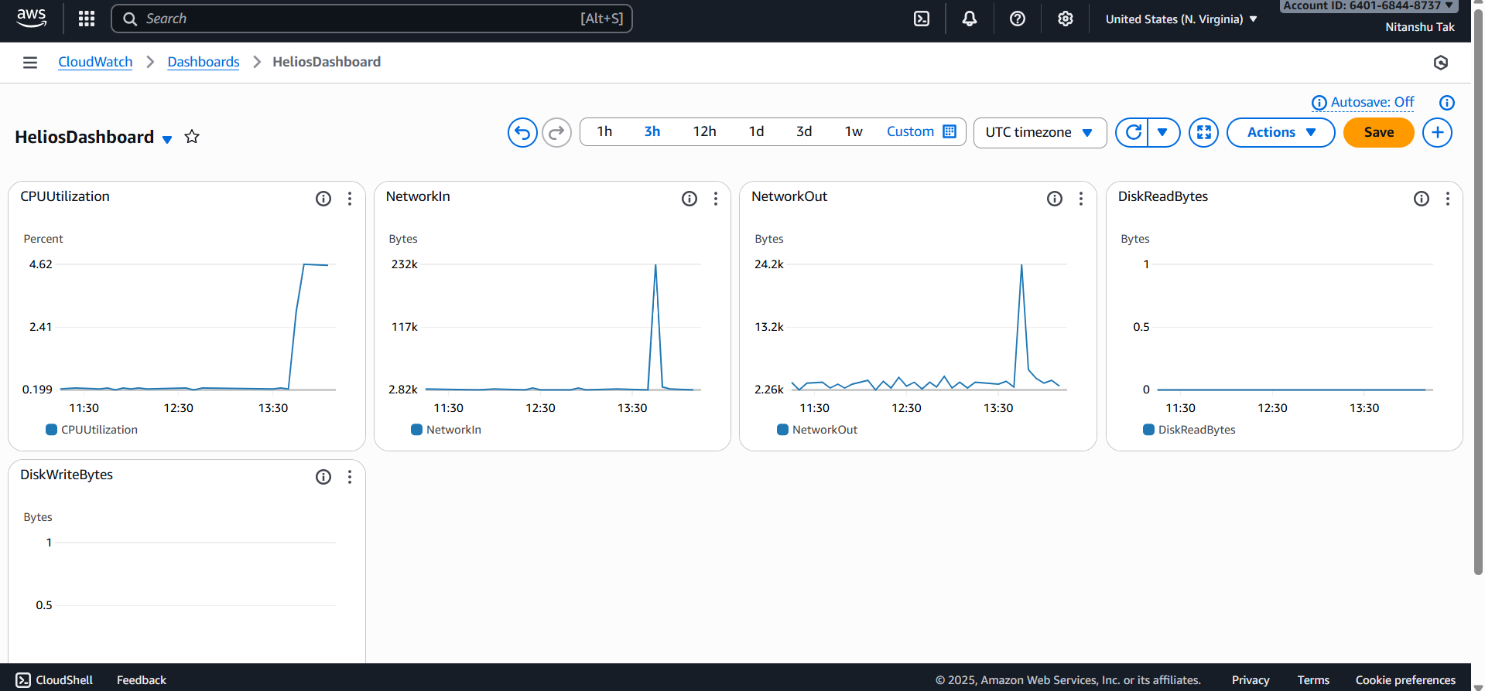

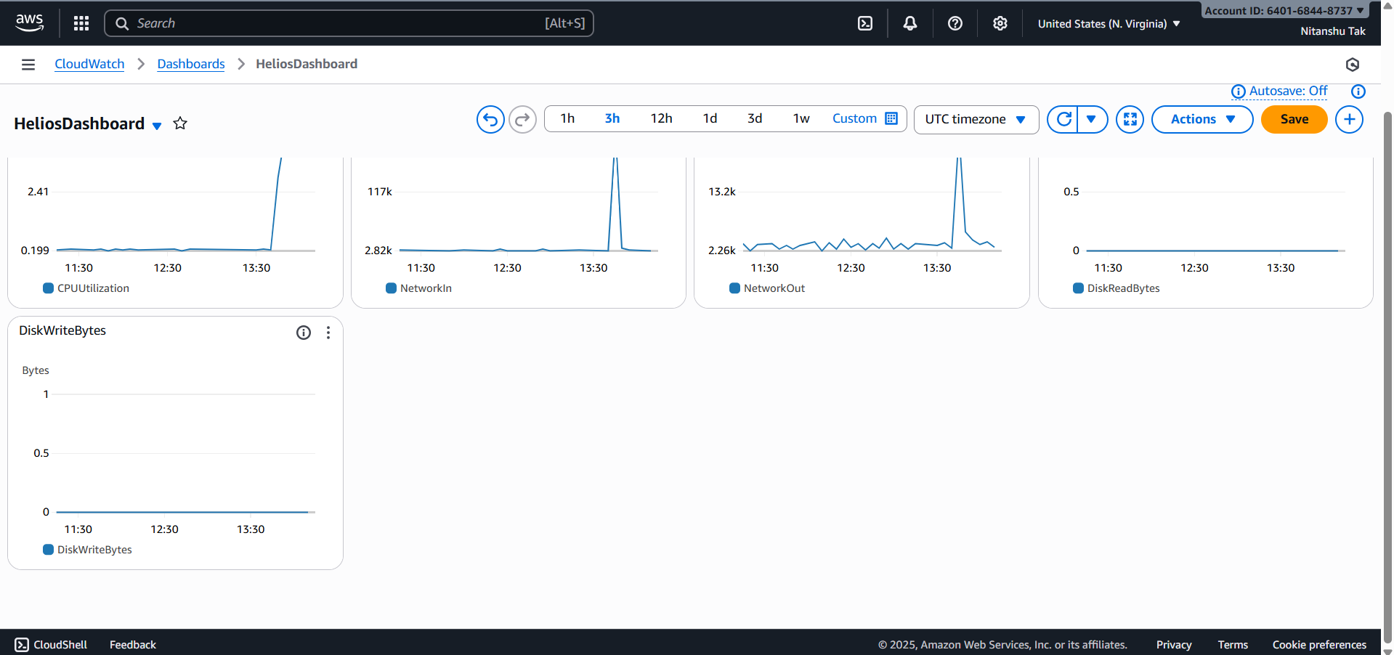

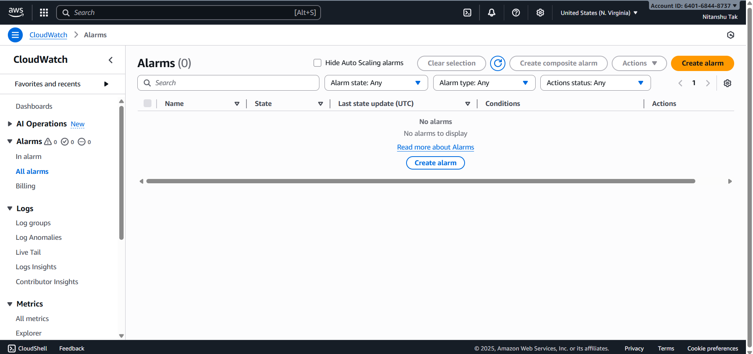

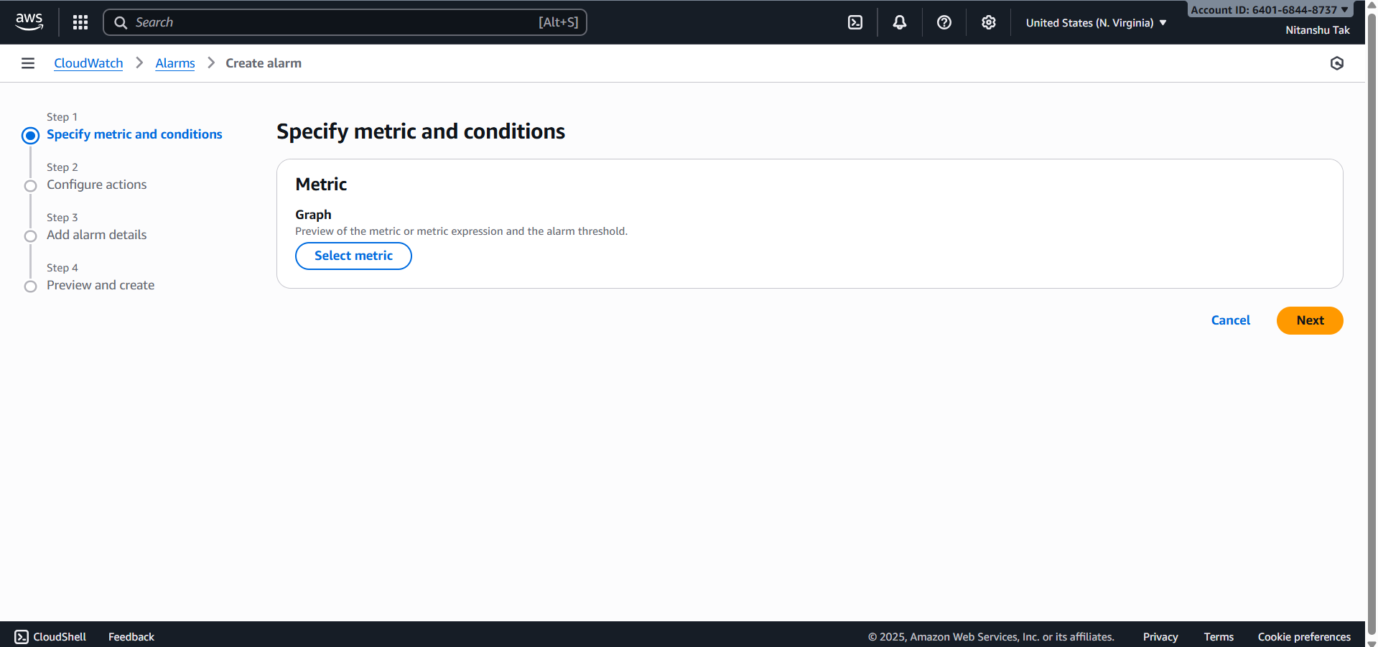

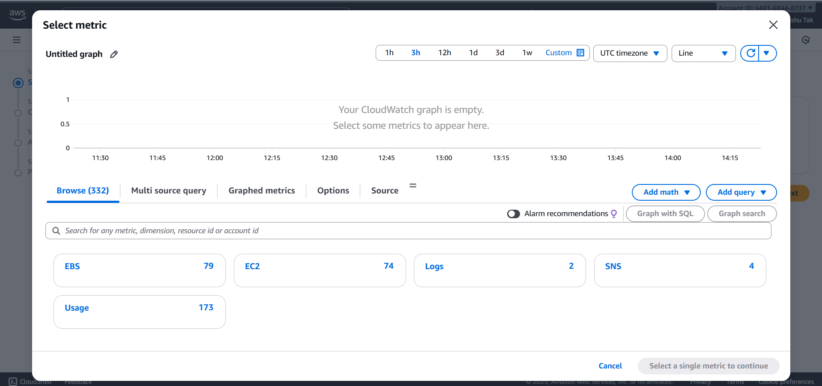

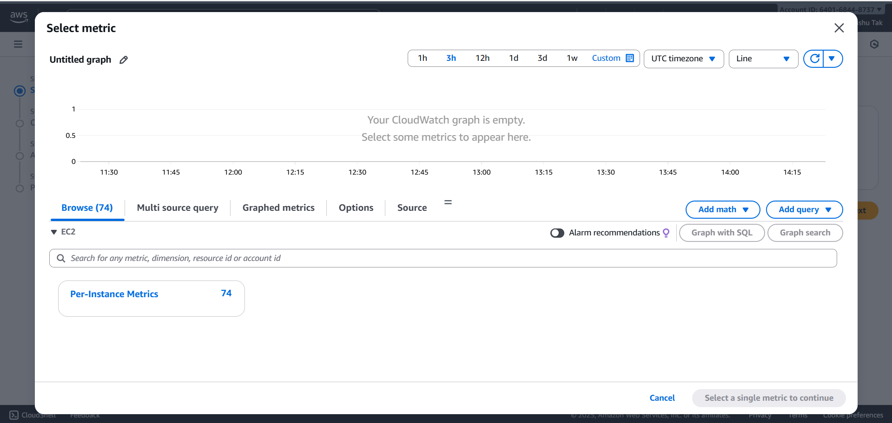

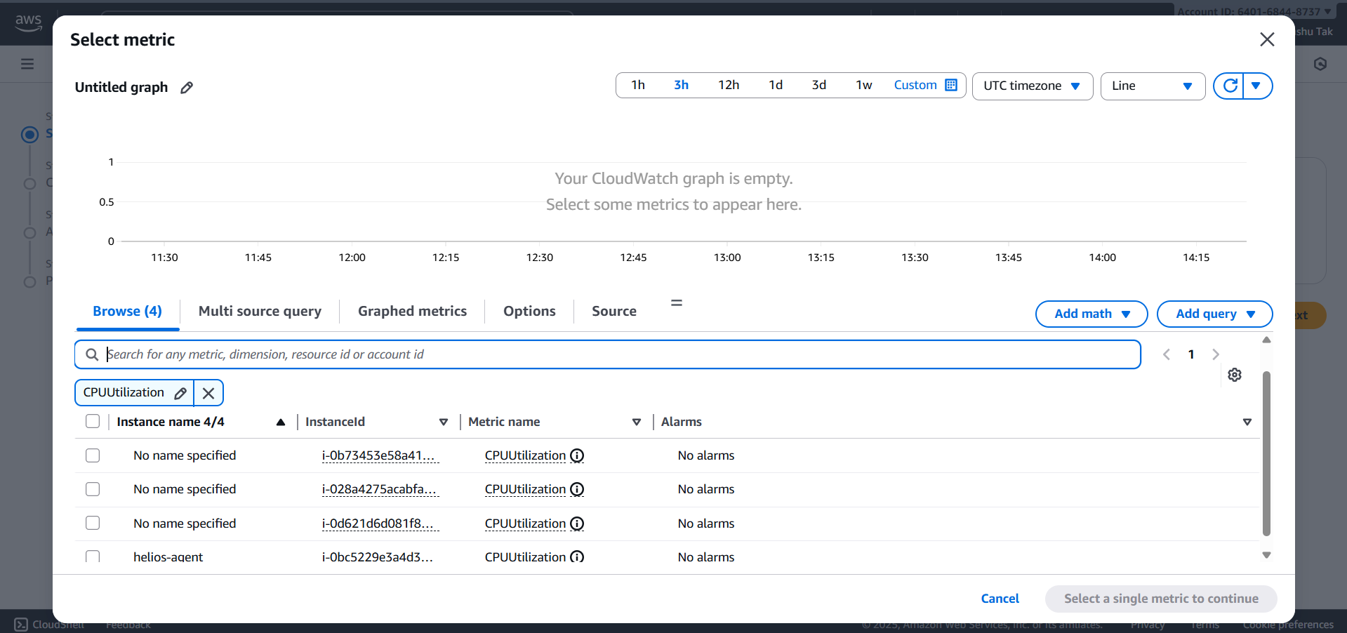

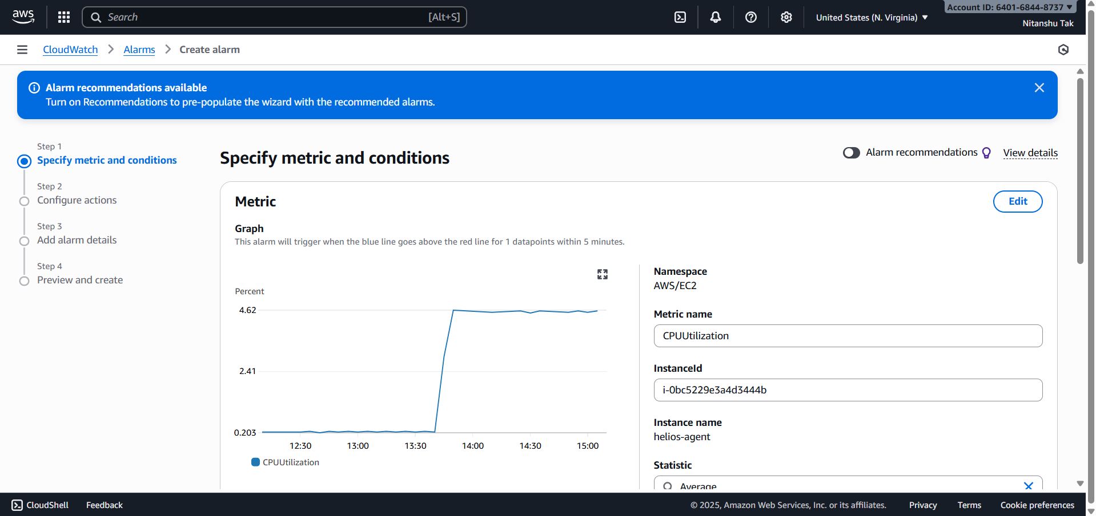

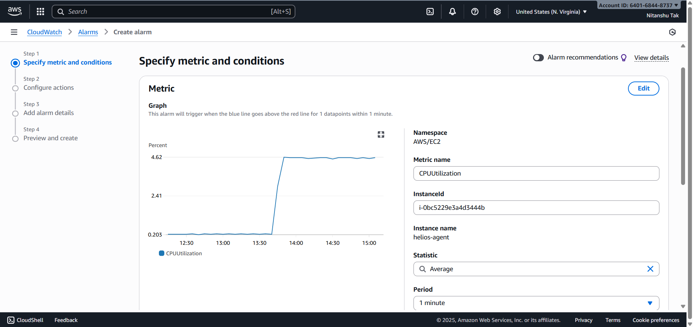

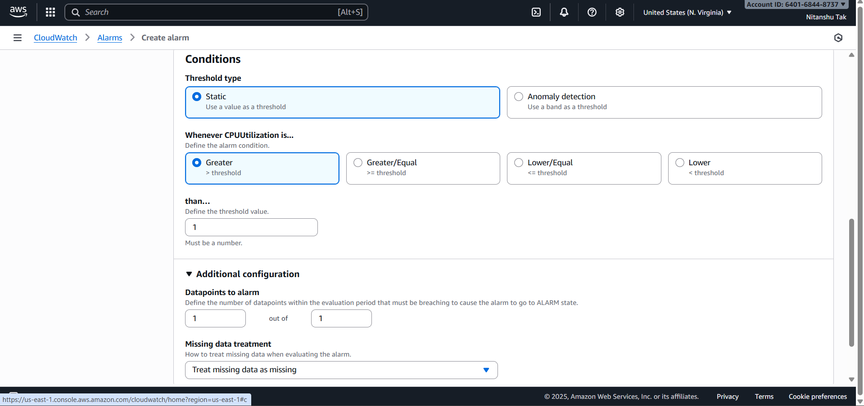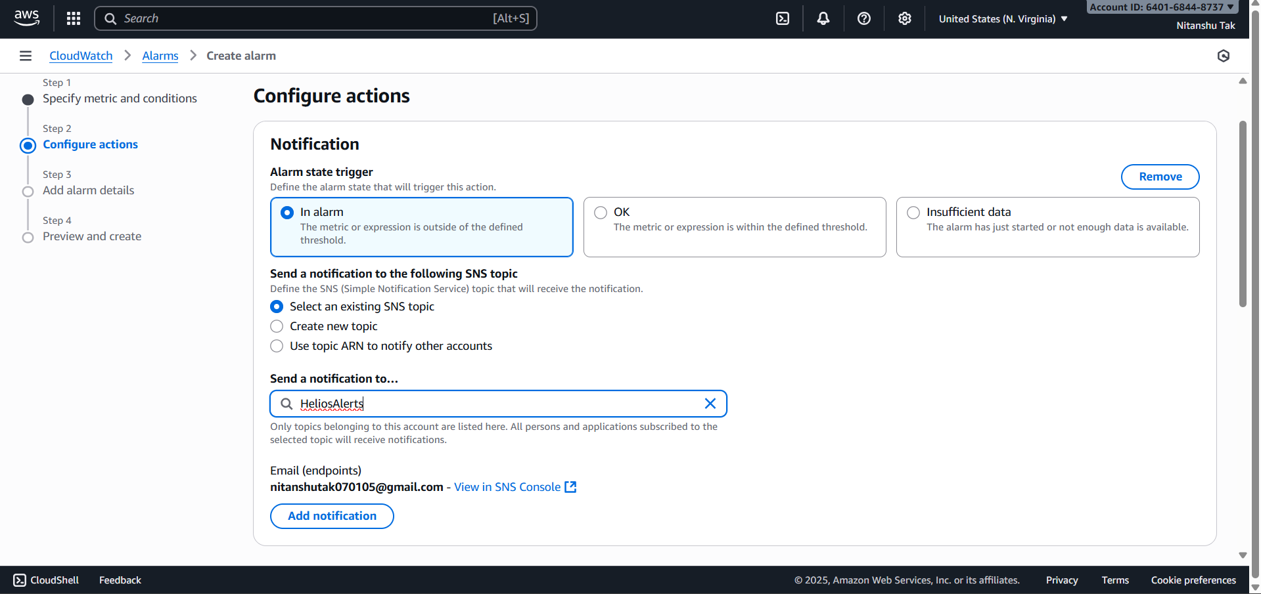

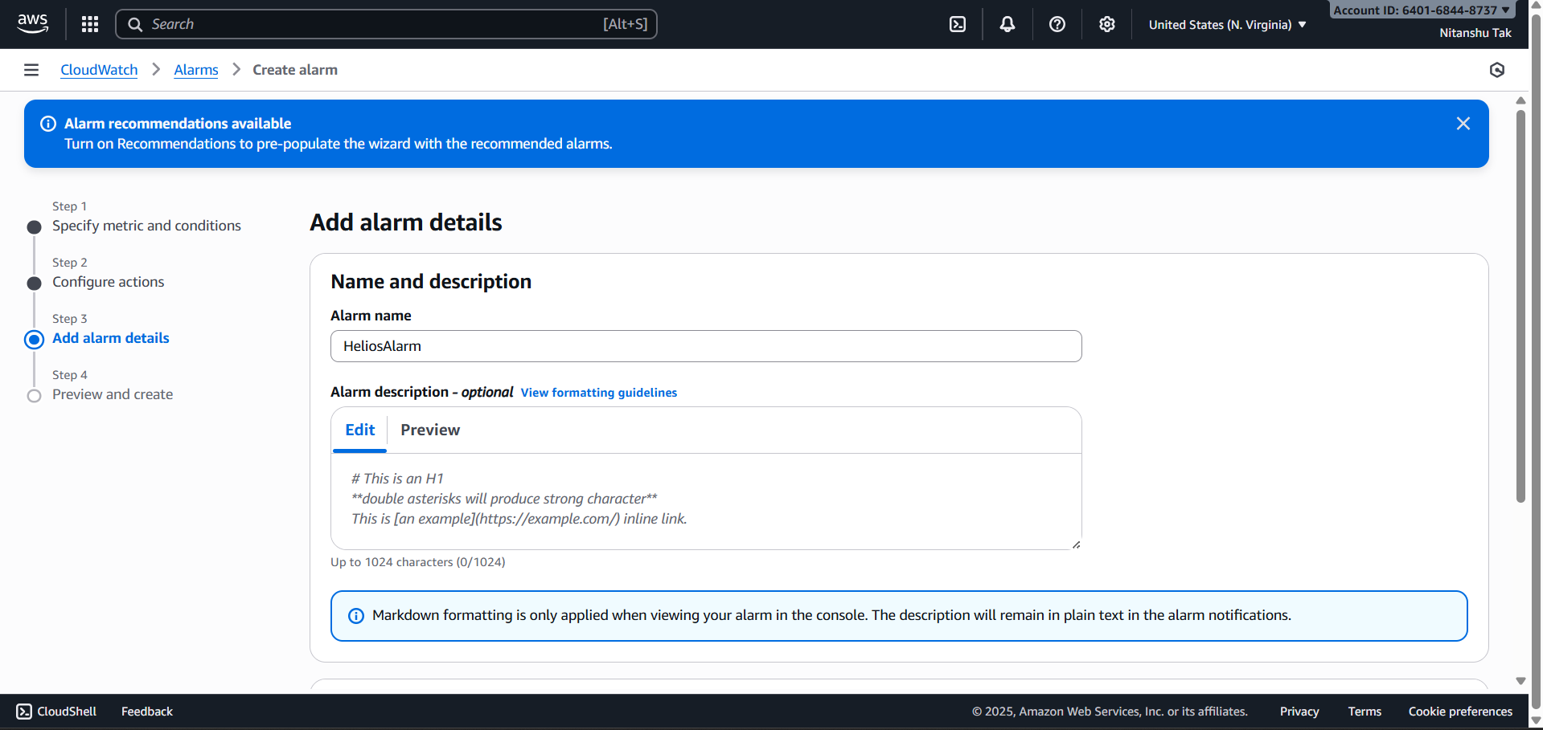

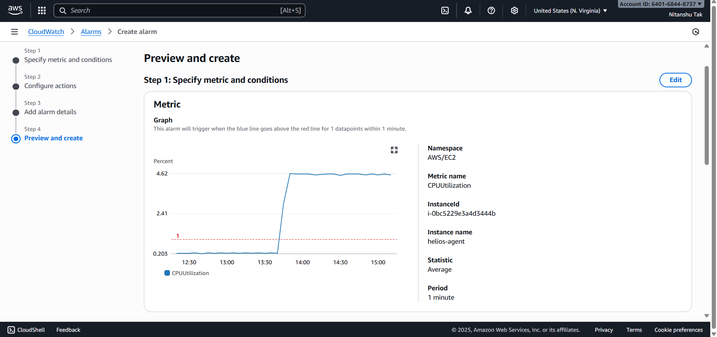

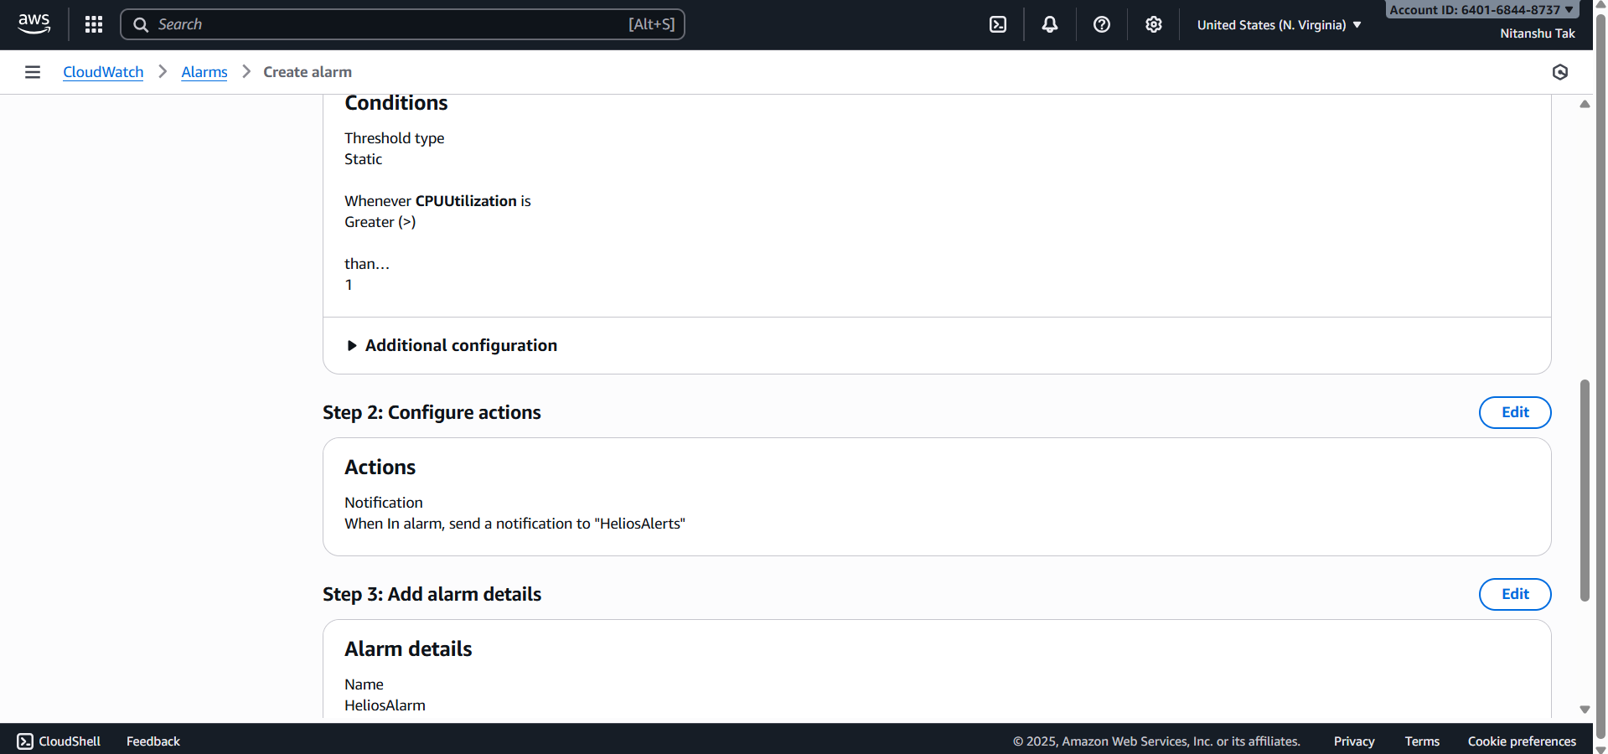

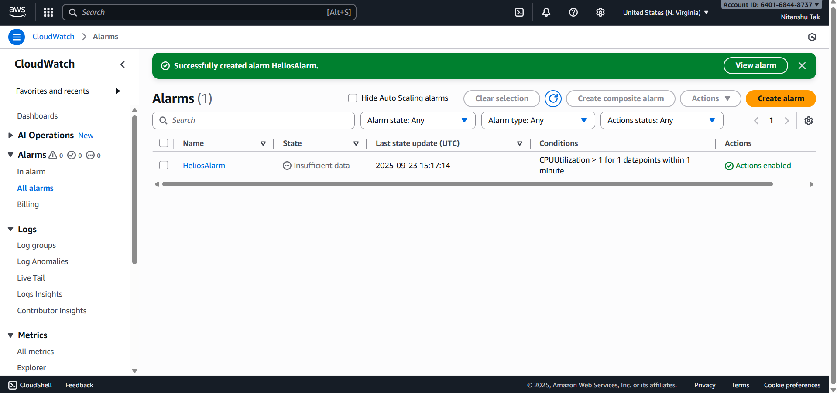

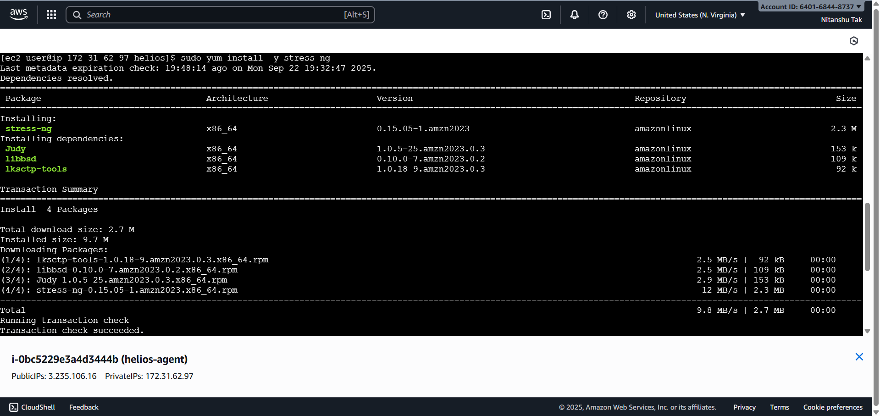

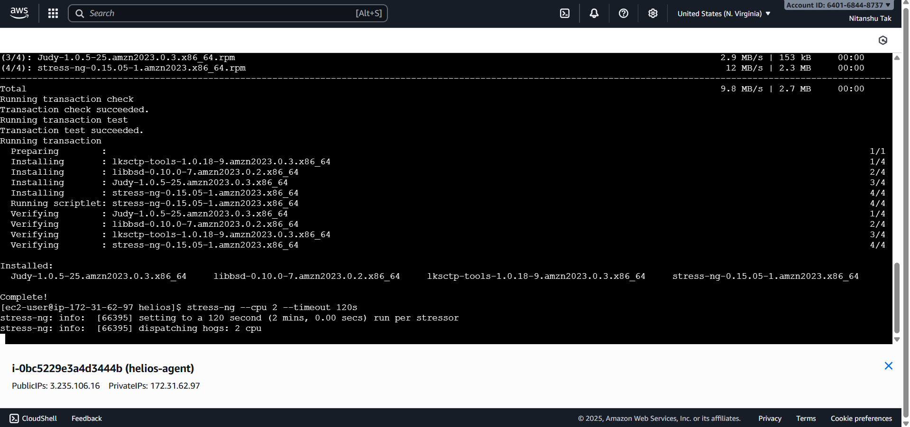

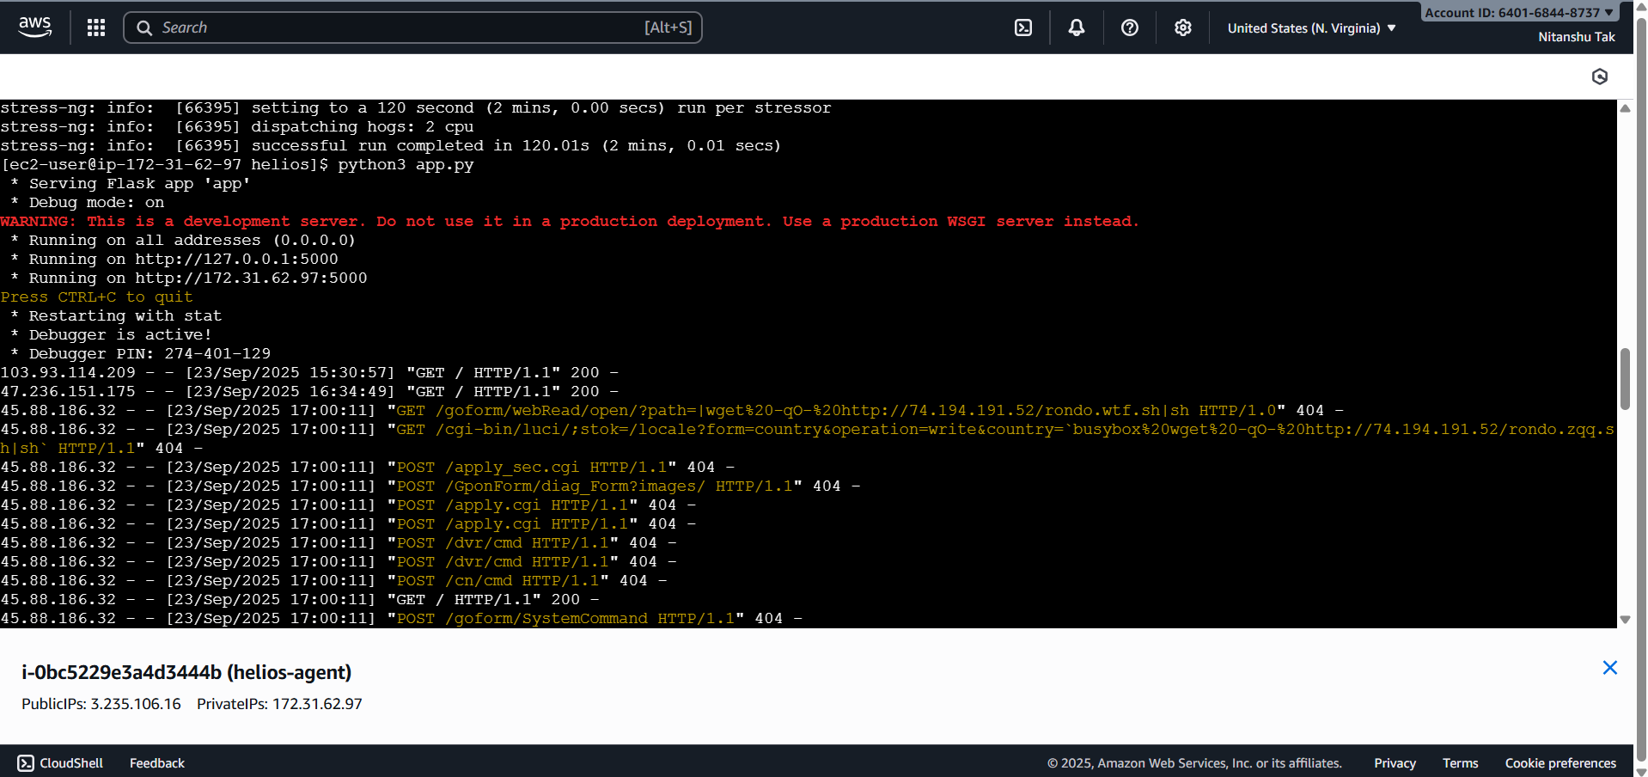

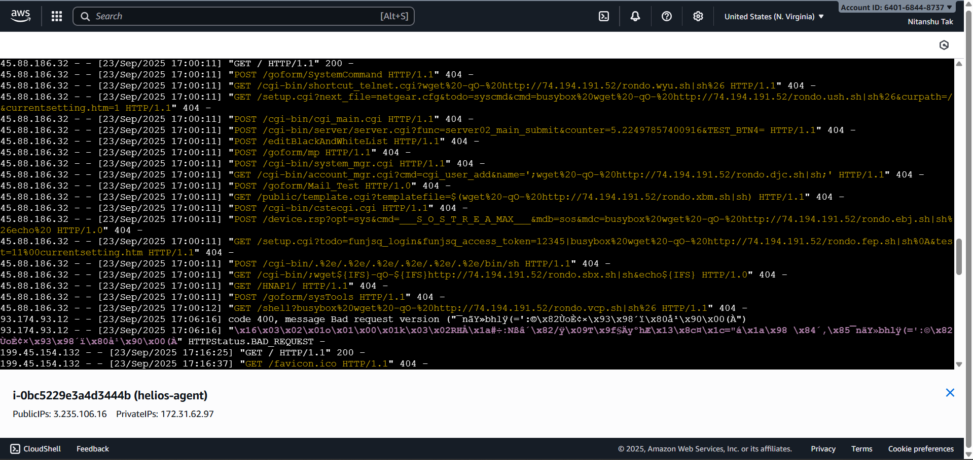

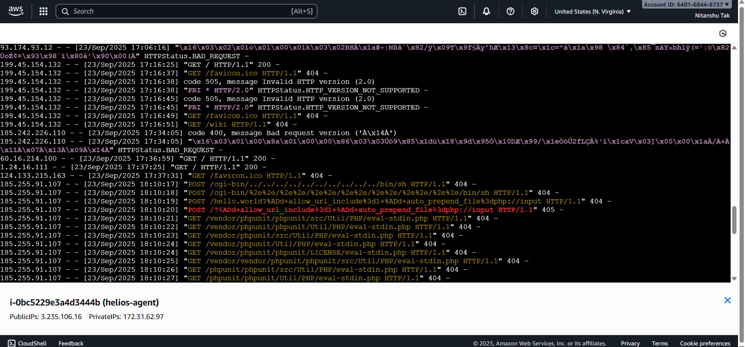

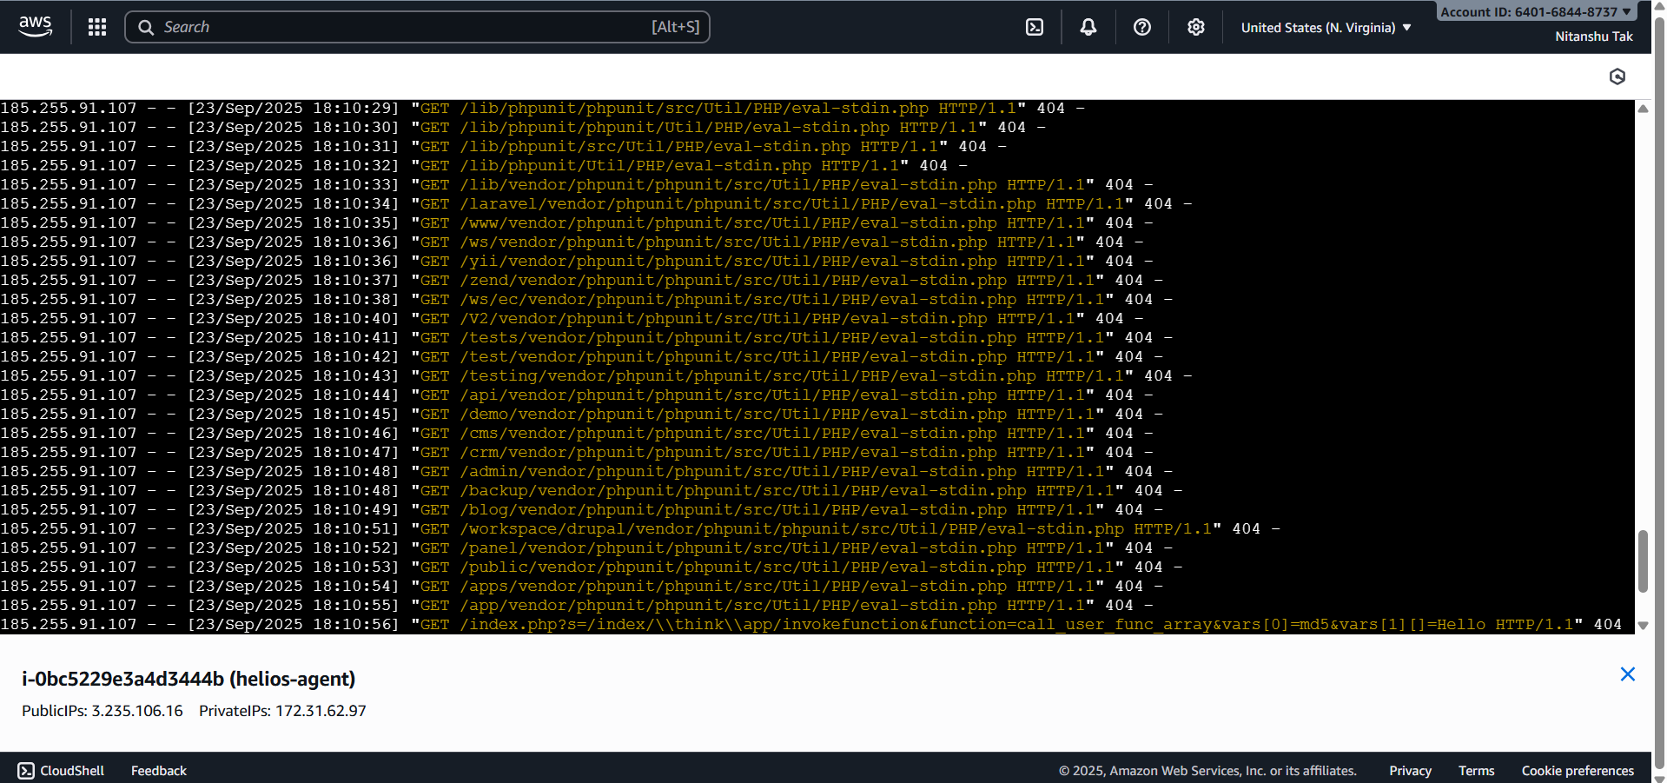

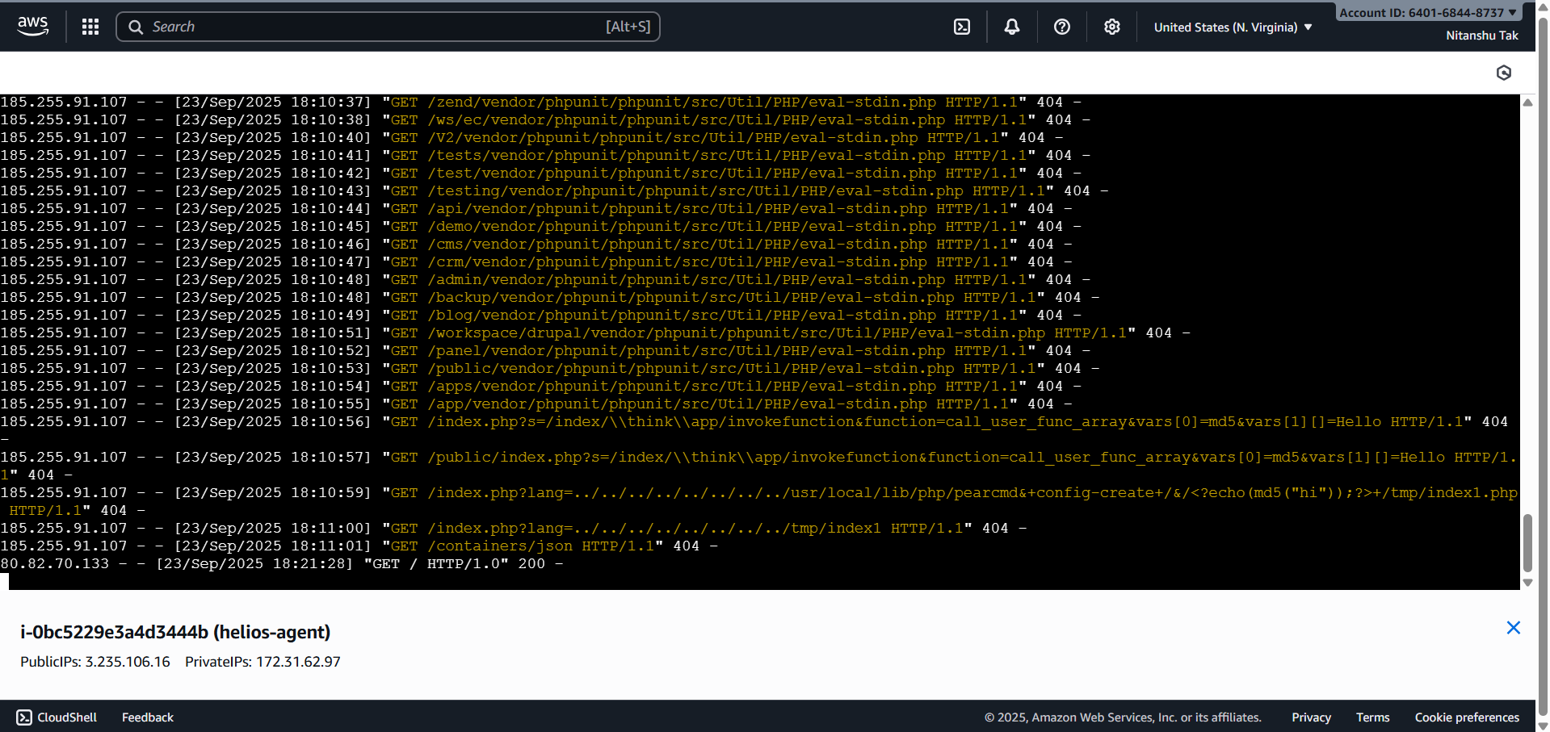



**8. Tools and Services Used**

• Google Colab – Training anomaly detection models.

• AWS S3 – Storage of serialized models.

• AWS EC2 – Running Flask anomaly detection agent.

• IAM – Role-based access control.

• Postman – Testing endpoints.

• AWS CloudWatch – Monitoring and alerts.

• AWS SNS – Real-time alert notifications.

**9. Results and Observations**

• Five anomaly detectors successfully deployed and tested.

• Flask API produced correct predictions for anomalies.

• Real-time monitoring through CloudWatch.

• Instant anomaly alerts received through SNS email.

• Project run at zero cost under AWS Free Tier.

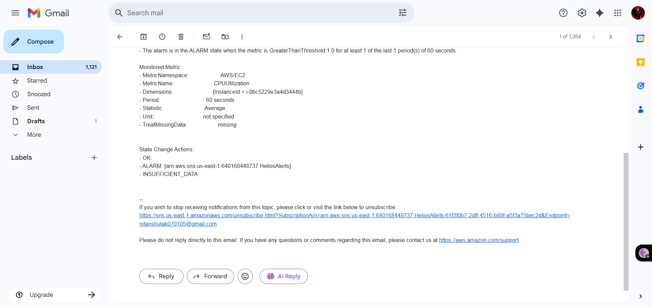

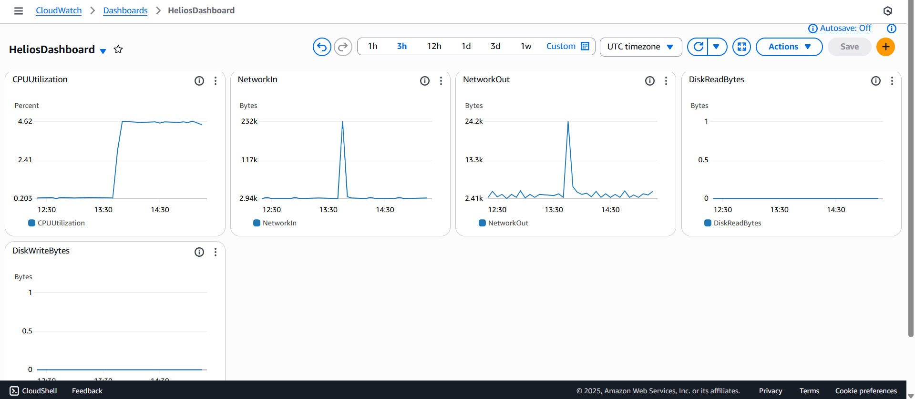

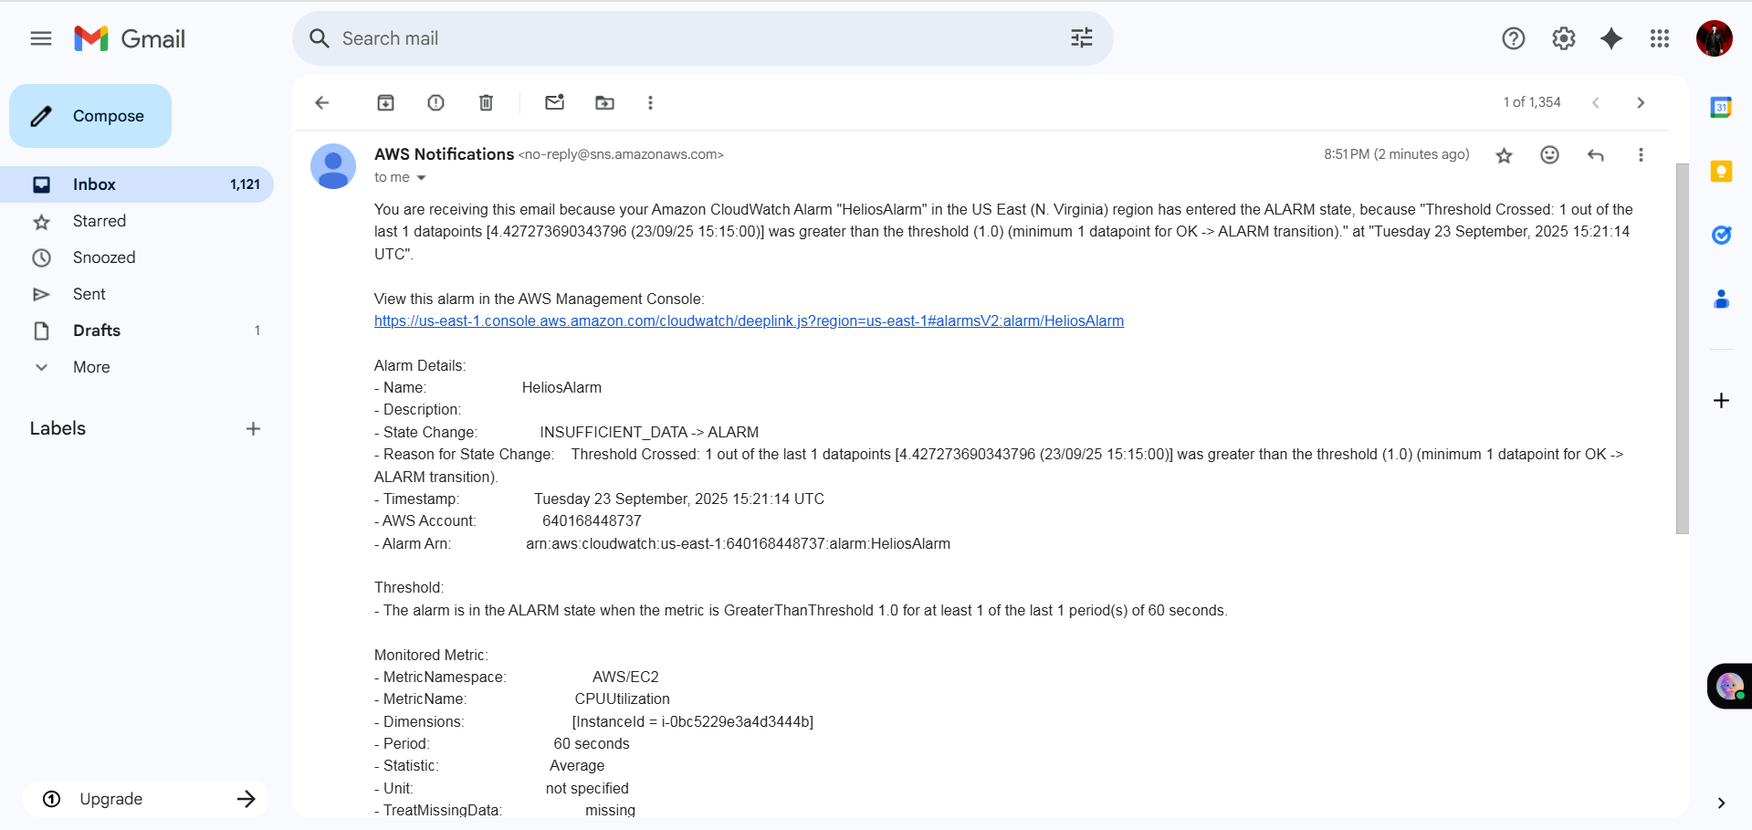

**10. Discussion**

Helios illustrates the potential of AI and cloud-native technologies to collaborate in providing strong, fault-tolerant systems. In comparison to fixed monitoring, anomaly detection via ML responds to dynamic cloud workloads. Drawbacks are the use of synthetic data sets, auto-healing limited to a sole EC2 instance, and no automated healing process. Potential future enhancements are:

• AWS Lambda integration for auto-healing.

• Auto-scaling policies based on discovered anomalies.

• Multi-region deployment expansion.

• Training with real-world datasets.

**11. Architecture & Service Usage**

Helios was designed and implemented using a cloud-native, modular, and scalable architecture. The project leverages multiple AWS services and integrates them with machine learning models to build an end-to-end anomaly detection and monitoring system.

* Machine Learning Models (Google Colab):  
  Five anomaly detection models (CPU, Network, Login, Content, Storage) were trained in Google Colab using Python and scikit-learn. This provided a cost-free environment for training while ensuring reproducibility.
* Model Storage (Amazon S3):  
  Trained .pkl model files were securely stored in an S3 bucket (helios-nitanshu). Bucket versioning was enabled to ensure data durability and rollback capability.
* Deployment (Amazon EC2):  
  A dedicated EC2 instance (helios-agent) was launched to host the Flask API application. Security Groups were configured to allow SSH (22), HTTP (80), and Custom TCP (5000). This ensured controlled access while exposing necessary endpoints.
* IAM for Access Control:  
  A restricted IAM user with S3ReadOnlyAccess policy was created to let the EC2 instance fetch model files securely. This demonstrates adherence to principle of least privilege.
* Monitoring & Alerts (CloudWatch + SNS):  
  AWS CloudWatch was used to monitor metrics like CPUUtilization, NetworkIn, NetworkOut, Disk Reads/Writes, while alarms were set to trigger SNS notifications (via email). This integrated alerting pipeline makes Helios proactive.

The architecture shows strong service utilization (Colab + S3 + EC2 + IAM + CloudWatch + SNS + Postman testing). Each service has a clear role, and together they form a resilient ecosystem.

**12. Implementation & Deployment**

Helios is not just a theoretical design—it was fully implemented and tested in a real cloud environment.

* Model Training & Export:  
  All five ML models were trained with synthetic but realistic datasets, then serialized into .pkl format for portability.
* S3 ↔ EC2 Integration:  
  The EC2 agent was configured with AWS CLI to directly pull models from S3 using IAM credentials. This automated pipeline ensured that updates in S3 could seamlessly propagate to the EC2 agent.
* Flask API (app.py):  
  The Flask server was developed to expose RESTful endpoints for anomaly detection. Each route corresponds to one model (/predict/cpu, /predict/network, etc.).
* Testing (Postman):  
  Postman was used to verify all endpoints with both normal and anomalous data. The system successfully differentiated between legitimate and abnormal behavior in all cases.
* Monitoring Setup:  
  CloudWatch alarms were linked to SNS topics, and test alerts were successfully received via email.

The project demonstrates a real-world deployment cycle: ML model → Cloud Storage → Agent Deployment → API Testing → Monitoring → Alerting. This end-to-end chain shows implementation maturity.

**13. Scalability, Automation & Security**

Helios was built with cloud scalability and resilience in mind.

* Scalability:
  + Additional models can be easily trained and dropped into the models/ S3 folder.
  + Multiple EC2 instances can run the same agent (behind a load balancer) for distributed anomaly detection.
  + Flask API can be containerized into Docker and run on ECS/EKS for even higher scale.
* Automation:
  + Models are automatically pulled from S3 whenever the EC2 agent is launched.
  + CloudWatch alarms auto-trigger SNS without human intervention.
  + Future scope: Auto-remediation (e.g., restarting services when anomalies occur).
* Security:
  + IAM user limited to S3 read-only access (no unnecessary privileges).
  + EC2 Security Groups restricted only to required ports.
  + S3 bucket access blocked from the public.
  + Data-in-transit secured via HTTPS (Flask can be extended with TLS).

The design is production-aligned: scalable, automated, and with security principles embedded.

**14. Documentation & Presentation**

Proper documentation and presentation make Helios a professional-grade project rather than a raw prototype.

* Detailed Documentation:  
  A structured Word file was prepared containing:
  + End-to-end workflow (model training → deployment → monitoring).
  + Step-by-step commands for reproducibility.
  + Screenshots of each stage (Colab, S3, EC2, Flask, Postman, CloudWatch, SNS).
  + Clear explanation of tools/services used.
* Research Paper Alignment:  
  The system aligns with the theme of AI-driven anomaly detection in cloud environments, supporting the research topic directly.
* Demo Video:  
  A short video demonstrates:
  + EC2 agent running,
  + Postman anomaly tests,
  + CloudWatch dashboard metrics,
  + SNS alert emails in inbox.

Good documentation and presentation prove that the project is not only implemented but also understandable, reproducible, and research-backed.

**15. Conclusion**

Helios integrates AI/ML anomaly detection with AWS cloud capabilities to provide an end-to-end self-healing cloud pipeline. Through the combination of model training, deployment, monitoring, and alerting, the project confirms the possibility of autonomous cloud systems. This is in line with the aim of this research to improve cloud resilience and security by leveraging intelligent, automated systems.

*This Project will further be extended and detailed in my research paper on a similar topic.